

**For Immediate Release:** Contact: Chandler Smith

July 15, 2014 202-224-6244

**Heller Urges ENR for Action to Help Wildfire Suppression in Nevada**

**(Washington, D.C.)** – Today, U.S. Senator Dean Heller (R-NV) urged the Energy and Natural Resources Committee to act on legislation aimed at spurring active management of public lands and forests across the West at a hearing titled “Wildfire Preparedness & Forest Service 2015 Fiscal Year Budget.” Heller discussed challenges posed by both the severity and length of the wildfire season in Nevada and the devastation resulting from wildfire damage. When questioning U.S. Forest Service Chief Tom Tidwell, Heller underscored the significance in pro-actively treating federal lands before danger arises by reducing fire risks instead of containing large and unmanageable wildland fire.

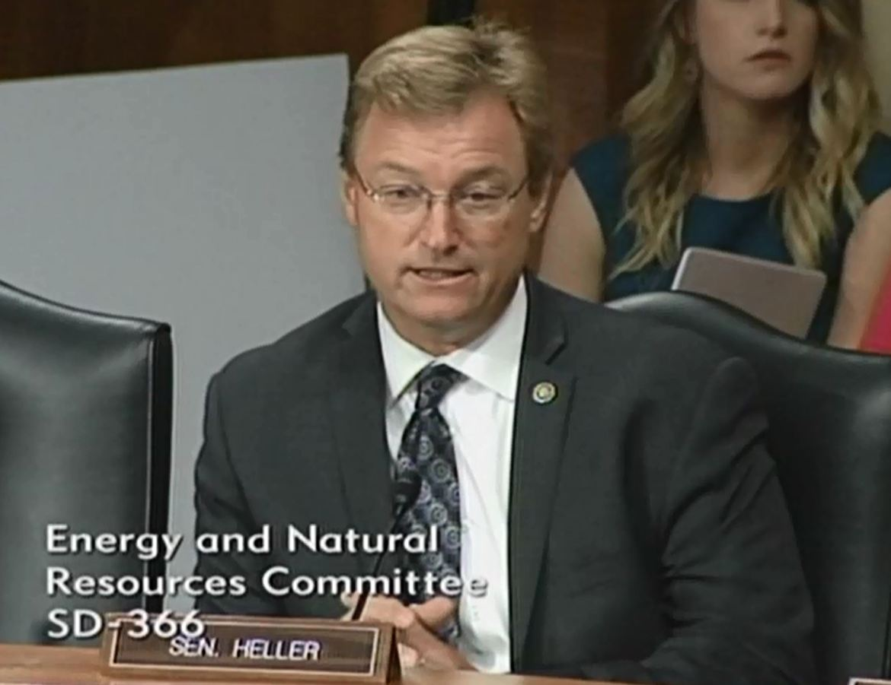

[**Click here to watch video**](http://youtu.be/Y7BR-yA4RqE)

###