

**For Immediate Release:** Contact: Neal A. Patel

January 22, 2015 202-224-6244

**Heller Promotes Economic Recovery and Job Creation for Nevada**

**(Washington, DC)** – Today, United States Senator Dean Heller spoke at the Senate Committee on Finance hearing titled, “Jobs and a Healthy Economy.” More specifically, Heller addressed the economic situation in Nevada and offered solutions to give the nation a more competitive marketplace.

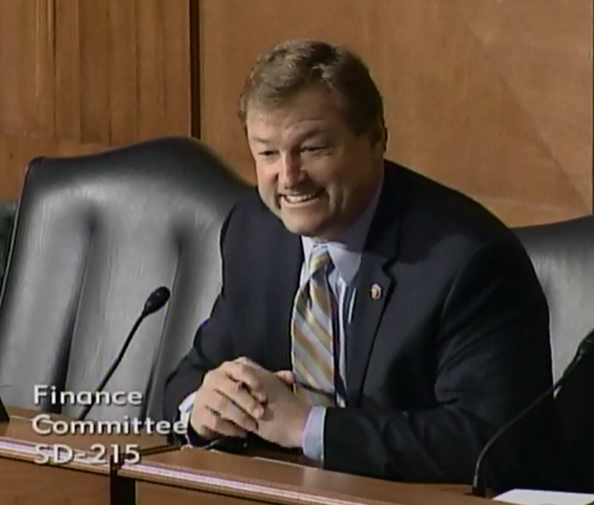

[**Click here to watch video.**](http://youtu.be/CxI7kte_6NM)

*The Senate Finance Committee is one of the oldest and most powerful committees in the United States Senate. Jurisdiction for the committee is vast as it covers tax, trade, commerce, health, national security, labor, Social Security, and monetary issues. Membership assignments for the committee are coveted by Senators and only reserved for senior members of the Senate.*

**REMARKS AS PREPARED:**

Mr. Chairman, I’d like to begin by thanking you for holding this critical hearing to focus on our nation’s most pressing issue – the economy.

Promoting real economic recovery and creating jobs must be the top priority for Congress, so I am encouraged that the Finance Committee has made this the first issue we address.

The economic recession affected everyone, but in my home state of Nevada, the effects were especially harmful.

Nevada experienced the nation’s highest unemployment rate – nearly 14% at its peak – as well as the highest foreclosure rate and one of the highest personal bankruptcy rates.

Though our situation has improved, Nevada’s unemployment rate unfortunately remains one of the nation’s highest. The recovery has been slow and thousands of Nevada families are still waiting for a true economic recovery they can see and feel in their pocketbooks.

Americans have been told the economy is getting better, but they aren’t feeling the effects, at least not in Nevada.

Though the national unemployment rate has gone down, millions of Americans have dropped out of the workforce entirely.

The fact is that this Administration’s policies have put up barriers to economic growth.

We have an already burdensome tax code that has only become more complicated under ObamaCare.

Businesses continue to face mountains of new federal rules and regulations.

And we have a health care law that makes it harder to see your doctor, makes it more difficult for employers to grow, and raises taxes on the hardworking American middle class.

To truly grow our economy, there are key issues that deserve the attention of Congress. Americans deserve a cleaner, simpler tax code, trade policies that ensure America’s competitiveness in the growing international marketplace, and health care policies that actually focus on improving access, affordability, and quality.

As a member of this committee, I look forward to working with the Chairman and Ranking Member to move these issues forward.

###