

**For Immediate Release:** Contact: Neal A. Patel

February 3, 2015 202-224-6244

**Heller Supports American Taxpayers in IRS Questioning**

**(Washington, DC)** – Today, United States Senator Dean Heller asked the following questions at the Senate Committee on Finance hearing titled, “[Internal Revenue Service Operations and the President’s Budget for Fiscal Year 2016](http://www.finance.senate.gov/hearings/hearing/?id=c1ff00a9-5056-a032-527d-d4ac3f013388).” More specifically, Heller voiced his support for accountability to the American taxpayer by ensuring the Internal Revenue Service stops waste, fraud and abuse of taxpayer dollars.

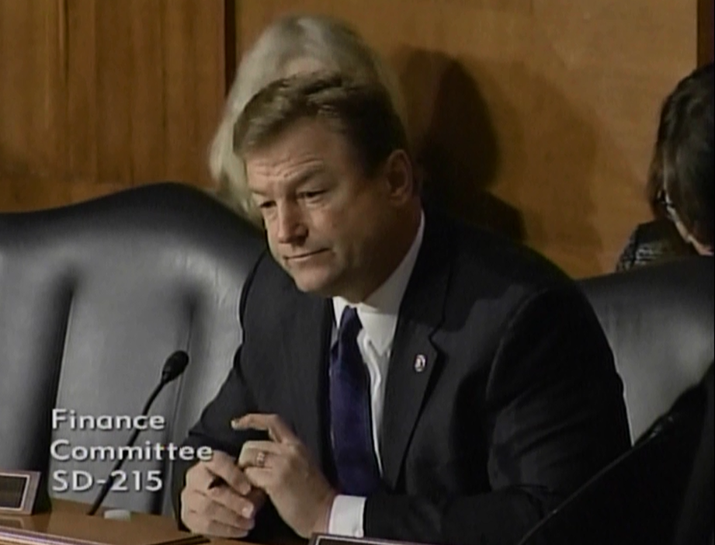

**Click here to watch video.**

###