

**For Immediate Release:** Contact: Neal A. Patel

February 5, 2015 202-224-6244

**Heller Addresses Burdensome Tax Code**

**(Washington, DC)** – Today, United States Senator Dean Heller spoke at the Senate Committee on Finance hearing titled, “The President’s Budget for Fiscal Year 2016,” questioning the United States Secretary of the Treasury Jacob Lew. More specifically, Heller voiced his concern about the complexity and cost of the current tax code.

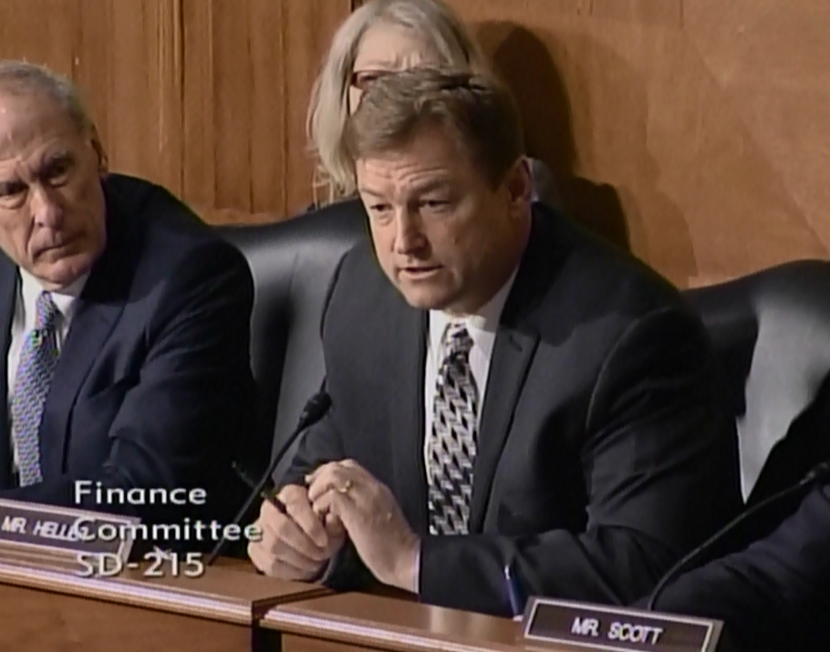

[**Click here to watch video.**](http://youtu.be/mnC92oIpcu4)

###