

**For Immediate Release:** Contact: Neal A. Patel

March 12, 2015 202-224-6244

**Heller Amendment Seeks Justice for Victims of Human Trafficking**

**(Washington, DC)** – Today, United States Senator Dean Heller spoke on the Senate floor about his amendment to S. 178, the Justice for Victims of Trafficking Act of 2015. More specifically, Heller’s amendment ensures that Department of Homeland Security personnel are properly trained to prevent human trafficking.

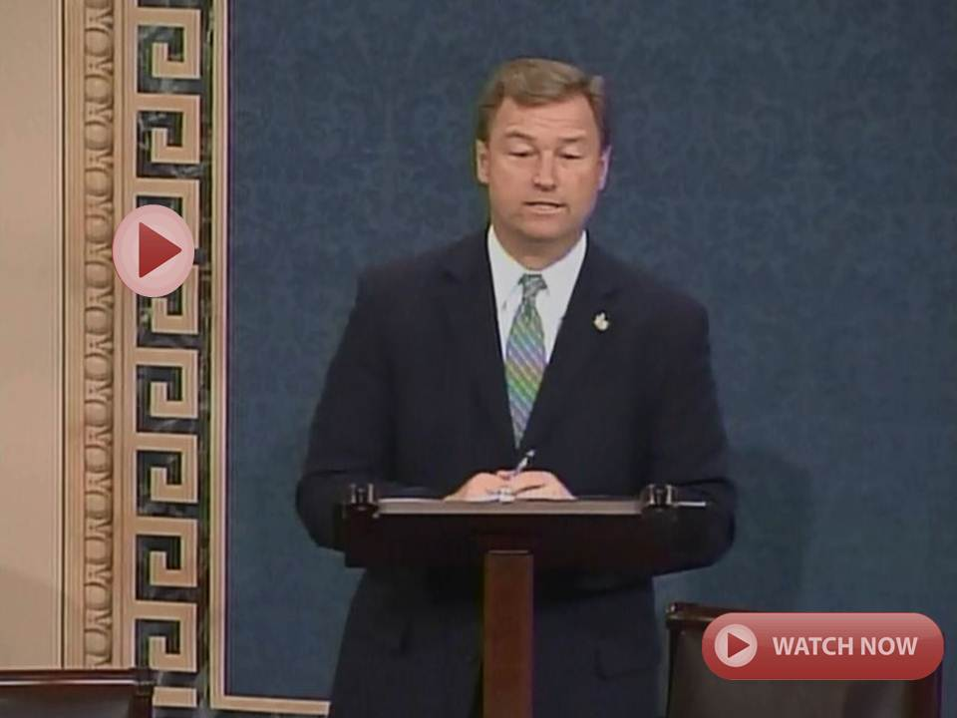

[**Click here to watch video.**](https://youtu.be/q50Oj_6u8Z8?list=UUTS6f940sIirkO6ICyx4ksw)

REMARKS AS PREPARED:

Mr. /Madam President,

I rise today in support of the bill that’s currently pending before us, the Justice for Victims of Trafficking Act.

I commend the senior Senators from Texas and Minnesota for coming together in a bipartisan fashion on this vitally important human rights legislation.

Because this is such a bipartisan bill and frankly a non-partisan issue, I am frustrated that we are at an impasse on moving this bill forward with an open debate.

Let me repeat, this is a non-partisan issue, and I encourage my colleagues across the aisle to move forward with an open debate on this vitally important human rights legislation.

Every day, countless innocent victims are bought and sold into modern-day slavery here in America.

All too often, many of these victims are children. As a father of four and a grandfather, I believe every child should have the opportunity to grow up in a loving and safe environment.

Unfortunately, this is not the case for too many children.

Recognizing this is an important issue, my home state of Nevada has taken action over the past several years, not only to assist victims of trafficking, but also to ensure these victims have the opportunity to seek compensation from their traffickers.

Given Nevada’s unique location, especially southern Nevada, this is a crime that is all too prevalent within my home state.

Just to give you an idea, two years ago, the Las Vegas Metropolitan Police Department reported that 2,144 sex-trafficking victims under age 18 were “rescued” in Las Vegas since 1994, which is an average of 126 per year. That’s one person every three days that was rescued.

More than half of these victims were from Nevada and the rest had been trafficked through the state.

While Nevada has taken important steps forward in providing restitution for victims of trafficking, much more needs to be done to stop this crime from occurring in the first place.

All too often, trafficking is a crime that is hidden in plain sight. But it occurs in every single state.

That is why it is vitally important to recognize the warning signs of someone who may be a victim of human trafficking, as well as those who are committing these crimes.

I am pleased to see this underlying bill recognizes this need, especially for local law enforcement, health providers, and first responders.

The bill, however, fails to recognize the important role our nation’s ports of entry play in our nation’s domestic and international transportation system and the opportunity they provide for human trafficking.

This is why I filed an amendment to this legislation to ensure that victims of human trafficking and perpetrators of this crime will not be able to pass through such places without additional law enforcement awareness.

My amendment simply requires the Department of Homeland Security to train TSA, CBP, and other relevant department personnel to effectively deter, detect, and disrupt human trafficking.

Recognizing the different needs of states and the critical role of local law enforcement in combatting human trafficking, it also allows DHS to provide training materials to any state, local, or tribal government or private organization in order to establish a human trafficking awareness training program.

Finally, this amendment requires DHS to keep records of the number of human trafficking cases reported or confirmed and report these numbers annually to Congress. That way, we can measure progress in our efforts to end human trafficking.

Instead of creating another layer of bureaucracy, my amendment simply complements and enhances the current efforts by DHS to equip its personnel with effective strategies to combat human trafficking at our nation’s ports of entry and other high-risk areas.

Earlier this year, I was pleased to see similar legislation pass the House of Representatives with unanimous support.

I think most of us can agree that the issue of human trafficking is not a partisan issue; it’s a human rights issue. Whether you’re a parent, a sibling, a child, or a relative, this issue is real.

This is why I was so pleased to see this chamber come together in a bipartisan manner to bring this bill to the floor.

Once again, I only hope that we can come together and move this debate forward.

As I tell Nevadans back home, I came to Washington, DC to work. I work with Republicans and I work with Democrats.

There are issues that we may at times have to agree to disagree on, but moving forward on a bipartisan bill like this one should not be one of them.

We need to do all that we can to end this disgraceful and disgusting crime once and for all.

We should move forward in providing much needed help to these victims – including children.

Now there is more work to do on this bill and ways to make it a better product through the amendment process, but we should be moving forward instead of stalling out.

I hope that I have the opportunity to call up my amendment and would urge my colleagues to support my amendment so we can ensure that DHS personnel are properly trained to prevent the serious threat of human trafficking.

Help is almost there for these victims. I hope that we can come to a resolution today to move forward on this bill.

Mr. President, I yield the floor.

###