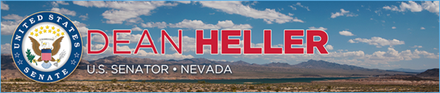

|  |  |
| --- | --- |
| **For Immediate Release:** | **Contact:** [Megan Taylor](mailto:Megan_Taylor@heller.senate.gov) |
| June 20, 2017 | 202-224-6244 |

**In Case You Missed It: Heller Continues to Advocate for Rural Broadband Improvements**

**Washington, D.C.** – During a Senate Commerce Subcommittee on Communications, Technology, Innovation, and the Internet hearing, U.S. Senator Dean Heller (R-NV) discussed his support for rural broadband improvements, and his legislation [the Rural Broadband Deployment Streamlining Act](https://www.heller.senate.gov/public/index.cfm/pressreleases?ID=D1AC86C9-DAC4-43F1-B72D-E6CE577C3925). Heller spoke with key stakeholders of the Universal Service Fund (USF) to discuss the importance of his legislation while also touting the effectiveness of utilities like Valley Electric in Nevada located in Pahrump, Nevada. However, what stands in the way to more innovation similar to Valley Electric is burdensome application waiting periods— Heller’s legislation is looking to address just that. Click HERE or below to watch the exchange.

[Click here or the above image to watch]

[Building on his efforts from last Congress](http://www.heller.senate.gov/public/index.cfm/2016/3/icymi-heller-s-fight-to-improve-broadband-access-in-nevada-continues), Heller remains committed to bringing broadband access to rural Nevadans and was pleased his amendments from last Congress were included in this year’s MOBILE Now Act (S.19).

One of the greatest inhibitors to broadband infrastructure expansion is the time it takes for federal agencies, particularly those that manage federal lands, to act on applications for easements or rights-of-way for constructing or modifying broadband infrastructure on federal property. To address this issue, [Heller recently introduced bipartisan legislation](https://www.heller.senate.gov/public/index.cfm/pressreleases?ID=D1AC86C9-DAC4-43F1-B72D-E6CE577C3925) that would expand Americans’ access to broadband by streamlining the application process required to construct broadband infrastructure on federal lands.

###  
  
[cid:image002.png@01D2E13F.9D4AF410](http://www.facebook.com/pages/US-Senator-Dean-Heller/325751330177)[cid:image003.png@01D2E13F.9D4AF410](http://twitter.com/SenDeanHeller)[cid:image004.png@01D2E13F.9D4AF410](http://www.youtube.com/user/SenDeanHeller)