

**For Immediate Release:** Contact: Chandler Smith

June 12, 2014 202-224-6244

**Heller: VA benefits must be addressed immediately**

**(Washington, D.C.)** – U.S. Senator Dean Heller (R-NV), Co-Chairman of the VA Backlog Working Group, today spoke on the Senate floor calling on Congress to take immediate action to help veterans access the benefits they earned while serving our nation. Yesterday, the Senate passed a bill addressing problems within the Department of Veteran Affairs’ (VA) healthcare system. Today, Heller argued that problems with delivery of VA benefits should not be ignored.

[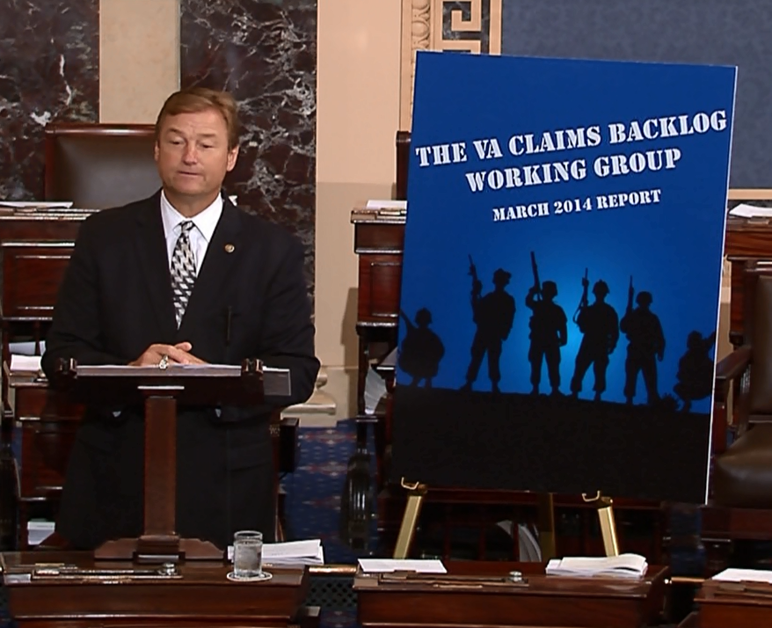](http://youtu.be/N36jev5xUOc)

[**CLICK HERE TO VIEW HELLER’S REMARKS**](http://youtu.be/N36jev5xUOc)

**Below are excerpts, as prepared, from Senator Heller’s speech**:

“Addressing the serious concerns with healthcare at the VA is an urgent issue, and one that needed quick action from Congress.

“But there is another side of the coin separate from the Veterans Health Administration, and that is the Veterans Benefits Administration. It is the responsibility of the VBA to administer benefits to our veterans.  The VHA has undergone intense scrutiny in recent weeks, but the veterans disability claims backlog is another urgent issue that needs action from Congress.

“Just as it is unacceptable for veterans to wait months for appointments, it is unacceptable for them to wait months for their benefits they have earned.

“To address this issue, Senator Casey and I introduced the VA Backlog Working Group Report along with a bipartisan group of our colleagues, Senators Moran, Heinrich, Vitter, and Tester.

“This report outlines the claims process, explains the history of VA's claims backlog, and offers targeted solutions to help the VA develop an efficient benefits delivery system.

“To put this report's targeted solutions into action, our Working Group introduced the 21st Century Veterans Benefits Delivery Act.  This comprehensive, bipartisan piece of legislation addresses three areas of the claims process: claims submission, VA Regional Office practices, and federal agency responses to VA requests.

“I am pleased that 18 of our Senate colleagues on both sides of the aisle have cosponsored this legislation, and that it has gained the support of Veterans Service Organizations, including the VFW, DAV, The American Legion, Military Officers Association of America, and AUSN.

“Senator Casey and I recognize that the claims process is complex and there is no silver bullet that is going to solve this problem, but the VA’s current efforts will not eliminate this backlog.

“So, just as we worked to address issues at the VHA, I encourage my colleagues to work to address some of these same issues at the VBA.

“Our proposal can no longer afford to wait in the backlog of bills to be considered by this Chamber.”

# # #