

|  |  |
| --- | --- |
| **For Immediate Release:** | **Contact:** [Megan Taylor](mailto:Megan_Taylor@heller.senate.gov) |
| July 18, 2017 | 202-224-6244 |

**In Case You Missed It: Heller Drives the Need for Sweeping Tax Reform**

***Heller: Tax Code Should Work for Average Taxpayer***

**Washington, D.C.** – During a U.S. Senate Finance Committee hearing, U.S. Senator Dean Heller (R-NV) expressed his strong support for comprehensive tax reform that will benefit everyday Nevadans and bring a full economic recovery to the state of Nevada. Heller specifically highlighted his long-held goals: broadening the base, reducing rates, and simplifying the tax code.

Heller went on to discuss what the specific effects of his goals would be for the average American taxpayer. Heller believes that the ellaverage taxpayers should stand to benefit from this tax reform and be able to calculate their own taxes not. Click [HERE](https://youtu.be/fofV7U5BZos) or below to watch the exchange.

[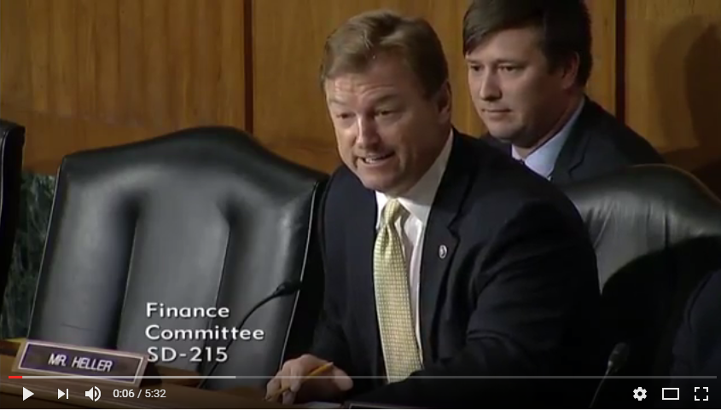](https://youtu.be/fofV7U5BZos)

[Click [here](https://youtu.be/fofV7U5BZos) or the above image to watch]

In 2015, [Heller chaired the Senate Committee on Finance hearing titled, “Fairness in Taxation.”](https://www.youtube.com/watch?v=Q6zhL82BN_I)  More specifically, Heller voiced his concern over the complexity and cost of the current tax code and questioned the panel about what constitutes fairness in taxation. With Republicans controlling the House of Representatives, the U.S. Senate, and the White House, Heller believes now is the time for tax reform.

###  
  
[cid:image002.png@01D2E13F.9D4AF410](http://www.facebook.com/pages/US-Senator-Dean-Heller/325751330177)[cid:image003.png@01D2E13F.9D4AF410](http://twitter.com/SenDeanHeller)[cid:image004.png@01D2E13F.9D4AF410](http://www.youtube.com/user/SenDeanHeller)