

|  |  |
| --- | --- |
| **For Immediate Release:** | **Contact:** [Megan Taylor](mailto:Megan_Taylor@heller.senate.gov) |
| May 25, 2017 | 202-224-6244 |

**ICYMI: Heller Stands Up For Nevada’s Priorities**

**Washington, D.C.** – U.S. Senator Dean Heller (R-NV) today advocated on behalf of Nevada priorities ranging from renewable energy, to the housing economy, and tax deductions in a discussion with U.S. Treasury Secretary Steve Mnuchin at a U.S. Senate Finance Committee hearing. Heller asked Secretary Mnuchin about protecting investment tax credits that create a level playing field for the energy sector as well as ensuring tax reform is fair and favorable to the state of Nevada. Heller also discussed the importance of addressing mortgage debt relief, [citing his previous conversation with Secretary Mnuchin](https://www.heller.senate.gov/public/index.cfm/2017/1/icymi-heller-demands-specific-answers-on-nevada-s-housing-crisis-from-mnuchinhttps:/www.heller.senate.gov/public/index.cfm/2017/1/icymi-heller-demands-specific-answers-on-nevada-s-housing-crisis-from-mnuchin) earlier this year. Click [HERE](https://youtu.be/F1ZZJBuYjWY) or below to watch video from the hearing.

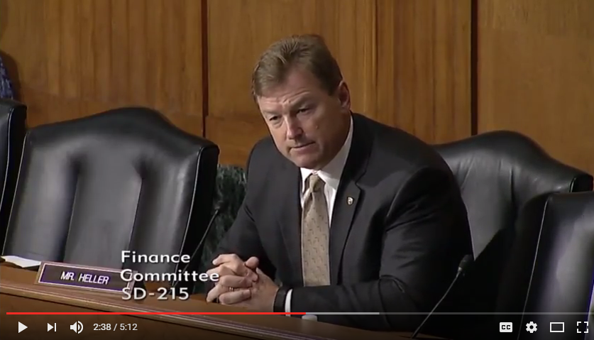

[Click [here](https://youtu.be/F1ZZJBuYjWY) or the above image to watch]

Heller has been working with a bipartisan group of senators to bring relief to Nevada’s housing economy. [Earlier this year, Heller (R-NV) joined with several of his colleagues to introduce S. bipartisan legislation aimed to prevent homeowners from being forced to pay taxes on forgiven mortgage loan debt.](https://www.heller.senate.gov/public/index.cfm/2017/1/heller-stabenow-isakson-and-menendez-lead-bipartisan-effort-for-home-mortgage-relief)

Since coming to Congress, Heller has been an outspoken advocate for regulatory and tax policies that promote the development of solar, geothermal, and other innovative technologies.

[In 2016, Heller cosponsored legislation with U.S. Senator Martin Heinrich (D-NM) called the Energy Storage Tax Incentive and Deployment Act](https://www.heller.senate.gov/public/index.cfm/2016/7/heller-supports-bipartisan-bill-to-create-tax-credit-for-energy-storage). The legislation establishes investment tax credits (ITC) for business and home use of energy storage. The proposed tax incentives are modeled on the current ITCs for solar energy and apply to either large, grid-connected energy storage systems or to smaller battery systems for residential power. Home battery storage, coupled with a small wind or roof-top solar system, and could be used to store energy during the day for use later in the day or during overcast skies and to help consumers reduce their energy bills.

###