

**For Immediate Release:** Contact: Chandler Smith

July 30, 2014 202-224-6244

**Heller Introduces Two Land Initiatives to Committee**

**(Washington, D.C.)** – Today, U.S. Senator Dean Heller (R-NV) spoke at the Senate Public Lands, Forests, and Mining Subcommittee hearing in favor of two pieces of legislation seeking to address two difficult public lands issues arising in Nevada: the Good Samaritan Search and Recovery Act (S. 1049) and the Pinyon-Juniper Related Projects Implementation Act (S. 1640).

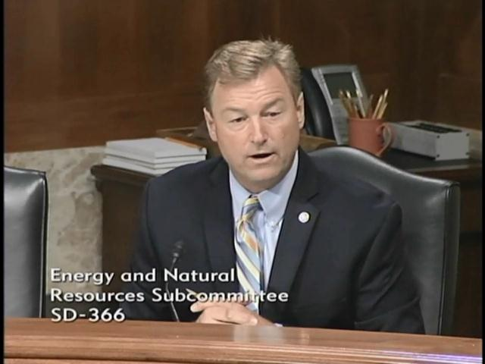

[**Click here to watch video.**](https://www.youtube.com/watch?v=DCD2tdJGrYw&feature=youtu.be)

**Remarks as prepared:**

Thank you Chairman Manchin and Ranking Member Barrasso for holding this important hearing today, and for including two of my bills that seek to address two difficult public lands issues that have come up in Nevada.

The first of the two bills, the Good Samaritan Search and Recovery Act would solve a long-standing public safety issue in our National Parks, Forests and Public Lands. My friend and colleague in the House, Congressman Joe Heck, and I introduced this legislation in response to the tragic stories of Mr. Keith Goldberg and Air Force Staff Sargent Antonio Tucker.

Both of these individuals were missing for over a year before volunteer, Good Samaritan rescue teams received government authorization to begin searching. This bipartisan common-sense legislation would allow for expedited access to public lands for Good Samaritan search and recovery organizations so that they may conduct searches for missing persons.

I would personally like to thank Keith Goldberg’s Sister Jodi and her husband Paul Thompson and Keith’s brother Jeff Goldberg who have joined us here today and support for their tireless work and advocacy on behalf of this legislation. This family’s courage and resilience is truly inspiring, I am grateful for the sacrifices they have made to advance our bill.

Their brother Keith disappeared on January 31, 2012. He was believed to be the victim of murder, but the police, operating on thin resources, were unable to continue the search for his body in the Las Vegas desert. His family went without closure for far too long.

When new evidence pointed towards the Lake Mead recreational area, Mr. Goldberg’s sister, Jodi, reached out to a private search and rescue team to look for her brother. All that prevented the rescue team from discovering Mr. Goldberg’s body was the bureaucratic red tape of the National Park Service, which refused to allow them to search the area without a permit and a $1 million insurance policy.

After the family spent six months finding an insurer and raising the money to buy the policy, the search team found Keith Goldberg in two hours.

Staff Sergeant Antonio Tucker’s family suffered a similarly frustrating ordeal. Staff Sergeant Tucker was stationed at Creech Air Force Base, when he went missing on June 23, 2012. He was believed drowned. A Good Samaritan search team offered to look for Staff Sergeant Tucker but was blocked by the Park Service, which required insurance and a special search permit. These hurdles were finally overcome about a year later. The team, possessing superior equipment to government divers, found the body within two days.

No family should have to go through what the Goldberg and Tucker families have had to endure by waiting a year to recover a loved one. Our legislation will prevent such needless red tape from interfering in the search and recovery of lost persons. It will provide qualified and trained search and rescue groups with expedited access to park service land if they sign a liability waiver. It requires the Secretary of the Interior and the Secretary of Agriculture to implement a process to expedite access to Federal lands for Good Samaritan search-and-recovery operations. And it will give the Secretary the authority to develop long-term partnerships with search and recovery organizations to help facilitate and expedite such Good Samaritan missions for missing persons.

The Good Samaritan Search and Recovery Act has the ability to conserve government resources, to provide families closure, and even to save lives. The House version of this bill passed the House of Representatives unanimously last year. I would also like to thank Senators Warner, Tester, Hatch, and Chambliss for cosponsoring my bill. I am confident it can garner similar overwhelming support in the Senate if given the opportunity.

My second bill before this committee, the Pinyon-Juniper Related Projects Implementation Act is a bipartisan bill, requested by local government officials from Lincoln County, Nevada.

The bill will amend existing law to provide local officials more flexibility to carry out conservation and land-use goals, such as infrastructure development, wildlife conservation, and wildfire prevention.

Because nearly 85 percent of the land in Nevada is administered by the federal government, it presents our local and state governments with many unique challenges. In order to accommodate the needs to of Lincoln County, Congress passed the Lincoln County Land Act in 2000 and the Lincoln County Conservation, Recreation and Development Act in 2004.

It has become apparent that the current authorities of those existing laws do not serve to effectively facilitate the successful implementation of these important environmental protections and land use initiatives. To address these limitations, I introduced this bill to makes minor improvements to those laws, by improving the Bureau of Land Management’s (BLM’s) administration of watersheds and wildlife habitat, and to enhance economic development in Lincoln County. Nevada Congressmen Mark Amodei and Steve Horsford introduced nearly identical bipartisan legislation in the House as well.

Given that this bill will spur economic growth and create much needed jobs, in a county faced with an unemployment rate of 10 percent, I look forward to working with the members of this committee to move this important legislation forward.

Once again, I would like to express my appreciation to the Committee of holding this important hearing today. I encourage our full Committee Chair to move both of these important bills forward in our next business meeting.

###