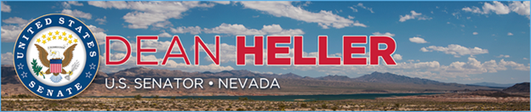

|  |  |
| --- | --- |
| **For Immediate Release:** | **Contact:** [Megan Taylor](mailto:Megan_Taylor@heller.senate.gov) |
| July 12, 2017 | 202-224-6244 |

**In Case You Missed It: Heller Highlights His Continued Fight against Human Trafficking**

**Washington, D.C.** – During a Senate Commerce Committee hearing, U.S. Senator Dean Heller (R-NV) discussed his efforts to combat human trafficking and child exploitation. Heller stated that in Nevada alone, 161 human trafficking cases were reported through the National Human Trafficking Hotline and 80% were sex trafficking— this does not account for unreported cases. Heller specifically mentioned XXXXXXX.

[Click here or the above image to watch]

Throughout the hearing, Heller highlighted his legislative efforts to fight human trafficking such as the [PROTECT Our Children Act, legislation that recently passed the U.S. Senate](https://www.heller.senate.gov/public/index.cfm/2017/6/senate-passes-heller-backed-bill-to-combat-online-exploitation-of-children) and would reauthorize the Internet Crimes Against Children (ICAC) Task Force Program, a national network of 61 coordinated task forces that combat child exploitation across the country.

Heller also highlighted the HERO Improvements Act, legislation he introduced that builds on a current program that helps wounded veterans work in efforts to still give back and fight child exploitation and trafficking online.

###  
  
[cid:image002.png@01D2E13F.9D4AF410](http://www.facebook.com/pages/US-Senator-Dean-Heller/325751330177)[cid:image003.png@01D2E13F.9D4AF410](http://twitter.com/SenDeanHeller)[cid:image004.png@01D2E13F.9D4AF410](http://www.youtube.com/user/SenDeanHeller)