

**For Immediate Release:** Contact: Neal A. Patel

January 21, 2015 202-224-6244

**Heller Questions Panel on Net Neutrality**

**(Washington, DC)** – Today, United States Senator Dean Heller asked the following questions at the Senate Committee on Commerce, Science and Transportation hearing titled, “Protecting the Internet and Consumers through Congressional Action.”

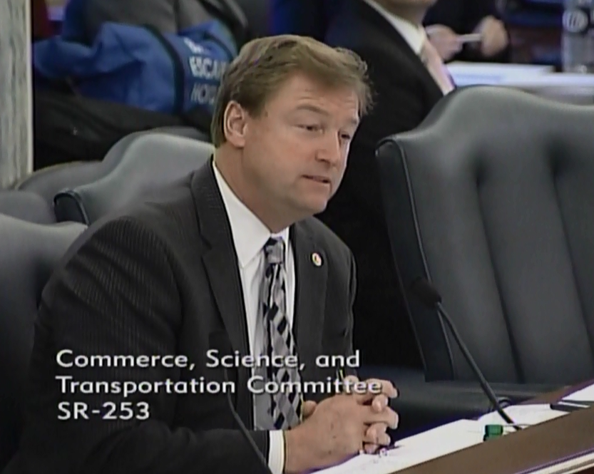

[**Click here to watch video.**](http://youtu.be/HISgqEOYCQU)

###