

**For Immediate Release:** Contact: Chandler Smith

July 31, 2014 202-224-6244

**Heller Ensures TBI Program for Vets Included in Conference Committee Legislation**

**(Washington, D.C.)** – Today, United States Senator Dean Heller spoke on the Senate floor about a very critical provision in the Conference Committee’s legislation that he, along with Senator Cory Booker, took a lead on addressing: extension of the Assisted Living Program for Veterans with Traumatic Brain Injury. This program operates in two locations in Nevada and serves wounded warriors who are trying to restore their quality of life.

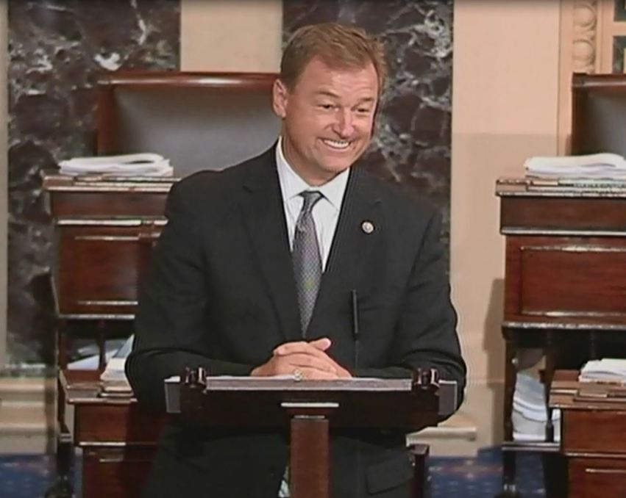

[**Click here to watch video.**](http://youtu.be/-ALWiHHknMU)

###