

**For Immediate Release:** Contact: Chandler Smith

July 30, 2014 202-224-6244

**Heller: Data Collection Practices Are Massive Intrusion of Privacy**

**(Washington, D.C.)** – Recently, U.S. Senator Dean Heller (R-NV) spoke on the Senate floor in support of legislation amending the USA Freedom Act. Reflecting bipartisan and bicameral changes, the legislation ends bulk data collection practices currently used by the government. The legislation goes one step further by clearly outlining to America’s intelligence officials specific rules to follow so that they can **keep** the operational capabilities necessary to protect the United States from a terror attack **without** infringing upon the Fourth Amendment rights of American citizens.

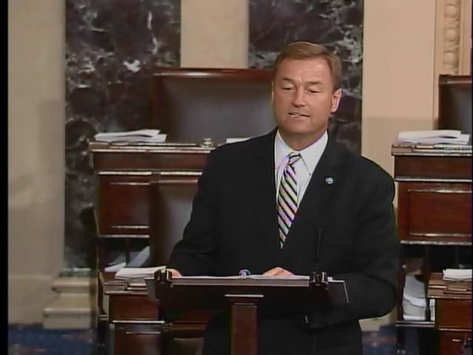

**[Click here to watch video.](http://youtu.be/PHCR1HZly3o)**

**Remarks as prepared:**

Mr. President,

Today, my colleague, Senator Leahy, the Chairman of the Judiciary Committee, introduced legislation that would amend the USA FREEDOM ACT. This new legislation reflects a bicameral and bipartisan compromise that ends the bulk data collection practices currently used. It also gives our intelligence officials specific rules to follow so that they can *keep* the operational capabilities necessary to protect the United States from a terror attack *without* compromising the Fourth Amendment to the Constitution.

I would like to thank Senator Leahy for his work, and am grateful for his partnership. This important step is necessary for restoring Americans’ privacy rights, which were taken by a well-intended, but overreaching federal government, in the wake of the 9/11 terrorist attacks.

Mr. President, the expanded authority given to the National Security Agency through executive action and the PATRIOT ACT was intended to prevent another attack on America. While I was not a member of Congress on 9/11, I shared the horror all Nevadans felt watching the murder of thousands of innocent Americans, and the profound sadness as buildings in New York City and Washington D.C. sat smoldering.

I *understand* as well as anyone here the reasoning behind the actions our nation’s leaders took to ensure that another attack on America never materialized, and why our leaders felt that no limits should be imposed, no matter what the cost. Americans had to be protected against another attack.

Viewing the situation from that lens, it is easy to understand how the Fourth Amendment was brushed aside as the United States Senate expanded law enforcement surveillance capabilities with just one dissenting vote.

The Federal Bureau of Investigation then used Section 215 of the PATRIOT ACT to expand the scope of surveillance far beyond even what some of the authors believed they were authorizing.

The FBI argued that Section 215 provided authority to collect phone data of law-abiding citizens without their knowledge. Specifically, they could use the “business records” provision to force phone companies to turn over millions of telephone calls when there is reasonable ground or relevance to believe that the information sought is relevant to an authorized investigation of international terrorism.

As a result we now have a bulk collection program in existence where telephone companies hand over millions of records to the NSA as part of a massive pre-collection database.

As someone who voted against the PATRIOT Act multiple times, I believe such data collection practices are a massive intrusion of privacy, which is why I partnered with the senior Senator from Vermont to end these programs. Our legislation tightens the definition of “specific selection term” for Section 215 of the PATRIOT ACT and FISA pen register trap and trace devices so that the information requested is limited to specifically identifying a person, account, address, or personal device.

With this legislation, bulk collection will be eliminated and the records will stay with the telephone companies. The massive information grabs from the federal government based on geography or email service will no longer be permissible. And of the information that is collected, the legislation imposes new restrictions on the use and retention of it.

These reforms will help shift the balance of privacy away from the federal government and back to American citizens.

I am proud that this bill also includes the Franken Heller Surveillance Transparency Act of 2013. I was pleased to join Senator Franken on this legislation because, at the very least, Americans deserve to know the number of people whose information is housed by the NSA. For the first time in American history, the government is forced to disclose to the American people roughly how many of them have had their communications collected.

Our provisions call for reports by the Director of National Intelligence detailing the requests for information authorized under the PATRIOT ACT and the FISA Amendments Act.

The reports would specify the total number of people whose information has been collected under these programs and how many people living in the United States (or “likely Americans”) have had their information collected. They also would permit the Intelligence Community to report on how many Americans actually had their information looked at by the NSA or any other intelligence agencies.

Furthermore, these provisions would allow telephone and Internet companies to tell consumers basic information regarding the FISA Court orders they receive and the number of users whose information is turned over.

The principles outlined in this bill to increase transparency for Americans and private companies would clear up a tremendous amount of confusion that exists with these programs.

And our private companies need the added disclosure. The Information Technology & Innovation Foundation estimates that American cloud computing companies could lose 22 to 35 billion dollars in the next three years because of concerns about their involvement with surveillance programs. The analytics firm Forrester puts potential losses much higher, at $180 billion.

I want to be clear; I share the concerns of all Americans that we must protect ourselves against threats to the homeland. I believe that terrorism is very real and the United States is the target of those looking to undermine the freedoms we hold as the core of our national identity.

And if the bulk collection programs in existence were bearing so much information to protect the Homeland, it would change my opinion on the need for the USA FREEDOM ACT.

However, the bulk collection program has simply not provided the tangible results that justify a privacy intrusion of this level. We know this because on October 2, 2013, the Chairman of the Senate Judiciary Committee, Senator Leahy, asked NSA Director Keith Alexander the following question, and I quote:

*At our last hearing, the deputy director, Mr. Ingliss stated that there’s only really one example of a case where, but for the use of Section 215, both phone records collection, terrorist activity was stopped. Was Mr. Ingliss’ right?*

To which Director Alexander responded:

*He’s right. I believe he said two, Chairman.*

Mr. President, Congress has authorized the collection of millions of law abiding citizens’ telephone metadata for years and it has only solved two ongoing FBI investigations.

Of those two investigations, the NSA has publicly identified one. And in fact, that case could have easily been handled by obtaining a warrant and going to the telephone company.

It is the case of an individual in San Diego who was convicted of sending $8,500 to Somalia in support of Al Shabab, the terror organization claiming responsibility for the Kenyan mall attack. The American phone records allowed the NSA to determine that a U.S. phone was used to contact an individual associated with this terror organization.

I am appreciative that the NSA was able to apprehend this individual, but it does not provide overwhelming evidence that this program is necessary. Mr. President, the Obama Administration has come to the same conclusion. So has the Intelligence community.

The operational capabilities the Intelligence community relies on to conduct their mission to keep us safe will not be impacted by the USA FREEDOM Act. If it were, the Intelligence Community and the Administration would not have brokered this compromise legislation. Ending the bulk collection programs and giving Americans more transparency so they can determine for themselves whether they believe these programs should exists is obligation we have to our constituents.

We have a bill introduced today that would give our law enforcement authorities the tools they need to keep us safe while also staying true to the Fourth Amendment. I encourage my colleagues to support these important reforms and hope that it can quickly be considered by this Chamber.

Mr. President, I yield the floor.

###