

|  |  |
| --- | --- |
| **For Immediate Release:** | **Contact:** [Megan Taylor](mailto:Megan_Taylor@heller.senate.gov) |
| June 8, 2017 | 202-224-6244 |

**In Case You Missed It: Heller Highlights Health Care Costs and Possible Effects on Nevada**

**Washington, D.C.** – During a Senate Finance Committee hearing, U.S. Senator Dean Heller (R-NV) discussed health care costs, and the effects health care reform will have on the state of Nevada with Health and Human Services Secretary (HHS) Tom Price. Heller discussed the importance of controlling health care costs and looking into the effects of the proposed cuts to Medicaid in the American Health Care Act (AHCA). Specifically, Heller highlighted Nevada’s state budget, which would see a $250 million annual budget shortfall as a result of the proposed changes to Medicaid. With the state legislature out of session, a special session would need to be called in order to address the budget shortfall. Click [HERE](https://youtu.be/votqCya25_o) or below to watch.

[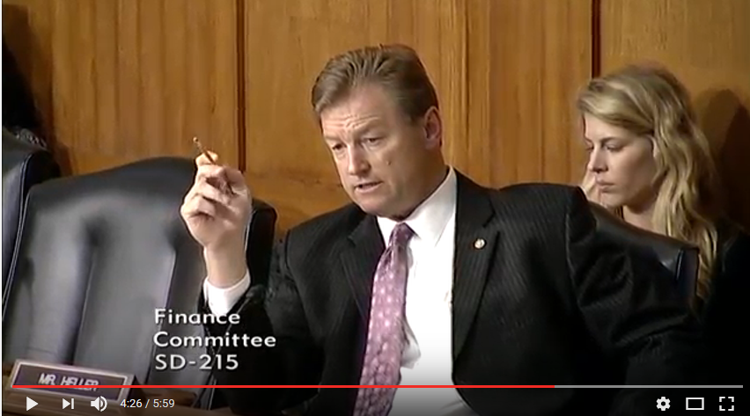](https://youtu.be/votqCya25_o)

[Click [here](https://youtu.be/votqCya25_o) or the above image to watch]

Heller opposes the AHCA in its current form partially because it doesn’t reduce health care costs. Heller has continued to advocate for solutions to the country’s health care crisis, working with members from Medicaid Expansion States, Nevada [Governor Brian Sandoval](https://www.usnews.com/news/best-states/nevada/articles/2017-03-17/sandoval-3-other-gop-governors-health-bill-wont-cut-it), the [Nevada State Legislature](https://www.heller.senate.gov/public/index.cfm/2017/2/icymi-heller-looks-to-protect-low-income-nevadans-and-seniors), as well as a [bipartisan working group](http://www.politico.com/story/2017/05/16/senate-health-care-bipartisan-238459) of senators on health care reform.

Earlier this year, [during Tom Price’s confirmation hearing, Heller asked for his commitment to working with Congress to protect access to care for patients in Nevada, particularly the more than 600,000 Nevadans that are currently on Medicaid.](https://youtu.be/BrIQkJ439s0)

###