

**For Immediate Release:** Contact: Neal A. Patel

September 9, 2014 202-224-6244

**Heller: “I remain committed to addressing the VA’s disability claims backlog.”**

**(Washington, D.C.)** – Today, United States Senator Dean Heller reaffirmed his commitment to address the VA’s disability claims backlog at a Senate Veterans’ Affairs Committee hearing held to assess the state of VA Health Care.

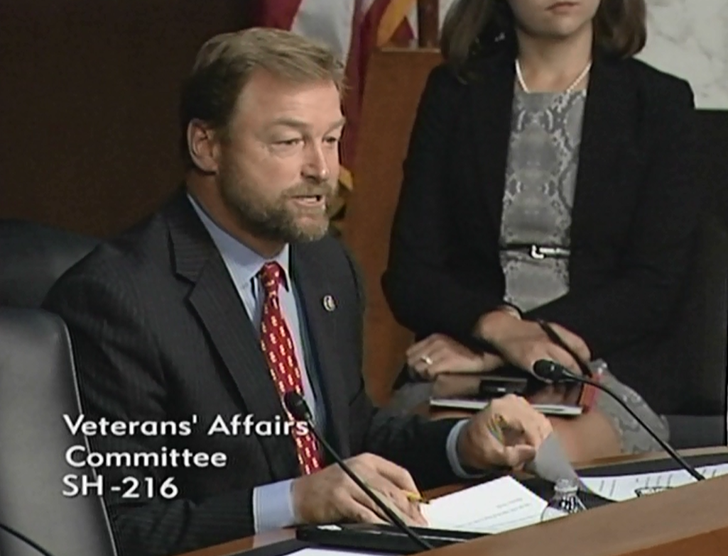

[**Click here to watch video.**](http://youtu.be/qq2WVlaG6Bs)

**Remarks as prepared:**

Thank you Chairman Sanders and Ranking Member Burr for holding this hearing.  Oversight by this Committee is critical at a time when the VA is in transition, and Nevada’s Veterans expect accountability.  
  
I know I, along with many Veterans in Nevada, have been pleased so far with Secretary McDonald.   
  
In the many times we have met in my office, in this Committee, and in Reno just a few weeks ago, Secretary McDonald has shown he is committed to bringing new vision and reforms to the VA to better serve Nevada and our nation’s Veterans.

But the task ahead will be VA’s most difficult challenge after having failed our veterans in delivering quality health care and timely benefits.  The gross mismanagement, poor treatment of veterans, and long delays revealed in Phoenix and elsewhere has shocked Congress and our nation, and is a significant crisis to overcome.

My hope is that the Secretary’s goals will not get lost in bureaucracy, and I expect consistent communication and honesty about what the VA needs from Congress to restore faith in the VA and achieve the best care possible for veterans.

Just last week, I had the privilege to meet with Veterans from Pahrump, Nevada.    
  
In the past 15 years, Pahrump has grown from a small town outside Las Vegas to a community of 36,000.  In Pahrump and all of Nye County, there are about 9,000 Veterans, which is why the community has fought for a larger VA clinic as more veterans flock to Pahrump.  
  
When visiting, I told them about the promise I made to you, Secretary, when we first met.

Every time I see you, I will always bring up several key issues to Nevada Veterans: building the VA clinic in Pahrump, improving the Las Vegas VA hospital, and eliminating the disability claims backlog at the Reno VARO.  
  
Bob deserves credit here for quickly approving the Pahrump clinic as soon as he was confirmed, and I also appreciate that Director Duff and Associate Director Caron worked closely with my office to keep me informed.  
  
But there is still a lot of work to be done on this clinic--a contract must be awarded, the clinic must be constructed, and then it must be fully staffed.

I'll be looking closely at each of these steps to determine if there are unnecessary bureaucratic barriers that delay projects like this and will hold the VA accountable.  
  
I also hope to see improvements at the Las Vegas VA hospital.  
  
There has been discussion about how to do this and I’d like to share a few key improvements that need to be made.

First, members of the Disabled American Veterans in Nevada want to improve transportation of rural veterans to the hospital.

Right now, DAV has a volunteer transportation program, but they are not allowed to take veterans confined to a wheelchair or utilizing an oxygen tank.

There needs to be a greater partnership and coordination with the VA to expand the VA’s own transportation service for these disabled veterans in rural areas.

Secondly, appointment wait times at the Vegas hospital must be improved.  New patients in Vegas waited 25 days on average for specialty care appointments, and 16 days on average for mental health appointments.

Director Duff has assured me her team is working to improve these wait times, and part of this improvement will be an enhanced scheduling system the VA is currently seeking.

Every VA hospital needs modern processes and technology that will give directors the information they need to determine where resources are missing.  
  
Lastly, a point that the Secretary has brought up to me is the differences in regions and management structure among the three VA administrations: health care, benefits, and cemeteries.

I look forward to working with him to improve the current structure and believe that reorganizing these administrations could be a positive step forward to enhance coordination and improve care at the VA.  
  
Finally, I remain committed to addressing the VA’s disability claims backlog.  For over a year now, Nevada is still the worst in the nation with claims being completed in 334 days on average.

As Co-Chair of the VA Backlog Working Group, I will be hosting a Roundtable later today along with Senator Casey to discuss the need to overhaul the outdated claims processing system.

I believe there is no better time to reform the claims process as the VA transforms under Secretary McDonald’s leadership, and the Working Group’s legislation is a strong platform for some of the changes that need to be made.

I look forward to hearing more about the changes and progress with improving care and benefits at the VA, and thank the Secretary and Inspector General Griffin for being here.

###