

|  |  |
| --- | --- |
| **For Immediate Release:** | **Contact:** [Megan Taylor](mailto:Megan_Taylor@heller.senate.gov) |
| May 17, 2017 | 202-224-6244 |

**ICYMI: Heller: VA Choice Program Failing Nevada’s Veterans***Chairman Isakson Affirms VA’s Commitment To Improve Choice Program*

**Washington, D.C.** – U.S. Senator Dean Heller (R-NV) today spoke at a U.S. Senate Committee on Veterans’ Affairs hearing about a number of issues affecting Nevada’s veterans, including problems with the VA Choice Program, the need to better address female veterans’ health needs, the challenge for veterans with dependents, and homelessness. Heller continues to work with his colleagues on the Veterans Affairs’ Committee toward bipartisan legislation to address the issues impacting Nevada’s veterans and improve the care that they receive.

During the hearing, Heller highlighted the Choice Program’s failure of Nevada’s veterans, in particular those who rely on the William Bee Ririe Hospital in Ely, Nevada. Rural communities like Ely are home to hundreds of veterans, and Heller argued that we need to make sure the Choice Program – and the VA – [doesn’t leave rural veterans behind](https://www.heller.senate.gov/public/index.cfm/pressreleases?ID=39106101-F138-41BE-9A96-578064AD7D41). It’s critical that veterans living in Ely and surrounding areas receive timely care in their community, not from a location hundreds of miles away. Heller has been in frequent contact with the VA about the hospital’s contract and requested the VA [host two community forums](https://www.heller.senate.gov/public/index.cfm/pressreleases?ID=39106101-F138-41BE-9A96-578064AD7D41) to address Ely veterans’ concerns. He also asked the VA Secretary David Shulkin to [answer specific questions about improvements to the Choice Program.](https://www.heller.senate.gov/public/index.cfm/pressreleases?ID=A3EF07EA-8701-4850-AAE3-7A6F6AB53F87)

While Heller appreciated the VA ensuring veterans have access to [the William Bee Ririe Hospital](https://www.heller.senate.gov/public/index.cfm/pressreleases?ID=BB515DFE-4AFE-4C89-84A7-1CB10379BB06) through September, he also called for a [permanent solution](https://www.heller.senate.gov/public/index.cfm/pressreleases?ID=BB515DFE-4AFE-4C89-84A7-1CB10379BB06). U.S. Senator Johnny Isakson (R-GA), Chairman of the Senate Committee on Veterans’ Affairs, assured Heller that the VA Choice Program will be modified to fix issues similar to what Heller described in Nevada.

*ISAKSON: As we speak, we have been working with Secretary Shulkin to come forward with new parameters to try and deal with these glitches so it doesn’t happen again.*

Click [HERE](https://youtu.be/5l0YTSIvfeU) or below to watch video from the hearing.

[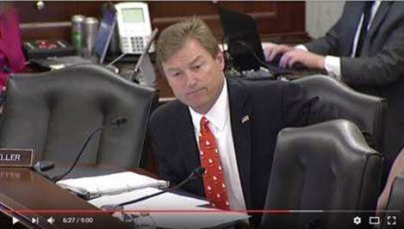](https://youtu.be/5l0YTSIvfeU)

[Click [here](https://youtu.be/5l0YTSIvfeU) or the above image to watch]

###