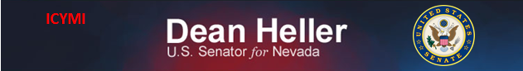

**For Immediate Release:** Contact: Neal A. Patel

December 10, 2014 202-224-6244

**Heller Urges Support of Lands Provisions for Nevada**

**(Washington, DC)** – Today, United States Senator Dean Heller spoke on the Senate Floor about his support of this year’s National Defense Authorization Act, specifically his support of some public lands provisions. The lands provisions include several Nevada public lands priorities that will grow the Nevada’s economy with mine expansion and development of public land.

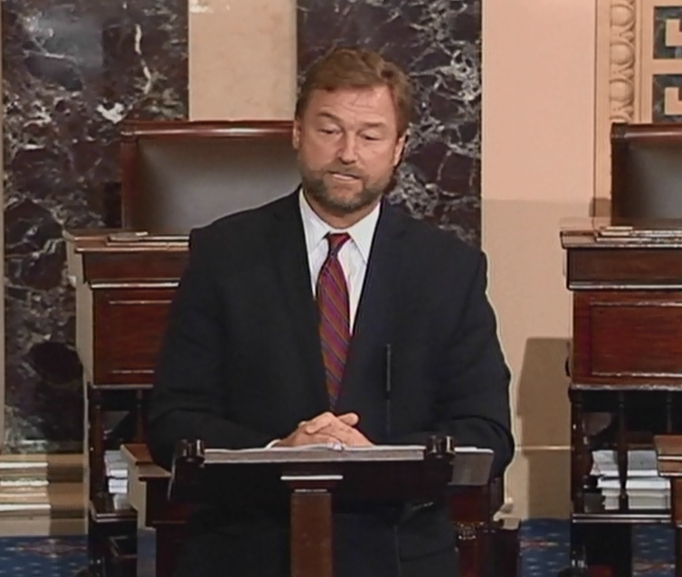

[**Click here to watch video**](http://youtu.be/OupbHe_zujg?list=UUTS6f940sIirkO6ICyx4ksw)

REMARKS AS PREPARED:

I rise today to speak in support of some of the public lands provisions that were included in this year’s National Defense Authorization Act.

Before I do so, I would first like to recognize the work Senators Levin and Inhofe have put into this bill and their dedication to reaching an agreement with the House so that this bill can move forward on time as it has for over 50 years.

As a member of the Veterans’ Affairs Committee, I hear every day about the sacrifices service members make to protect our country.

Passing the authorization bill that helps ensure they have the equipment they need and the resources required to meet the mission they are tasked with is important.

While I am pleased the Senate will be moving forward on this bill, I would like to note that the bill’s reduction in service members’ benefits concerns me. I believe Members should have had the chance to debate and amend this, and I hope the Senate will have that opportunity in the future.

This year, the final defense bill includes several Nevada public lands priorities that will spur economic development and job creation in our state while enhancing U.S. national security. I have been working on many of these proposals since I was first elected to Congress in 2006.

I want to thank incoming Senate Energy and Natural Resources Committee Chair Lisa Murkowksi for her leadership and work on this public lands package.

We have been working together for years on many of the bills included in the package, and I’m glad to see them get across the finish line.

Let me first clarify that just because some of these bills are related to public lands does not mean that they do not have a direct relationship to defense and protecting our national security. My Nevada Copper bill will increase domestic production of copper, the second most used mineral at the Department of the Defense as well as directly benefitting two bases located in the State of Nevada.

Mr. President, as you may know, roughly 85 percent of the land in Nevada is controlled by the federal government. This presents our local and state governments with many unique challenges. Our communities’ economies are directly tied to the way the federal government manages those lands.

They often work closely with me to develop legislative solutions to their problems. Whereas out east, local government can acquire land on their own to build public works projects; out west we unfortunately have to get Congress’ permission.

That is why reducing the federal estate and increasing access to our public lands has been one of my top priorities in Congress, and this package goes a long way towards accomplishing these goals.

It resolves over sixty of these types of issues throughout the west. In total, over 110,000 acres of land will be removed from federal ownership and utilized for mineral production, timber production, infrastructure projects and other community development. In addition, it releases approximately 26,000 acres of current wilderness study areas, which unlocks lands to be used for multiple-use.

It is important to discuss the eight Nevada provisions today, to show my colleagues here the many hoops our western communities have to go through to take the same steps that many eastern communities can accomplish in a day’s time.

The Lyon County Economic Development and Conservation Act is a jobs bill that I first introduced while in the House but has been held up by Senate gridlock for years.

This bill allows the City of Yerington to partner with Nevada Copper to develop roughly 12,500 acres of land surrounding the Nevada Copper Pumpkin Hollow project site to be used for mining activities, industrial and renewable energy development, and recreation.

Senate passage is the final hurdle to more than 1,000 new jobs at an average wage of over $85,000 per year. The mine will contribute nearly $25 million in property and net proceeds taxes per year that would be distributed to the State, Lyon County, their Schools, the hospital district, and the Mason Valley Fire Protection District.

In addition, Nevada Copper plans to invest $80 million in infrastructure for the mine and processing facilities that can be utilized to support other land uses and economic development. This bill will transform the local economy of the one of the counties in our nation that is struggling most due to the recent economic downturn.

As I said before, Copper is the second most used mineral at the Department of the Defense, and is considered an essential mineral for weapons production.

Copper is also the primary mineral from which other strategic and critical metals like Rhenium are derived. A domestic supply of this important resource greatly benefits our national security.

Second – there is a provision in this package that will allow Naval Air Station Fallon to acquire over 400 acres of BLM land for a safety arc for an explosive ordinance handling facility and to construct the much needed family housing at the station. Both of these plans will greatly benefit mission operations and the quality of life for our brave service members serving there. The station first asked for these lands over twenty years ago. I am glad their wait will finally end.

Third – the package includes the Pine Forest Range Recreation Enhancement Act, a proposal that has been in the works in Humboldt County for nearly a decade. Just north of the Black Rock Desert, the Pine Forest offers a diverse landscape of sagebrush, aspen and rock formations. Scenic lakes and reservoirs offer world-class trout fisheries.

From the ranchers who make their livelihood on grazing allotments to conservationists’ intent on preserving a rugged landscape, anyone familiar with the place agrees it’s special.

In addition to conserving these areas the bill releases areas from wilderness that needs watershed restoration and treatment due to a high wildfire threat. It also provides for the construction of additional campsites and accommodations for motorized camping.

The initial work on the Pine Forest bill was grassroots driven, transparent, and ultimately supported unanimously by all stakeholders and local governments in this county.

Fourth – the package includes the Elko Motocross and Tribal Conveyance Act, another bill I first introduced in the 111th Congress as a member of the House. This common-sense bill conveys 275 acres of BLM lands to Elko County for a public motocross park. Additionally, it provides 373 acres to the Elko Band of the Te-Moak Tribe for housing and tribal economic development.

Outdoor recreation and tourism are such important parts of life in Nevada. Opening up this land will benefit the residents of Northern Nevada for years to come.

Fifth - this lands package includes the Las Vegas Valley Public Land and Tule Spring Fossil Beds National Monument Act, which is the culmination of several years of effort to conserve the ancient Tule Springs Fossil Beds while providing job creation opportunities and critical civilian and military infrastructure that will be necessary to meet the needs of the Las Vegas Valley.

After working with stakeholders at every level, I am pleased that we can navigate a path forward for southern Nevada.

While serving in the House, I also introduced legislation in both the 110th and 111th Congresses to convey parcels of BLM land to the Nellis Air Force Base, to create an off-highway vehicle park in the Nellis Dunes, and to convey land to the Nevada System of Higher Education to expand educational opportunities for Southern Nevadans.

Those smaller bills were ultimately included in S.973 this Congress, so I am pleased that over six years of work on this Tule Springs legislation will finally become a reality.

The final three Nevada bills included in the lands package are newer proposals, but achieve long-term economic development objectives that the affected communities have long-pursued.

The Fernley Economic Self-Determination Act provides Fernley the opportunity to purchase up to 9,114 acres of federal land within the city boundaries for the purpose of economic development.

Fernley was incorporated in 2001. Since incorporation, the City has been working with private business partners and state and federal regional agencies to develop a long-term economic development plan. These parcels have significant potential for commercial and industrial development, agriculture activities, and the expansion of community events.

Similarly, the Carlin Economic Self-Determination Act allows Carlin to purchase up to 1,329 acres of BLM lands. This city, located in Elko County, is completely landlocked by federal land. Without this legislation, it would be impossible for their leaders to meet the demand for expansion their growing population needs.

Finally, the Storey County provision conveys over 1,700 acres of BLM lands to Virginia City. These properties have been occupied for decades by individuals who purchased them or acquired them legally, yet their continued residency is trespass according to the federal government.

It is a very burdensome oversight by the federal government that must be resolved for the sake of my constituents. They have struggled for years haunted by this error that is the result of no fault of their own.

As you can see, these small public lands proposals are going to make a MAJOR impact on Nevada’s economy. They have all been developed at the local level and signed off on by the local communities

I understand my colleagues concerns that would have liked the opportunity to debate and vote on more amendments to this bill. I too, had filed a number of amendments that I would have liked to see considered and will continue pushing those priorities next year.

Right now, Congress has the rare opportunity to pass this public lands package that enables important mining, energy development, ranching, and timber work to go forward generating economic and employment opportunities for my and other states and local residents. Let’s get the government off these Nevadans’ backs and allow them to do what they do best – creating jobs.

###