

**For Immediate Release:** Contact: Chandler Smith

July 16, 2014 202-224-6244

**Heller Highlights Backlog of VA Claims in Nevada to VA Top Brass**

**(Washington, D.C.)** – Today, U.S. Senator Dean Heller (R-NV) spoke at the Senate Committee on Veterans’ Affairs to discuss the state of the VA healthcare system. With over 300,000 veterans living in the state of Nevada, Senator Heller remains concerned about the healthcare being administered to veterans in the state and across the nation. He raised concerns over the backlog of veterans’ claims in addition to the clear need of a VA clinic for Nevada’s veterans.

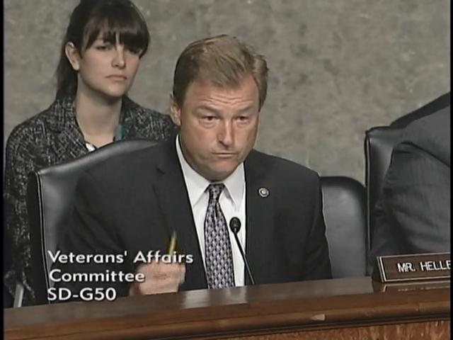

[**Click here to watch video.**](http://youtu.be/875En6ji-J4)

###