

**For Immediate Release:** Contact: Neal A. Patel

November 20, 2014 202-224-6244

**Heller Leaves Auto Execs Scrambling with Line of Questioning**

**(Washington, DC)** – Today, United States Senator Dean Heller questioned auto executives during a Senate Commerce, Science, and Transportation Committee [hearing](http://www.commerce.senate.gov/public/index.cfm?p=Hearings&ContentRecord_id=d71026cd-07a0-41a7-bc48-5cc08043acc1&ContentType_id=14f995b9-dfa5-407a-9d35-56cc7152a7ed&Group_id=b06c39af-e033-4cba-9221-de668ca1978a) examining airbag defects and the vehicle recall process.

Senator Heller first asked a Takata Corporation executive if his company took responsibility for its actions.

Senator Heller then asked a Honda executive if members of his own family were safe driving Honda vehicles.

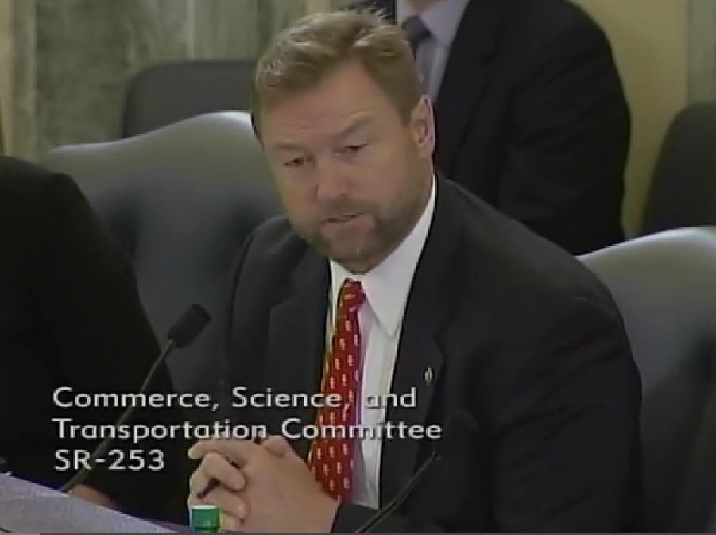

[**Click here to watch video**](http://youtu.be/p4bX1J6xvB0)**.**

###