

**For Immediate Release:** Contact: Neal A. Patel

November 19, 2014 202-224-6244

**Heller Highlights Importance of Stability in the Mortgage Market**

**(Washington, DC)** – Today, United States Senator Dean Heller spoke at the Senate Banking, Housing, and Urban Affairs Committee hearing, “The Federal Housing Finance Agency,” about the importance of consistent growth in the mortgage market, paired with affordability.

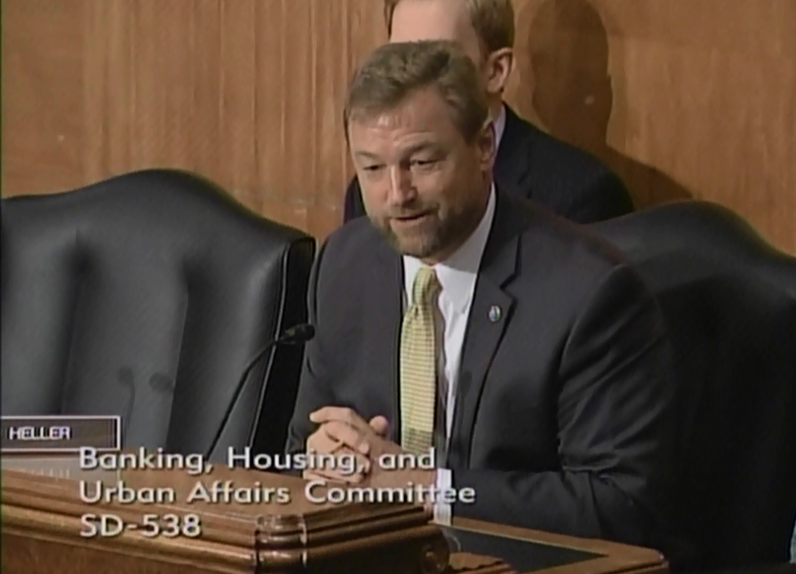

[**Click here to watch video.**](http://youtu.be/qoCQtt6hNuw)

###