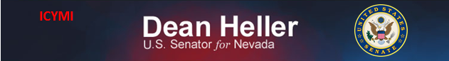

**For Immediate Release:** Contact: Neal A. Patel

January 8, 2015 202-224-6244

**Heller Emphasizes Importance of TRIA Program Extension**

**(Washington, DC)** – Today, United States Senator Dean Heller spoke on the Senate floor, urging his colleagues to support the reauthorization and extension of the Terrorism Risk Insurance Act (TRIA). This legislation provides a safeguard for many industries in Nevada, such as hospitality, tourism, and gaming.

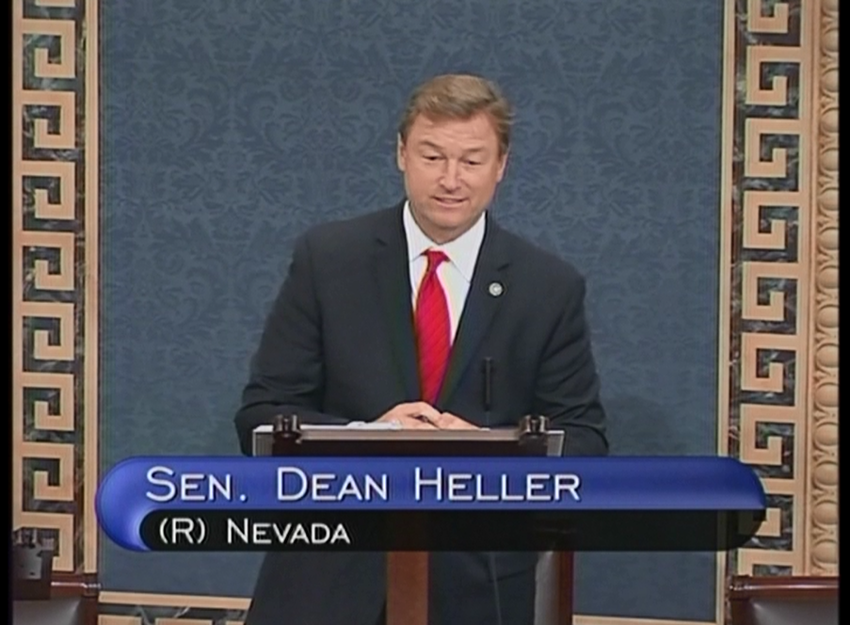

[**Click here to watch video.**](http://youtu.be/C4MyBNTO70Y)

REMARKS AS PREPARED:

I rise to speak on the Terrorism Risk Insurance Program. As a member of the Banking Committee and co-author of the Senate TRIA reauthorization bill, this is a critical issue that I have worked on closely with my colleagues on this for over a year.

Madam President Terrorism is a real threat in both rural and urban areas, North, South, East and West. That’s why I have been so involved in trying to get TRIA extended.

I’ve stated this before but I want to re-emphasize this. In my home state, Las Vegas is considered to be one of the leading international business and visitor destination cities in the world. Southern Nevada welcomes 40 million visitors annually and has a population of nearly two million people. We have 35 major hotels along the Las Vegas strip, many of which have 15,000 occupants at once.

If a terrorist attack were to occur in Las Vegas, our entire state economy would be devastated without TRIA.

But, it’s not just about Las Vegas. In Northern Nevada, our visitor and gaming industry is one of the largest private employers in Washoe County, which includes Reno.

They know that unless they can have access to affordable terrorism coverage, they will have difficulty starting new capital projects and creating new jobs.

TRIA has helped many hotels, hospitals, office complexes, shopping centers, colleges and universities have access to terrorism insurance coverage.

While I was disappointed we could not reach an agreement before TRIA expired at the end of 2014, I’m pleased that this legislation has been brought to the floor so quickly by the Majority Leader.

The bill before us today is a good bill. Yesterday, it passed the House with 416 votes. Let me repeat that – 416 Members of the House, both Democrats and Republicans supported this bill.

I strongly support this bill. I urge all of my colleagues to support passage of this bill today.

Madam President, I yield the floor.

###