

**For Immediate Release:** Contact: Neal A. Patel

November 18, 2014 202-224-6244

**Heller Fights for Privacy with USA FREEDOM Act**

**(Washington, DC)** – Today, United States Senator Dean Heller spoke on the Senate floor about the USA FREEDOM Act, written to address the intrusion of privacy prevalent in the PATRIOT Act. Heller stated he would do everything possible to end the PATRIOT Act and change the system so only appropriate and related information is collected.

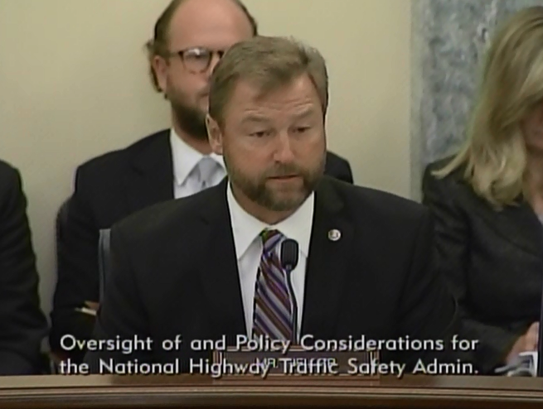

[**Click here to watch video.**](http://youtu.be/4jKvtOoloGw)

REMARKS AS PREPARED:

###