

**For Immediate Release:** Contact: Neal A. Patel

January 21, 2015 202-224-6244

**Heller Continues to Fight for Vets in the 114th Congress**

**(Washington, DC)** – Today, United States Senator Dean Heller spoke at the Senate Veterans’ Affairs Committee hearing addressing the rules of the committee in the 114th Congress and pending legislation. Heller specifically spoke about his dedication to implementing all of the bills included in the VA Claims Backlog Working Group that he started in 2013, as well as focusing specifically on the needs of Nevada’s veterans.

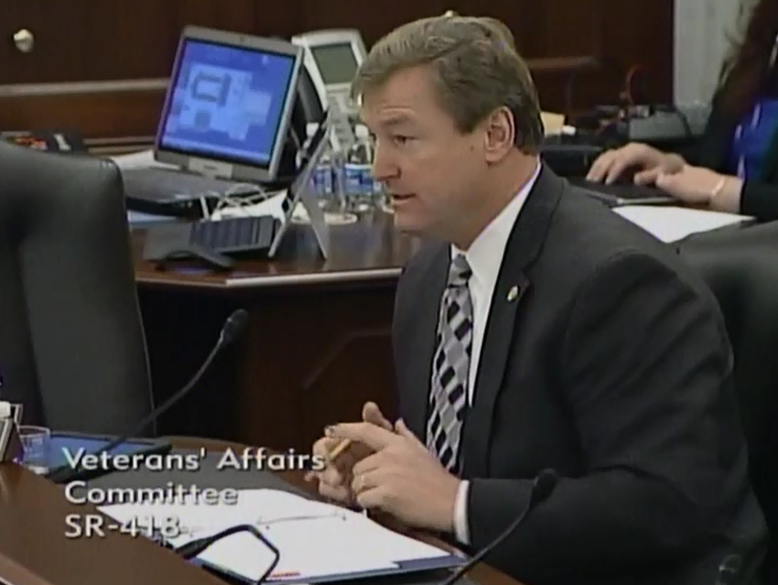

[**Click here to watch video.**](http://youtu.be/Uo296JkM1_A?list=UUTS6f940sIirkO6ICyx4ksw)

REMARKS AS PREPARED:

First off, thank you to the Chairman and Ranking Member for your work in moving forward the Clay Hunt SAV Act.  This could very well be the first bill signed by the President from this Congress.

I admire the mothers who came before this Committee last Congress to tell their stories about their sons.  It took a great amount of courage, and I hope this bill will turn the tide for all the veterans out there who may be facing this problem.

Secondly, I am honored to be back on this Committee for the 114th Congress.  Serving on this committee has always been a priority for me, not only because my father and brother are veterans who served, but also because Nevada has 300,000 veterans.

The veterans organizations in my state are a passionate group of people who are truly dedicated to ensuring their fellow veterans and all future service members are cared for.

And last Congress, after it came to light that veterans were mistreated in VA facilities across the nation, this Committee came together to fulfill our oversight responsibilities and hold the VA accountable.

I was proud to be part of the Committee at such a crucial time and am pleased that Chairman Isakson has committed to continuing this oversight and ensuring the Choice Act is implemented properly for our veterans.

However, our work as a Committee is nowhere near complete. There are many other issues our veterans are facing beyond just appointment wait times at VA health care facilities.

As I have stated during every Committee hearing, I believe the disability claims backlog is one of the most pressing issues our veterans are facing.

The VA made a commitment to end the backlog by 2015 so that no veteran waits more than 125 days for their claim to be completed.

Yet today, in my home state of Nevada, nearly 4,000 veterans are waiting longer than 125 days and the Reno VA Regional Office remains one of the worst in the nation.   Across the country, 245,000 veterans are also languishing in the VA’s claims backlog.

That is why, in 2013, I started the VA Claims Backlog Working Group along with Senator Casey so that we could come up with solutions to fix the VA backlog permanently.

Together, the Working Group developed a VA Backlog Working Group Report and legislation, which members of this Committee—Ranking Member Blumenthal, Senator Moran, and Senator Tester—all joined in supporting.

While some of the solutions in this bill were implemented by the VA or passed by Congress, there are many reforms that still need to be made to ensure the claims process moves into the 21st Century.

I look forward to continuing to work with Senator Casey and my other colleagues to reintroduce this bill and report so that the VA has the tools it needs to eliminate the backlog.

I also think this Committee has an opportunity to renew its focus on caring for our women veterans.

Given that the number of women veterans will be increasing in the years to come, the VA must do its part to ensure that VA facilities are meeting their needs.

I have been working with a colleague to address many of the issues facing women veterans through legislation, and I hope it is a topic that this Committee can have a hearing on in the months to come.

Lastly, I remain committed to advocating on behalf of the issues facing Nevada’s veterans, locally.

This includes the availability of rural care, transportation to VA facilities, wait times at the Reno and Las Vegas Medical Centers, construction of new VA clinics in Pahrump and Laughlin, among many other priorities.

Again, we have a lot of work ahead as a Committee to truly keep the commitment our nation made to care for those who served and sacrificed.

And the best part of this Committee is that it has a strong history of bipartisanship, so I look forward to working with members of both sides of the aisle to achieve this goal.

Thank you, Mr. Chairman.

###