

**For Immediate Release:** Contact: Chandler Smith

July 22, 2014 202-224-6244

**Heller: New VA Secretary must restore accountability and integrity to this organization**

**(Washington, D.C.)** – Today, U.S. Senator Dean Heller (R-NV) offered the following remarks at the U.S. Senate Committee on Veterans’ Affairs hearing on the pending nomination of Robert A. McDonald to be Secretary of the Department of Veterans Affairs (VA). Senator Heller has been critical of the current state of affairs at the VA and wants new leadership to correct and address the rampant problems facing the VA’s healthcare system.

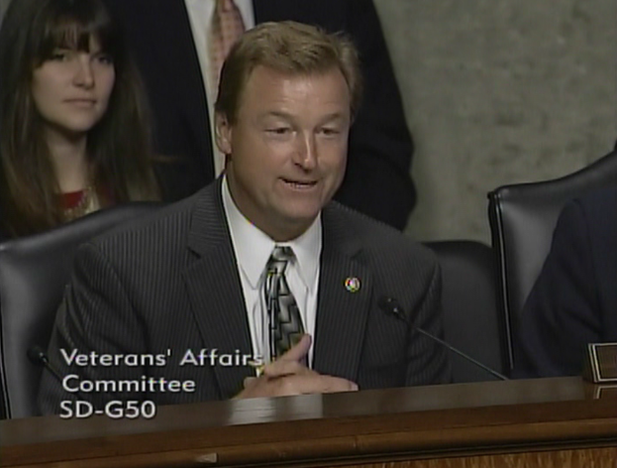

[**Click here to watch video.**](http://youtu.be/xBTMhq5bdSI)

**Remarks as prepared:**

Thank you Chairman Sanders and Ranking Member Burr for working quickly to schedule a hearing on this nominee.

At a time when the VA is facing a serious crisis of care and culture, this is by far the most important nomination to come before the Committee.

In a short number of months, Congress, Veterans, and the American public have had a glimpse into the failure of the VA to provide quality care to Veterans across the nation. It is disturbing, to say the least, that many of our Veterans went without health care because some employees decided to cheat the system.

Every time I am home, I repeatedly hear from Nevada veterans about their individual stories and difficulties they’ve faced with the VA, and many of them are doubtful it will ever improve.

I understand and share their frustration given all the issues facing the veteran community in Nevada.

For example, at the Las Vegas VA Hospital, more than 6,100 Veterans were forced to wait more than 30 days for an appointment.

Just last year, a blind female veteran waited nearly 6 hours in the Las Vegas VA Emergency Room before being seen by a nurse or doctor.

Over in Pahrump, 6,000 Veterans have waited more than two years for a clinic to be built, and VA officials have not provided a timeline for final approval of this facility.

And these problems with access to care extend beyond VA health care. Veterans are also facing difficulty receiving their benefits due to the disability claims backlog at the Veterans Benefits Administration.

I bring this issue up and will continue to do so because the claims backlog impacts Veterans in my state worse than any other.

Nevada Veterans still have the longest wait in the nation at 338 days on average to complete claims, and the Reno VA Regional Office remains the worst-performing VARO.

A few months ago, a Veteran from Fallon wrote to me saying:

“After 7 months of no retroactive payment, I returned to the VARO again. I spoke with the same advisor and he told me because I was retired from the Navy and in receipt of retirement benefits, I was considered a ‘low priority’ for processing payment.”

No Veteran should ever be told by the VA that they are a “low priority.”

That is why I have been working hard with Senator Casey to continually urge Chairman Sanders to have a hearing on our comprehensive, bipartisan legislation—the 21st Century Veterans Benefits Delivery Act—so that Congress can take action to fix the backlog and have veterans receive the benefits they rightly deserve.

These issues—the claims backlog, long appointment wait times, lack of access to quality health care, and rural clinics—are just of few of the concerns in Nevada that I expect the new VA Secretary to tackle head on and work with this Committee to address.

Furthermore, this agency needs more than a few initiatives. It needs substantial reforms from within if the VA hopes to restore veterans’ confidence and trust in the system.

This crisis—arguably one of the worst in the VA’s history—is the result of a corrosive culture due to management and some employees who believed they were above reproach.

To change the VA in the long-term, its new leadership must be unrelenting and capable of transforming the agency to meet what should be its core mission—serving our nation’s veterans honorably and honestly.

I expect the new VA Secretary to restore accountability and integrity to this organization, and to ensure leadership and management teams will undoubtedly uphold these values and ultimately their promise made to our nation’s veterans.

And as a member of the Committee with jurisdiction over the VA, I want absolute assurance that the new Secretary will be committed to transparency and accountability as the Committee conducts vigorous oversight moving forward.

While I commend you Mr. McDonald for your willingness to take on this challenging task, I also need to be fully confident that you are prepared to transform the VA and address the needs of Nevada’s Veterans.

I look forward to hearing your testimony and discussing these issues further.

Thank you, Mr. Chairman.

###