

**For Immediate Release:** Contact: Neal A. Patel

November 19, 2014 202-224-6244

**Heller Demands Improvement of Backlog to Address Poor Mental Health of Veterans**

**(Washington, DC)** – Today, United States Senator Dean Heller spoke at the Senate Veterans’ Affairs Committee hearing, “Mental Health and Suicide Among Veterans,” about the importance of addressing the VA’s disability claims backlog in order to speed up services for mental health treatment and lower suicide rates for veterans.

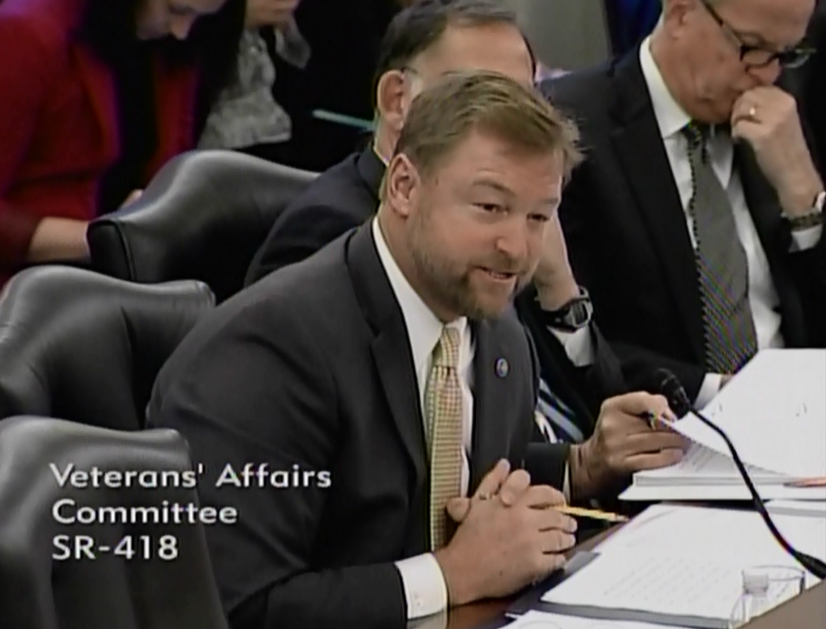

[**Click here to watch video.**](http://youtu.be/FPLedTjcrXc?list=UUTS6f940sIirkO6ICyx4ksw)

REMARKS AS PREPARED:

First, I would like to take a moment to acknowledge two witnesses here today, Mrs. Selke and Mrs. Pallotta.  I cannot begin to imagine your loss and I truly admire your bravery coming here today to talk about your sons. They served our country with valor and we must honor that by making sure every veteran from here on out is cared for when they return home.

Chairman Sanders and Ranking Member Burr—I also want to thank you for bringing this issue before the Committee, especially because of the impact it has on veterans in my state.

To put it in perspective—between 2008 and 2012, 593 veterans from Nevada were lost to suicide.

Six months ago, I would have looked at that number and asked why is it so high? What is missing within the VA or VA benefits that so many of Nevada’s veterans resort to this?

I think we now know that a big part of the problem is veterans’ access to care at VA facilities. This is such a critical thing to get right at the VA because of the ripple effect it has on a veteran’s well-being.

Whether it is medical care, mental health treatment, or support during transition to civilian life, veterans being forced to wait for care from the VA can be detrimental.

That is why I have asked the Las Vegas VA Director to send me reports about wait times for primary care, specialty care, and mental health treatment for Southern Nevada’s Veterans.

Every two weeks, for both Las Vegas and Reno, I track these numbers for improvements.

In the most recent data, patients already receiving mental health care from VA facilities in Nevada wait a week or less for an appointment.

Unfortunately, the average wait time for new patients seeking mental health treatment is 23 days in Reno and 46 days in Las Vegas.

Even worse, a clinic in Northwest Las Vegas has an average wait time of 64 days for new patients.

Veterans in need of mental health treatment absolutely cannot be waiting more than 2 months to be seen.

I have been pushing every one of these facilities to improve these wait times in the coming months and want to hear from the VA today about what resources it will be devoting to mental health treatment.

We must also remember that scheduling an appointment is not the only barrier to receiving care. Veterans must also qualify for this care.

One of the best ways to ensure veterans qualify for mental health services is by reducing the VA’s disability claims backlog.

Veterans with post-traumatic stress who have a PTS-related claim approved will be able to access VA’s mental health services and treatment.

This claims backlog is an issue I have brought up during every Committee hearing because I believe it should be a top priority of the VA and of this Committee.

That is why I sent a letter to the Chairman requesting that he re-schedule a legislative hearing to consider my bipartisan bill to address the VA claims process.

Nevada Veterans have one of the longest waits in the nation at 248 days on average to complete a claim, and 240,000 veterans nationwide are still waiting longer than the VA’s 125-day deadline.

Until this backlog is eliminated, veterans will continue to face delays to accessing the mental health treatment they need.

With 22 veteran suicides a day and nearly 600 veteran suicides in Nevada over the past five years, it is clear that something must be done to improve the current state of mental health services at the VA.

The VA facilities in my state know that I will use my oversight role on this Committee to continue holding them accountable for performance, timeliness and the quality of care they provide to Nevada’s veterans.

I look forward to hearing from the witnesses today about what VA is doing to address this crisis and how Congress can help in this effort.

Thank you, Mr. Chairman.

###