

**For Immediate Release:** Contact: Neal A. Patel

February 24, 2015 202-224-6244

**Heller Thanks Disabled American Veterans Organization**

**(Washington, DC)** – Today, United States Senator Dean Heller spoke at the Senate Committee on Veterans’ Affairs hearing titled, “[Legislative](http://www.commerce.senate.gov/public/index.cfm?p=Hearings&ContentRecord_id=d3e33bde-30fd-4899-b30d-906b47e117ca&ContentType_id=14f995b9-dfa5-407a-9d35-56cc7152a7ed&Group_id=b06c39af-e033-4cba-9221-de668ca1978a&MonthDisplay=2&YearDisplay=2015) Presentation of Disabled American Veterans.” More specifically, Heller thanked the witnesses from the Disabled American Veterans (DAV) for their hard work in helping veterans after returning home. Earlier today, Heller received the first-ever DAV Outstanding Senate Legislator of the Year award for 2014.

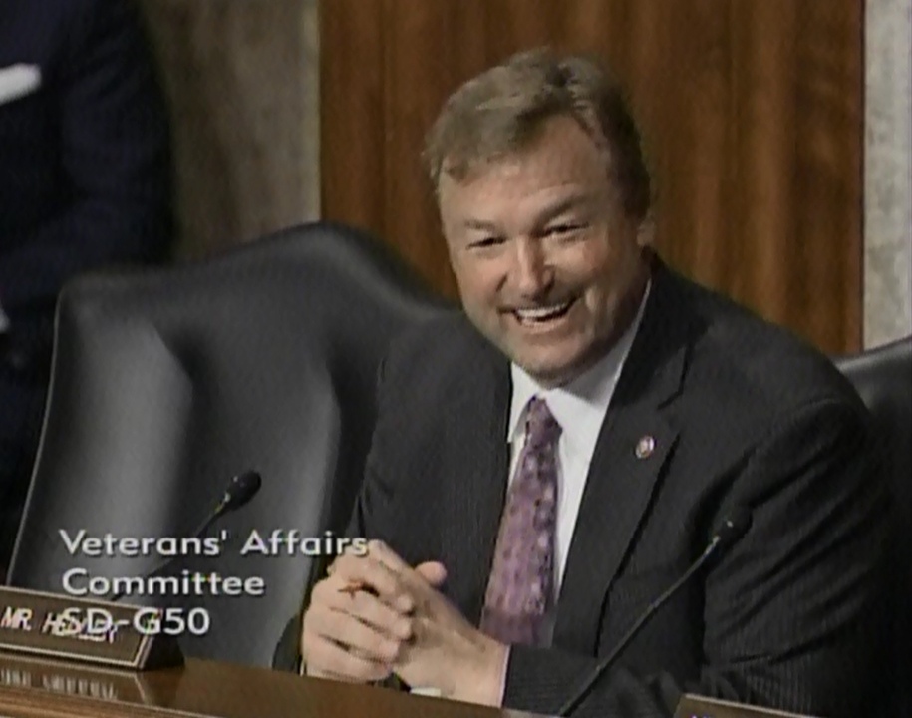

[**Click here to watch video.**](http://youtu.be/lkwe7cKJ2E8?list=UUTS6f940sIirkO6ICyx4ksw)

###