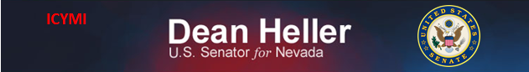

**For Immediate Release:** Contact: Neal A. Patel

March 4, 2015 202-224-6244

**Heller Welcomes Nevadan John Stroud, VFW Commander**

**(Washington, DC)** – Today, U.S. Senator Dean Heller (R-NV) spoke at the Senate Committee on Veterans’ Affairs hearing titled, “Legislative Presentation of Veterans of Foreign Wars,” introducing fellow Nevadan and Veterans of Foreign Wars (VFW) Commander John Stroud. Following the introduction, Heller asked Commander Stroud about his assessment of the care provided by the Department of Veterans Affairs, as well as specific issues facing Nevada veterans.

**[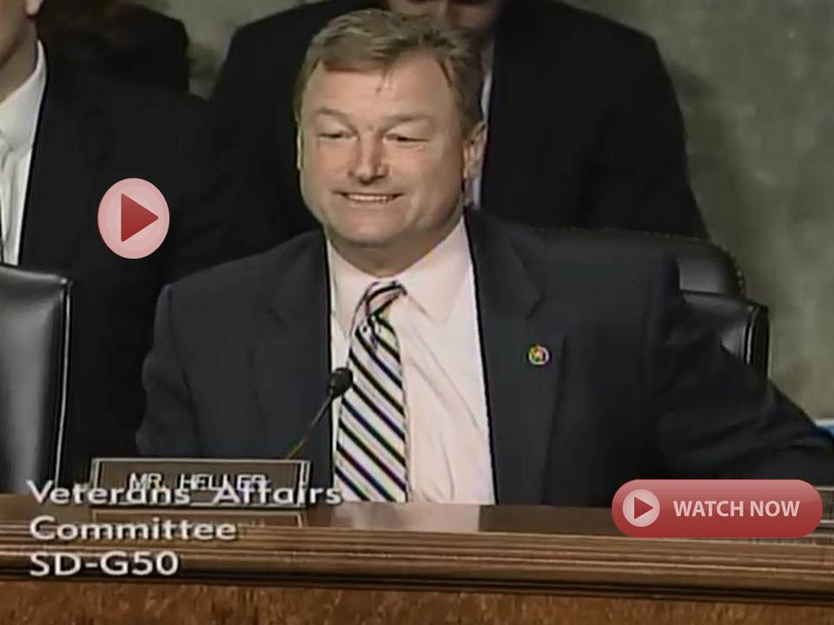](http://youtu.be/m8RxnjlnF8Y)**

[**Click here to watch video.**](http://youtu.be/m8RxnjlnF8Y)

To watch Senator Heller’s questions, [click here](http://youtu.be/Q510g5tDjeI).

REMARKS AS PREPARED:

Thank you Chairmen and Ranking Members. I’m honored to have this opportunity to introduce Commander John Stroud today.  He has been a friend to me and to my office for many years.

In fact, I have this poker chip he gave me in 2012 to prove it. Only in Nevada would you have a Challenge Coin in the form of a poker chip.

It is very fitting that John was chosen to be the Commander-in-Chief for the Veterans of Foreign Wars.

Since its inception in 1899, the VFW has served many different purposes for veterans.

While it is most known for advocating for veterans, a VFW post is also a place for members to foster friendship with others who served.

In a state like Nevada, this solidarity among the veteran community rings true.

And within this tight knit Nevada veteran community, Commander Stroud has been one of our most outspoken advocates.

I cannot thank him enough for all that he has done from the start of his service in the U.S. military to today.

Commander Stroud first began his military career in the U.S. Air Force, serving for 21 years, from 1976-1997.  This service included a tour in Korea with the 51st Fighter Wing at Osan Air Base, where he was a Flight Operations Superintendent.

During Commander Stroud’s time in the military, he received:

* Four Meritorious Service Medals
* Three Air Force Achievement Medals
* The Korea Defense Service Medal; and
* The National Defense Service Medal.

But like all of the VFW members we see here today, his service to our country and his fellow service members was not over after his 20 years.

In 1996, Commander Stroud joined the VFW in Las Vegas, and later Hawthorne, Nevada.

And not only did he embrace the camaraderie of joining a post, but he also dedicated himself to serving the VFW in many leadership positions, including Nevada Department Commander from 2006 to 2007.

Commander Stroud has also served on numerous National Committees, including Chairman of the National Veterans Service Committee.  He is also a Triple Crown All American Commander Award recipient.

I also want to acknowledge an important person here today—the one who has had to deal with the Commander’s difficult travel schedule—his wife Mary.

Mary has been a committed member of the VFW’s Ladies Auxiliary, which also works to serve our nation’s veterans.

Thank you again Commander Stroud for your service to our nation as a veteran, and as Commander-in-Chief for the VFW.

I look forward to your testimony on how this Committee and Congress can do better to serve America’s brave men and women in the Armed Forces.

###