

**For Immediate Release:** Contact: Chandler Smith

July 15, 2014 202-224-6244

**Heller to Federal Reserve Chair Yellen: “Do you believe the stock market is rigged?”**

**(Washington, D.C.)** – Today, U.S. Senator Dean Heller (R-NV) questioned Federal Reserve Chair Janet Yellen at the “The Semiannual Monetary Policy Report to the Congress” hearing. Heller asked the Chair for her views about whether an end of quantitative easing is forthcoming, as well as whether the markets are an accurate view of the state of the economy.

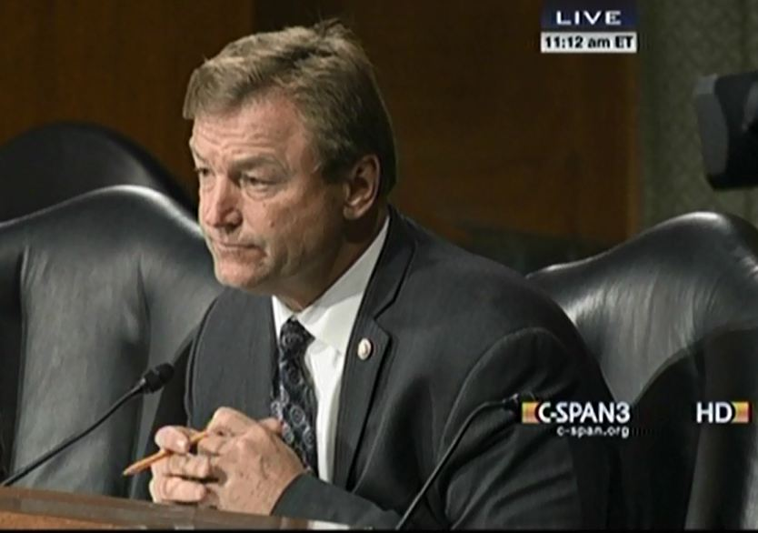

[**Click here to watch video**](http://youtu.be/-tqBnP3xLK0)

###