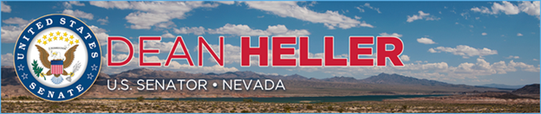

|  |  |
| --- | --- |
| **For Immediate Release:** | **Contact:** [Megan Taylor](mailto:Megan_Taylor@heller.senate.gov) |
| May 25, 2017 | 202-224-6244 |

**ICYMI: Yucca Mountain Puts Taxpayers on the Hook**

**Washington, D.C.** – U.S. Senator Dean Heller (R-NV) spoke on the U.S. Senate floor today about how billions of dollars has already been wasted on Yucca Mountain, and efforts to restart the project will only cost more. The Department of Energy estimates that the entire cost of Yucca Mountain could easily approach $96 Billion.

*“As a small government, fiscal conservative, I hoped that this new Administration would focus on budget priorities that would reduce duplicative spending and streamline programs in order to save taxpayer dollars.”*

Senator Heller has continued to fight any proposal that would revive the Nuclear Waste Repository at Yucca Mountain, citing the damaging effect it will have on Nevada’s economy as well as the public safety issues associated with the transportation of this nuclear waste.

Instead, Heller wants a viable solution to our nation’s nuclear waste problem, his bipartisan legislation, the [Nuclear Waste Informed Consent Act](https://www.heller.senate.gov/public/index.cfm/pressreleases?ID=0a660176-afb7-427d-a988-62918b702c6a). This legislation permits the construction of a nuclear waste repository only if the Secretary of Energy receives written consent from the governor of the host state, affected local officials, and affected Indian tribes. Under Heller’s legislation, state’s like Nevada that do not want to store spent nuclear waste will not be forced to do so by the federal government. Click [HERE](https://youtu.be/_70bcLkvZ-s) or below to watch.

[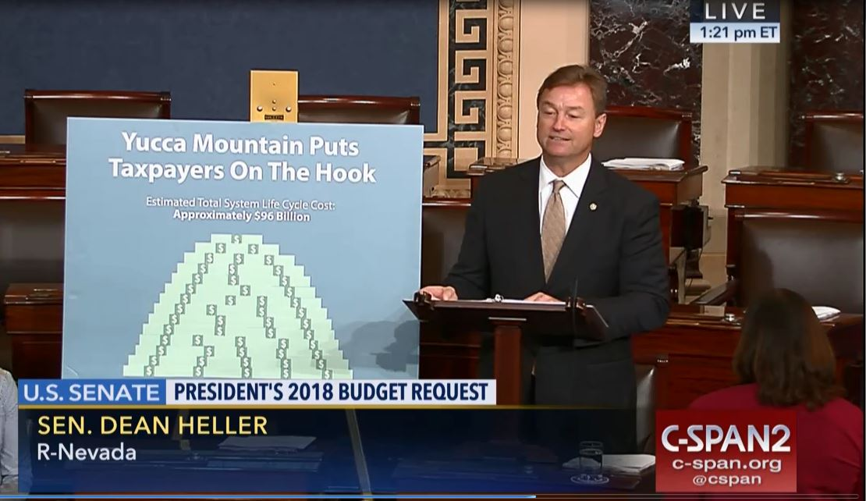](https://youtu.be/_70bcLkvZ-s)

[Click [here](https://youtu.be/_70bcLkvZ-s) or the above image to watch]

**Remarks as prepared for delivery:**

“I rise today to discuss my grave concern with one the President’s priorities included his 2018 Fiscal Year budget, namely Yucca Mountain.

“Specifically, the President included $ 120 million in his budget for the Department of Energy to restart licensing activities for the Yucca Mountain Nuclear Waste repository.

“As a proponent and author of legislation – the No Budget, No Pay Act – which would restore regular order to the budget and appropriations process, I am pleased to see the President submit to Congress a detailed budget proposal.

“As a small government, fiscal conservative, I hoped that this new Administration would focus on budget priorities that would reduce duplicative spending and streamline programs in order to save taxpayer dollars.

“You can imagine my disappointment that they instead decided to prioritize funding to restart licensing activities for a failed proposal.

“Now Mr. President, over the past few weeks, I have outlined on the Senate floor some of the issues with Yucca Mountain, whether it be the crippling effect it will have on Nevada’s economy or the public safety issues associated with the transportation of this nuclear waste.

“And I will continue to come down to the floor to educate my colleagues on the many issues associated with Yucca Mountain because, plain and simple, it is not a viable option for the long-term storage of our nation’s nuclear waste.

“Instead of throwing more taxpayer dollars at a failed proposal, we should be working on a real long-term solution rooted in consent-based siting.

“Now you have heard me, Mr. President, raise the question that many Nevadans are thinking: Why should a state without any nuclear power plants of its own be forced against its will to house all of our nation’s nuclear waste?

“I stand by the Department of Energy’s 2010 decision to terminate the Yucca Mountain program and its 2015 recommendations on consent-based siting.

“Mr. President, Yucca Mountain is dead, but let me take a moment to walk you through what it would take to put this failed project back on life-support.

“Prior to suspension of the program in 2010, the federal government had spent close to $ 15 billion on Yucca Mountain.

“Now I recognize that some of my colleagues may say, “Well, the government has already spent this much money on the repository, shouldn’t we complete it?”

“First of all, restarting the Yucca Mountain program would mean spending about $2 billion more, just to complete the licensing proceeding: $1.66 billion for the Department of Energy, and $330 million for the Nuclear Regulatory Commission.

“And after 3-5 years spent on licensing, there could well be another 5 years of legal challenges, with no certainty that Yucca Mountain would ever be built.

“Second, even if Yucca Mountain were to go forward, it would be an expensive repository project. DOE’s best estimate is that ANOTHER $82 billion would be needed to license, litigate, build, operate, decommission and eventually close Yucca Mountain.

“On top of the money already spent, that adds up to more than $96 billion for what is called the total system life cycle cost.

“That leads to my third point. We need to re-evaluate the whole nuclear waste cost question. There is a business case to be made against Yucca Mountain. DOE’s own cost estimates for Yucca Mountain say that the Nuclear Waste Fund will only pay about 80 percent of the total life-cycle cost – more than $77 billion.

“The remaining $19 billion will have to come from annual appropriations voted on by Congress – that means more money paid by tax payers. But it does not have to be that way.

“In 2012, DOE did its own cost assessment, and concluded that all other costs (like transportation) being equal, walking away from Yucca Mountain, and starting with a new repository site in a deep salt bed or a deep shale formation, could actually save between $12 billion and $27 billion over the life of the repository.

“Before we spend any more taxpayer money on Yucca Mountain, we need to ask DOE’s experts to come before us and explain what they learned about repository costs in their previous studies.

“Beyond that, we need new cost studies on geologic disposal in repositories, studies that include the lessons learned from recent progress with repositories in Europe.

“And new studies that look at the nuclear waste management system overall, and incorporate the cost of safe on-site storage at reactors, early removal of spent fuel from shutdown reactors, and consolidated interim storage facilities, as recommended by the Blue Ribbon Commission on America’s Nuclear Future.

“It is clear that rather than forcing the state of Nevada to accept nuclear waste at a scientifically unsound site, taxpayer dollars would be better spent identifying viable alternatives for the long-term storage of nuclear waste in areas that are willing to house it. Finding alternatives is the common sense path forward, as well as the fiscally responsible decision.

“I urge my colleagues, as we continue the budget and appropriations process for this next fiscal year, to conduct oversight over the life cycle cost of repositories.

“And to focus on further implementing the Department of Energy’s consent-based siting process instead of wasting more taxpayer dollars on a failed proposal.

“I stand ready to partner with my colleagues on both sides of the aisle on this issue and am confident that together we can find a solution to this problem once and for all.”

###

[cid:image002.png@01D2CD66.FDD0BF00](http://www.facebook.com/pages/US-Senator-Dean-Heller/325751330177)[cid:image003.png@01D2CD66.FDD0BF00](http://twitter.com/SenDeanHeller)[cid:image004.png@01D2CD66.FDD0BF00](http://www.youtube.com/user/SenDeanHeller)