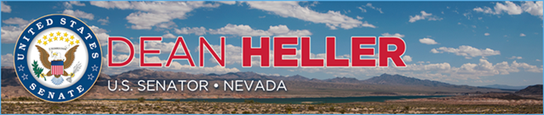

|  |  |
| --- | --- |
| **For Immediate Release:** | **Contact:** [Megan Taylor](mailto:Megan_Taylor@heller.senate.gov) |
| October 18, 2017 | 202-224-6244 |

**In Case You Missed It: “A New Las Vegas Has Risen”***Heller Delivers Speech Honoring Victims and Heroes of the Las Vegas Shooting*

**Washington, D.C.** – In a speech delivered on the U.S. Senate floor this evening, U.S. Senator Dean Heller (R-NV) honored the victims of the Las Vegas shooting, and applauded the many heroes who emerged that night and helped respond to the tragedy.

Click [HERE](https://youtu.be/w9Ch_95sfZ4) to watch the video.

[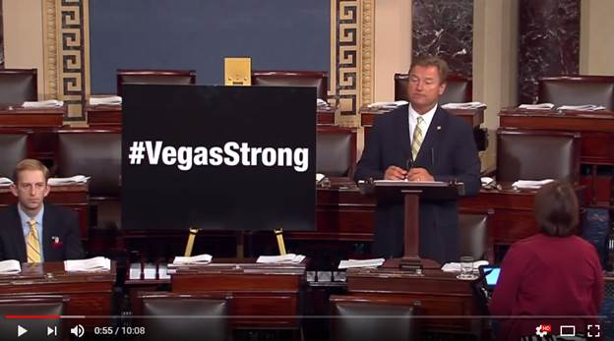](https://youtu.be/w9Ch_95sfZ4)

[Click [here](https://youtu.be/w9Ch_95sfZ4) or the above image to watch]

Heller’s speech arrives shortly after the [U.S. Senate unanimously passed his bipartisan resolution](https://www.heller.senate.gov/public/index.cfm/pressreleases?ID=21255F83-4603-4C21-9BB1-492768E2E388), introduced with Sen. Catherine Cortez Masto (D-NV) that commemorates the victims of the mass shooting in Las Vegas, on October 1st, 2017. The resolution, which can be found [here](https://www.heller.senate.gov/public/_cache/files/3fad33dd-001e-469d-95fb-232c032244c7/LEW17090.pdf), also recognizes the bravery of all first-responders, law enforcement officials, and emergency medical technicians on the scene, as well as the countless staff at local hospitals and hotels who assisted in the response.

**Below is Heller’s speech as prepared for delivery:**

*Mr. President, I rise today still in shock and mourning over the events of October first, when 58 people – some of them Nevadans, many of them visitors to our state – were brutally gunned down by a madman on the Las Vegas Strip.  In addition to those horrible deaths, almost 500 people were injured.  Many of them face a long road to physical recovery, and an even longer and more painful road to emotional recovery. I know I speak for all of my Senate colleagues in praying for them and wishing them the quickest recovery possible.*

*This madman’s actions devastated our city but I rise today to tell you that that sense of devastation is being replaced by a renewed sense of community, of family, of unity, of faith, and of strength.  I have had the honor of experiencing it firsthand, in the eyes and the voices of those who survived and those who chose to stay in harm’s way to help others when they could have fled to safety.  I have seen and heard this renewed sense of community and strength in the faces of our first responders, none of whom had ever encountered anything as horrific as the carnage of October first but who plunged into the danger to save lives.  Because that’s what they do.*

*I had the privilege of meeting a Las Vegas police officer, Sergeant Jonathan Riddle, who was stationed a block from the shooting scene doing traffic control.  When he first heard the popping noises, like most of the concert-goers, he thought it was fireworks.  But the second volley told him otherwise, and his training kicked in.  He grabbed his rifle and sprinted toward the chaos.  Now, keep in mind: this police officer knew, through his training, that heavy-caliber bullets were being fired and that his protective vest would not stop them.  He also knew that his rifle was useless, because the shots were coming from Mandalay Bay and he couldn’t shoot at a hotel for fear of hitting an innocent bystander.  So he was, for all intents and purposes, defenseless.  He knew it.  But he ran anyway.  He ran toward the violence.  He ran toward it with one purpose: to help.  Any way he could.  It’s almost not fair to single him out because dozens of Metro police officers did the same thing.  Firefighters, paramedics, and ambulance drivers also.*

*And it was not just professional first responders who emerged as true heroes on October first.  Taylor Winston, a Marine, was just trying to enjoy the concert that night.  But when the bullets started raining down, he was driven by his training, his instincts, and his compassion for his fellow human beings.  He helped several people over a fence where they took cover but he realized the danger wasn’t over.  Looking around, he spotted a pickup truck with a long bed.  He “borrowed” the truck, loaded the back of it with injured people and rushed them to the hospital.  But he wasn’t done.  He made a return trip, loaded the pickup again with individuals wounded and got them to the hospital.*

*Jack Beaton’s last act on earth was one of sacrifice and heroism.  He draped himself over his wife, protecting her from the deadly bullets.  He told her he loved her, then was hit and died in her arms.*

*Jonathan Smith shouted warnings when he realized what was happening, but when some people were too stunned to move toward safety, Jonathan moved toward them, getting them out of the line of fire.  That’s when Jonathan himself was hit.  He survived, but will likely always have a bullet lodged in his neck.  It’s a painful reminder of his heroics but I hope it always reminds him of the people he saved.*

*And John, a cab driver, accelerated toward the screams and the chaos and shouted for a frightened group of girls to jump in his cab, and he drove them to safety.  Then John turned around, drove back to the shooting scene, and transported another group to safety.  In all, John possibly saved eleven lives.*

*There was a woman at the concert, a respiratory therapist, who had her cell phone shattered by a bullet…while the cell phone was in her hand.  Shards of hard plastic tore through her hand and imbedded in her skin.  What did she do?  Pulled the shards out of her hand, bandaged herself up, and rushed to the hospital where she worked to try to help people more badly injured.*

*At our local hospitals, doctors and nurses worked miracles around the clock.  When operating rooms were not available, they treated the wounded in hallways.  Surrounded by shouting, crying, chaos, and blood, they saved one life after another after another.  Their skill, their composure, and their dedication to saving lives was stronger that night than the evil intentions of a madman with a rifle.  I was walking the hallway of one of our hospitals with the hospital’s CEO when a woman rushed toward him, grabbed him by the arm, and through tears and sobs, thanked him for the work his staff had done.  Her niece had been wounded, but was heading home.  She said she could never thank the hospital staff enough.*

*In the aftermath, the community banded together to provide every resource possible to victims and their families.  The Las Vegas Convention Center’s South Hall was dedicated to family reunification and support services. Airlines answered the call to provide free flights to the families of victims. Hotels and casinos across Las Vegas offered free rooms. The American Red Cross partnered with the Mirage to host a blood drive.  Millions of dollars have been raised by local businesses and people across the country to support the victims.*

*The employees of Mandalay Bay and other MGM Resorts properties were understandably stricken and horrified by the shooting but they, too, asked how they could help.  And instead of being frozen by their shock and grief, they mobilized.  Donating blood, offering help to the families of the victims, organizing memorials and otherwise coming together as a team, motivated by compassion and selflessness and providing comfort and solace.*

*True leaders have emerged in the wake of this tragedy.  My friend, Sheriff Joe Lombardo, head of the Las Vegas Metropolitan Police Department, has been steadfast in this crisis.  He will always be remembered as a rock solid presence when our city most needed one.*

*And let me say this, for the world to hear:  our great city will not cower in fear because of this horrible act.  We will mourn, we will heal, we will comfort each other, we will pray.  But make no mistake about it – Las Vegas is open for business.  Las Vegas will not simply go on, we will thrive.  So come to Las Vegas, and maybe come away with a greater appreciation of what our city…our people…are all about.*

*From the blood and the terror and the carnage of October first, a new Las Vegas has risen.  We have never shied away from our image as the city of entertainment.  Our hospitality defines us. But the world has now seen a side much more profound – something we have always seen. A home.  A family.  A community of people who will stand by each other during the darkest moments.  A community of people bound by faith who will stand in the face of danger to protect a neighbor, a friend, a family member…or someone they’ve never met.  Everyone around the world has heard of Las Vegas.  The very name conjures images almost immediately.  Its skyline cannot be mistaken for any other.  Yet, prior to October first, almost no one knew the true Las Vegas.  The Las Vegas we are seeing now.  A city that responds to cowardly violence with love and compassion for each other.  A city that responds to hatred with faith and strength.*

*Las Vegas Strong.  It’s a slogan we’re now seeing on billboards, marquees, and t-shirts. But behind that slogan is a story of true strength.  A story of a city growing, emerging, and becoming closer and more united.  A deranged man with a rifle brought death and carnage and terror to Las Vegas.  But today Las Vegas stands stronger.  Las Vegas stands unafraid.  Las Vegas’ true identity has been revealed and it is one of compassion and heroism.  It is my hope that we will honor the memory of those lost by holding on to the sense of unity and family that has emerged since October first.  That we will, all of us, continue to be Las Vegas Strong.*

*God bless the city of Las Vegas, the state of Nevada, and God bless the United States of America.*

###

[cid:image003.png@01D3483C.84C05070](http://www.facebook.com/pages/US-Senator-Dean-Heller/325751330177)[cid:image004.png@01D3483C.84C05070](http://twitter.com/SenDeanHeller)[cid:image005.png@01D3483C.84C05070](http://www.youtube.com/user/SenDeanHeller)