

|  |  |
| --- | --- |
| **For Immediate Release:** | **Contact:** [Megan Taylor](mailto:Megan_Taylor@heller.senate.gov) |
| April 11, 2018 | 202-224-6244 |

**In Case You Missed It: “Our Own Senator Dean Heller Put Zuckerberg on the Hot Seat”**

**WASHINGTON –** In case you missed it,Nevada media yesterday highlightedU.S. Senator [Dean Heller’s (R-NV) questions to Facebook CEO and Founder Mark Zuckerberg](https://www.heller.senate.gov/public/index.cfm/pressreleases?ID=8558CBAD-5047-4460-9F9C-4281A928613D) about the collection of Facebook users’ data without their consent.



[**Heller Presses Facebook CEO on Collection of Users’ Data**](https://youtu.be/0kXoCdoS2-E)

Fox 5 Las Vegas

*Our Nevada senators grilled the Facebook chief. For Dean Heller, the Facebook information sharing scandal hits close to home. He told Zuckerberg his daughter and six of his staff are affected by the breach. He asked Zuckerberg if he considers them and 87 million others victims. Heller: the 87 million users, do you consider them victims? Mark Zuckerberg: Senator I think, yes. I think they did not want their information to be sold to Cambridge analytical by a developer. And even though we didn't do it we have a responsibility to prevent that and we're committing to make sure we do that going forward.*

[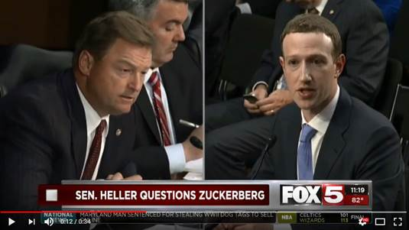](https://youtu.be/0kXoCdoS2-E)  
Click [HERE](https://youtu.be/0kXoCdoS2-E) or the above image to watch the clip



[**Senator Heller Asks Mark Zuckerberg if Users Are Victims**](https://youtu.be/7Kor_dNLUto)

KRNV

*For Nevada Senator Dean Heller, the Facebook information sharing scandal hits close to home. The Republican told Zuckerberg his daughter and six of his staff are affected by the breach. He asked Zuckerberg if he considers them and 87 million others victims or not. Heller: the 87 million users, do you consider them victims? Mark Zuckerberg: Senator I think, yes. I think they did not want their information to be sold to Cambridge analytical by a developer. And even though we didn't do it we have a responsibility to prevent that and we're committing to make sure we do that going forward.*

[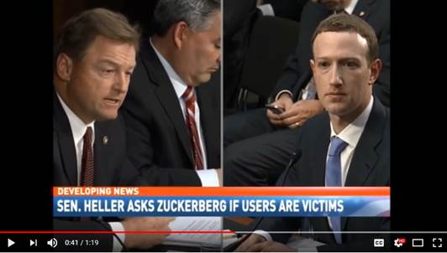](https://youtu.be/7Kor_dNLUto)

Click [HERE](https://youtu.be/7Kor_dNLUto) or the above image to watch the clip



[**Heller Puts Zuckerberg on the Hot Seat**](https://youtu.be/L2yECOmAFwI)

Channel 2 Reno

*Looking around the nation... Facebook CEO Mark Zuckerberg wrapped up the first day of testimony before Congress. The hearing focused on the social media company's failure to protect the data of millions of its users after the data was sold to political consulting firm Cambridge analytical. Our own Senator Dean Heller put Zuckerberg on the hot seat during the hearing. Heller: the 87 million users, do you consider them victims? Mark Zuckerberg: Senator I think, yes. I think they did not want their information to be sold to Cambridge analytical by a developer. Zuckerberg promised changes to the sites security.*

[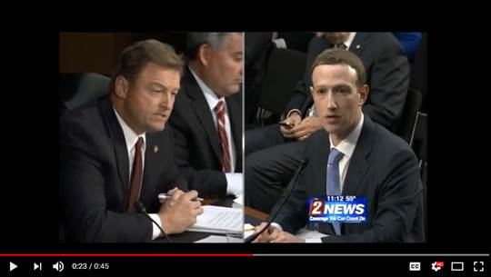](https://youtu.be/L2yECOmAFwI)

Click [HERE](https://youtu.be/L2yECOmAFwI) or the above image to watch the clip



[**Heller, Cortez Masto grill Facebook’s CEO over privacy**](http://news3lv.com/news/local/heller-cortez-masto-grill-facebooks-ceo-over-privacy)

Channel 3 Las Vegas KSNV-TV

Jeff Gillan

*Facebook notified the 87 million this week. Just ask Senator Dean Heller. “My daughter was one of the 87 million, and six of my staff, all from Nevada, all received this notification,” the Nevada Republican told Zuckerberg, who sat alone at a table in a subdued suit, a change from his usual jeans-and-t-shirt attire back at Facebook HQ. Heller asked Zuckerberg if he considered the 87 million people victims. Yes, the CEO said. “They did not want their information to be sold to Cambridge Analytica by a developer. And that happened, and that happened on our watch,” Zuckerberg told Heller, adding, “I think that we have a responsibility to prevent that and take action sooner.”*



[**Key moments from Mark Zuckerberg's Senate testimony**](https://www.politico.com/story/2018/04/10/zuckerberg-senate-testimony-facebook-key-moments-512334)

Politico

Quint Forget

*Facebook is more responsible with users’ data than the federal government would be, Zuckerberg told Sen. Dean Heller (R-Nev.) when asked about the social network’s hesitancy to provide personal information to the U.S. intelligence community. He also said he wouldn’t call himself or his company a victim — but said the 87 million users at the center of Facebook’s privacy controversy deserved that label. “Yes, they did not want their information to be sold to Cambridge Analytica by a developer,” Zuckerberg said. “That happened. And it happened on our watch.”*



[**For One Senator, Cambridge Analytica Breach Hits Close to Home**](https://www.wsj.com/livecoverage/facebook-mark-zuckerberg-live-coverage)

Wall Street Journal

*Sen. Dean Heller, Republican of Nevada, says that his daughter and several staffer were among the 87 million users affected by the Cambridge Analytica data breach, and asks how many of the affected users were from Nevada. Mr. Zuckerberg says he doesn't have that on hand, but can provide it.*



[**‘Your user agreement sucks’: Mark Zuckerberg’s Senate grilling, in 10 key moments**](https://www.washingtonpost.com/news/the-switch/wp/2018/04/10/your-user-agreement-sucks-mark-zuckerbergs-senate-grilling-in-10-key-moments/?utm_term=.8c45a69ce3b3)

Washington Post

Brian Fung

*Asked by Sen. Dean Heller (R-Nev.) whether he thought Facebook's 87 million users who were affected by the Cambridge Analytica leak were victims, Zuckerberg said yes. “Senator, I think — yes, they did not want their information to be sold to Cambridge Analytica by a developer,” Zuckerberg said. “That happened, and it happened on our watch.”*

 ###

[cid:image012.png@01D3D193.CED35370](http://www.facebook.com/pages/US-Senator-Dean-Heller/325751330177)[cid:image013.png@01D3D193.CED35370](http://twitter.com/SenDeanHeller)[cid:image014.png@01D3D193.CED35370](http://www.youtube.com/user/SenDeanHeller)