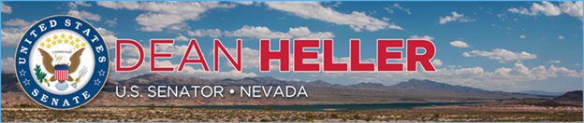

|  |  |
| --- | --- |
| **For Immediate Release:** | **Contact:**[Megan Taylor](mailto:Megan_Taylor@heller.senate.gov) |
| June 7, 2018 | 202-224-6244 |

**In Case You Missed It: “There Will Be More Survivors And There Will Be Healthier Survivors”**

**WASHINGTON** – In case you missed it, U.S. Senator Dean Heller (R-NV) joined President Trump, members of the Administration, and his colleagues earlier this week as two bipartisan pieces of legislation he backed to support Nevada’s veterans and pediatric cancer patients were signed into law. **Watch KTVN-TV Channel 2 Reno’s coverage of these events by clicking**[**here**](http://www.ktvn.com/story/38367364/veterans-health-care-childhood-cancer-research-bills-signed-into-law)**.**

Specifically, Heller attended the signing ceremonies at the White House for the [John S. McCain III, Daniel K. Akaka, and Samuel R. Johnson VA Maintaining Internal Systems and Strengthening Integrated Networks (VA MISSION) Act](https://www.heller.senate.gov/public/index.cfm/pressreleases?ID=CFEFA8BC-5617-41EA-8B18-DA3A2254F863) yesterday, and the [Childhood Cancer Survivorship, Treatment, Access, and Research (STAR) Act](https://www.heller.senate.gov/public/index.cfm/2018/2/heller-backs-bipartisan-bill-to-fight-childhood-cancers) on Tuesday.

Included below are official White House photos of the signing of the VA MISSION Act and Childhood Cancer STAR Act, as well as Nevada media coverage of these events.

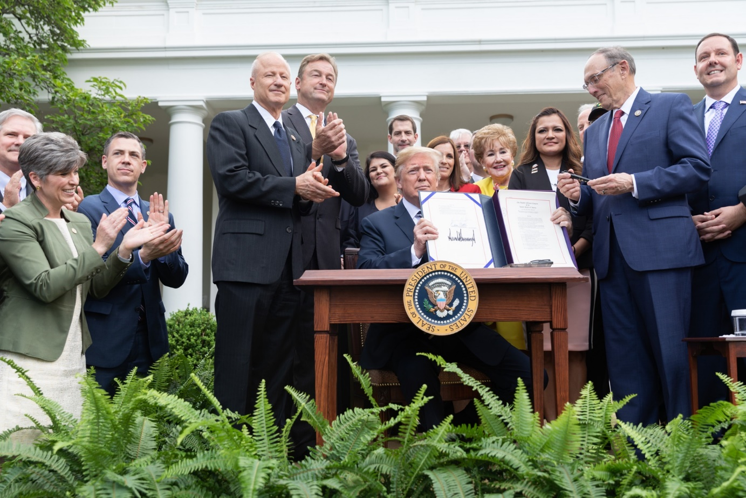

Official White House Photo

*Heller joins President Trump in the Rose Garden at the Signing of the VA MISSION Act.*

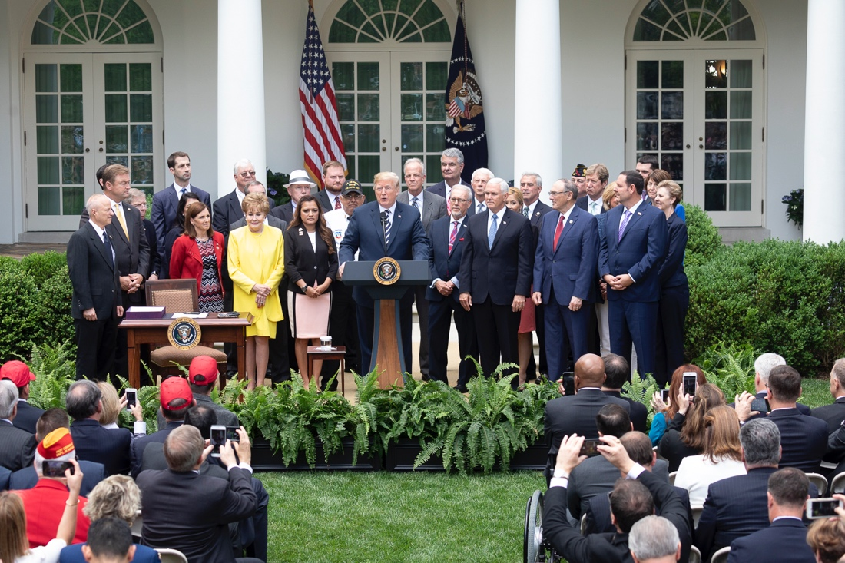

Official White House Photo

*Heller joins President Trump in the Rose Garden at the Signing of the VA MISSION Act.*

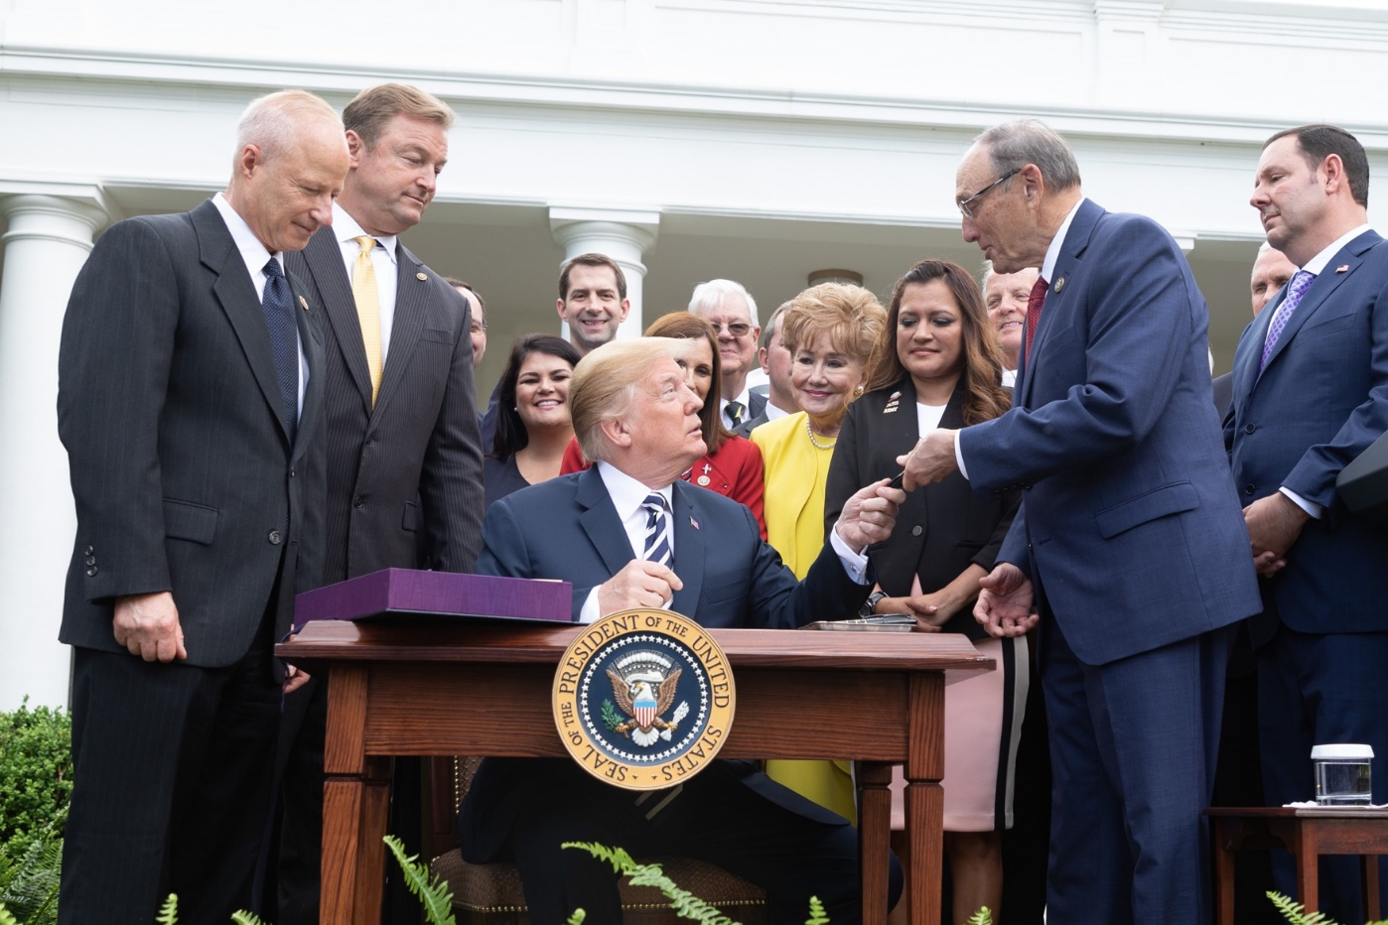

Official White House Photo

*Heller joins President Trump in the Rose Garden at the Signing of the VA MISSION Act.*

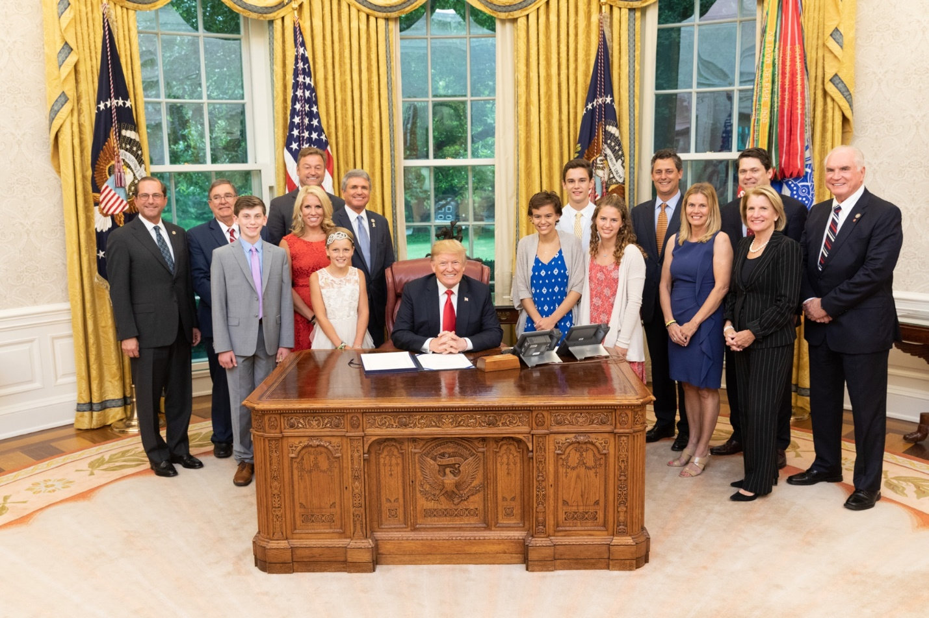

Official White House Photo

H*eller joins President Trump for the signing of the Childhood Cancer STAR Act.*

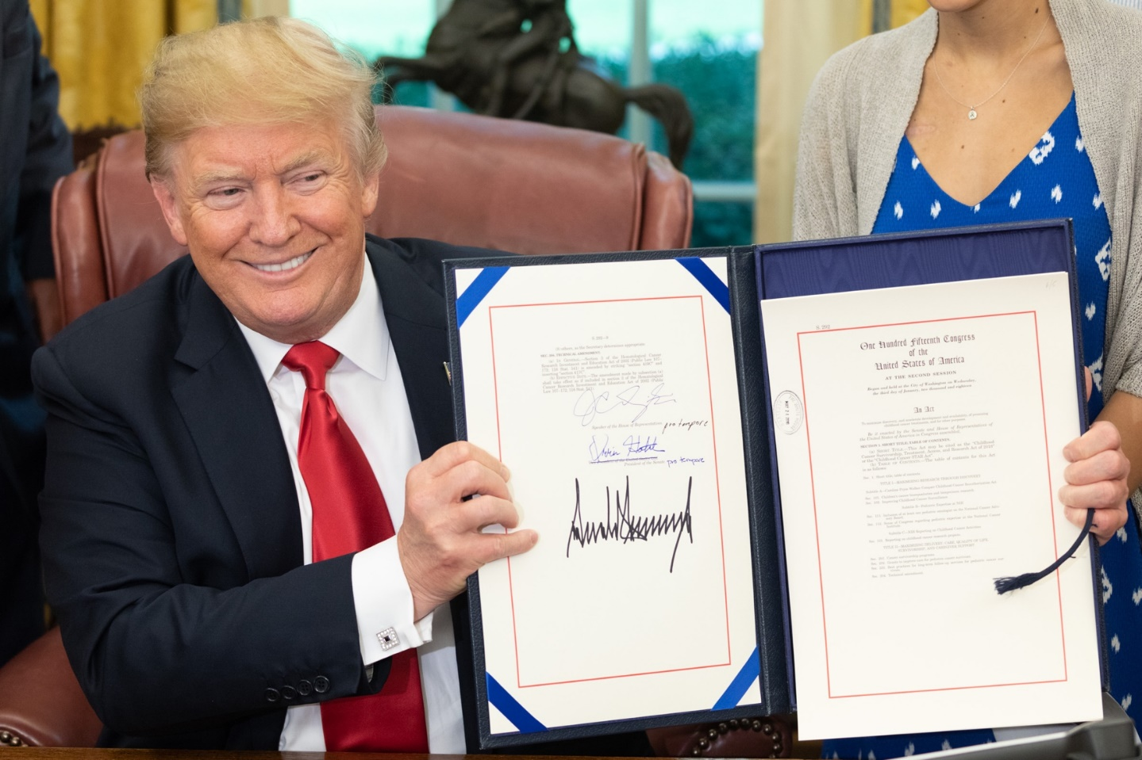

Official White House Photo

*President Trump shares the signed Childhood Cancer STAR Act.*



[**Veterans Health Care, Childhood Cancer Research Bills Signed Into Law**](http://www.ktvn.com/story/38367364/veterans-health-care-childhood-cancer-research-bills-signed-into-law)

**Paul Nelson**

*Senator Dean Heller was at the White House Tuesday and Wednesday as President Donald Trump signed two pieces of legislation into law. The Childhood Cancer STAR Act will fund $30 million to help America's young cancer patients. The money will be used for research, quality of life for survivors and to increase pediatric expertise at the National Institute of Health.*

*"We're in great shape now that we have the funding mechanism that's in place and be able to help these young adults and be able to help all those children as we continue to fight this terrible disease," Heller, R-Nevada said…*

*…Heller also attended the signing of the VA MISSION Act at the White House Rose Garden, Wednesday morning. The bill is expected to further fund and reform the U.S. Department of Veterans Affairs, including streamlining the health care system.*

*"We're trying to make sure that these veterans get the best health care that they've earned and also do it as quickly as possible," Heller said.*

*Heller says many rural Nevada veterans have to drive hours to get to the closest VA Hospital. This legislation allows veterans to go to a private doctor who is certified to treat veterans. Heller says the VA will pay for it at a lower price, rather than making a long trip.*

*"It doesn't make sense if you're waiting nine days, 10 days, two weeks to get health care treatment when you can go down the street for a hospital or to a private clinic, and get the same work done."*

*$55 billion is going into the VA health system. Three of Heller's proposals are in the MISSION Act, including the Veteran Transplant Coverage Act. It allows veterans to get an organ donation from a non-veteran…*

[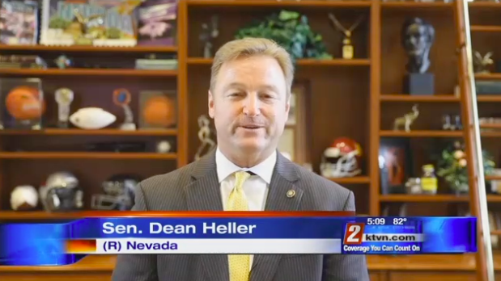](http://www.ktvn.com/story/38367364/veterans-health-care-childhood-cancer-research-bills-signed-into-law)

 The full article and video is available above and [HERE](http://www.ktvn.com/story/38367364/veterans-health-care-childhood-cancer-research-bills-signed-into-law).



[**$52B funding for Veterans Affairs includes sweeping overhaul**](https://www.reviewjournal.com/news/military/52b-funding-for-veterans-affairs-includes-sweeping-overhaul/)

**Gary Martin**

[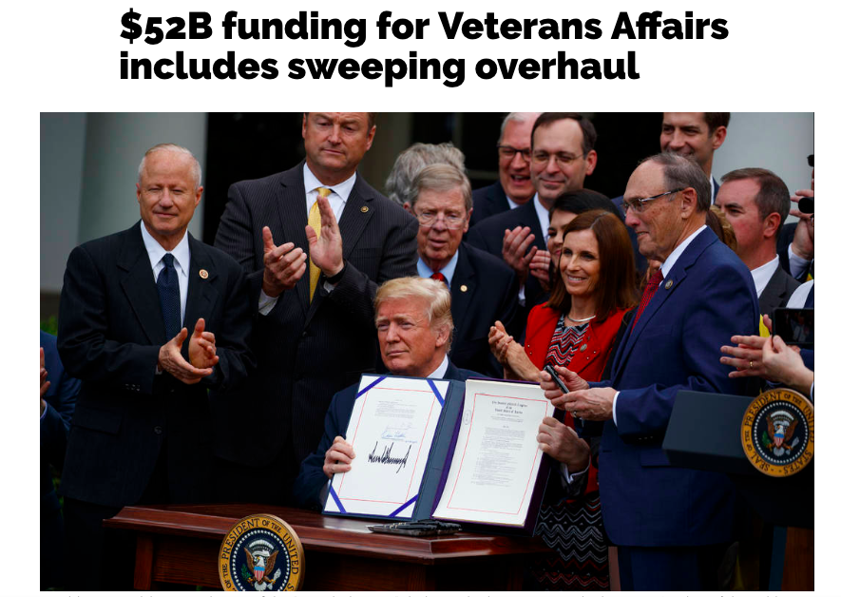](https://www.reviewjournal.com/news/military/52b-funding-for-veterans-affairs-includes-sweeping-overhaul/)

*Heller, a member of the Senate Veterans’ Affairs Committee, was part of a bipartisan coalition that included Sens. Patty Murray, D-Wash., Susan Collins, R-Maine, Sidney Blumenthal, D-Conn., Isakson, Tester and others who wrote the legislation.*

*Provisions on liver transplants, VA performance reviews and a pilot program to free up doctors from data entry were tucked into the bill by Heller, who attended the White House signing ceremony with other lawmakers who helped write the law.*

*“Our veterans deserve to know that our nation will support them when they return from the frontlines, and that’s what this bill is all about,” Heller said.*

The full article is available [**HERE**](https://www.reviewjournal.com/news/military/52b-funding-for-veterans-affairs-includes-sweeping-overhaul/).

cid:image010.png@01D3FE59.12FB7450

[**Cancer Bill Backed By Senator Heller, Signed by the President**](http://www.kkoh.com/2018/06/05/cancer-bill-backed-by-senator-heller-signed-by-the-president/)

**KOH News Talk**

*Senator Dean Heller joined the President Trump at the signing ceremony for the Childhood Cancer Survivorship, Treatment, Access, and Research or “STAR” Act. It’s bipartisan legislation cosponsored by Heller to accelerate pediatric cancer research and provide resources for young patients. According to the National Institutes of Health’s (NIH’s) National Cancer Institute, childhood cancer is the leading cause of death by disease past infancy among children in the U.S. Heller says the new law supports survivors and gives our nation’s top disease fighters the critical resources they need to develop new treatments to save lives.*

The full article is available [**HERE**](http://www.kkoh.com/2018/06/05/cancer-bill-backed-by-senator-heller-signed-by-the-president/)**.**