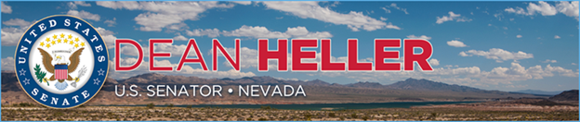

|  |  |
| --- | --- |
| **For Immediate Release:** | **Contact:**[Megan Taylor](mailto:Megan_Taylor@heller.senate.gov) |
| August 8th, 2018 | 202-224-6244 |

**IN CASE YOU MISSED IT: Bipartisan 22nd Annual Lake Tahoe Summit a Great Success**

**RENO, NV –** U.S. Senator Dean Heller (R-NV) hosted the bipartisan 22nd Annual Lake Tahoe Summit at Sand Harbor State Park in Incline Village, Nevada. U.S. Senator Lisa Murkowski (R-AK), Chairman of the U.S. Senate Energy and Natural Resources Committee and Chairman of the U.S. Senate Appropriations Subcommittee on the Interior, Environment, and Related Agencies, delivered the keynote address, and the following members of the Nevada and California delegations participated in the Tahoe Summit: U.S. Senator Catherine Cortez Masto (D-NV), U.S. Senator Dianne Feinstein (D-CA), U.S. Representative Mark Amodei (NV-02), U.S. Representative Tom McClintock (CA-04), and U.S. Representative John Garamendi (CA-03). Dr. Graham Kent, Director Nevada Seismological Laboratory who has been instrumental in ensuring AlertTahoe’s success, also spoke at the event.

“In light of numerous threats, including wildfire, invasive species, and water clarity, we must continue to prove that Lake Tahoe is not, and never will be, a partisan issue,” **Heller said at the event.**

Heller’s remarks at this year’s Lake Tahoe Summit focused on his bipartisan [Lake Tahoe Restoration Act](https://www.heller.senate.gov/public/index.cfm/2016/9/heller-carries-lake-tahoe-restoration-act-across-senate-finish-line), legislation that was crafted to protect the Lake Tahoe Region by improving water clarity, reducing wildfire threats, jumpstarting innovative transportation and infrastructure projects, and combating invasive species. Last week, [Heller announced that he secured $12 million in federal funding to implement his Lake Tahoe Restoration Act](https://www.heller.senate.gov/public/index.cfm/pressreleases?ID=D9F37E9F-A058-4EE5-B24F-F0DADAD7B3B5) in a spending measure approved by the U.S. Senate.

“While we have some great folks at the Forest Service, they can’t do what they do without the appropriate resources,” **Heller remarked.** “So I worked with Chairwoman Murkowski to include $6 million in the Senate’s Interior Appropriations bill for hazardous fuels at the Lake. She is a champion for this lake and for Nevada. Thank you, Lisa for working with me and addressing this need.”

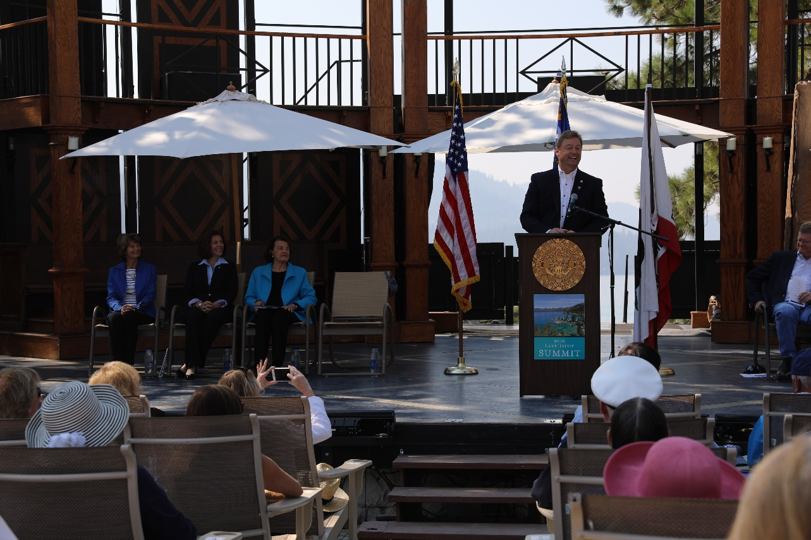

*Sen. Heller delivers remarks at the 22nd Annual Lake Tahoe Summit.*

*\*Media has permission to use image.*

In addition to securing funding to implement his Lake Tahoe Restoration Act, Heller also discussed his work with Chairwoman Murkowski to include additional funding to help combat the threat of invasive species and [fight wildfires in legislation that was recently approved by the U.S. Senate.](https://www.heller.senate.gov/public/index.cfm/pressreleases?ID=D9F37E9F-A058-4EE5-B24F-F0DADAD7B3B5) He also spoke about the importance of public-private partnerships and his support for AlertTahoe and other innovative technologies.

“As we did last year, we’ll continue to make sure that organizations - like AlertTahoe – and others, are able to use new and emerging technologies to detect wildfire will be eligible for federal funding so they have the resources they need to get the job done,” **said Heller.** “[I’m proud to announce that the U.S. Forest Service has allocated $226,000 to AlertTahoe](https://www.heller.senate.gov/public/index.cfm/pressreleases?ID=AEAA0B1D-7D1D-4ED3-9692-7B5767389320) to install and maintain new fire cameras in the Tahoe basin. I have stressed the importance of programs like this one to both Secretary Perdue and Secretary Zinke because investing in these technologies and catching fires before they expand, we will save time, money, and most importantly, lives.”

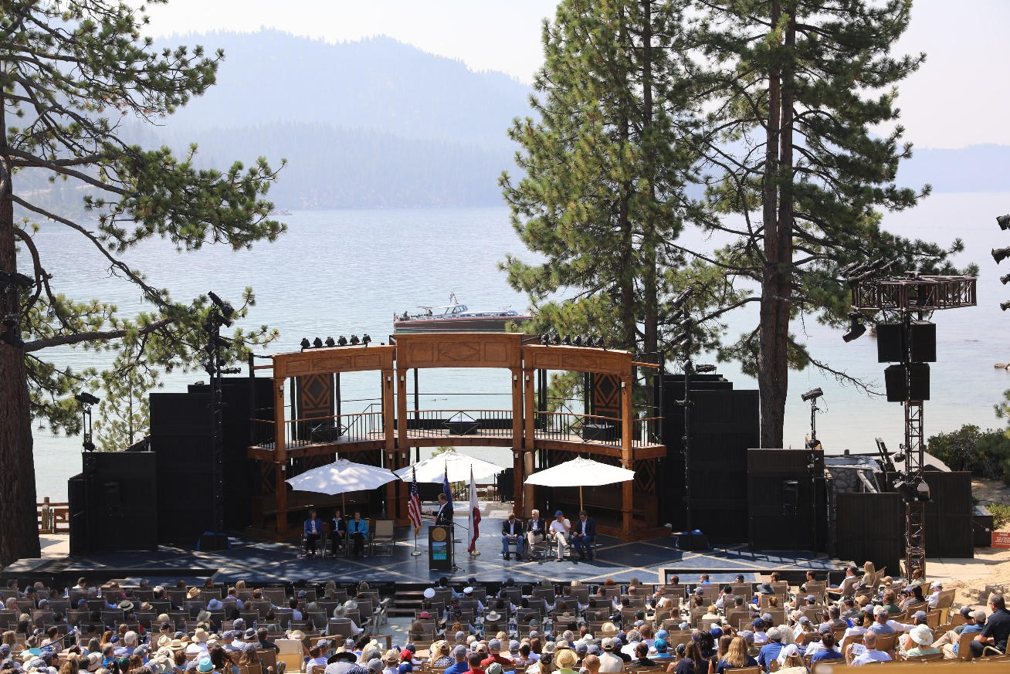

*A bipartisan group of members from the Nevada and California delegations gathered at Sand Harbor State Park for the Lake Tahoe Summit.*

*\*Media has permission to use image.*

Heller concluded by reflecting on the life of Paul Laxat, who passed away earlier this week.

“As my friend and mentor Paul Laxalt – whose family by the way owns property just north of us in the heart of the Sierra Nevada next to Marlette Lake – once said, ‘I guess our reward for these efforts is being able to view beautiful Lake Tahoe – still blue, still clear – and say, ‘we had a little bit to do with saving it,” **said Heller.** “Paul had a lot to do with saving it. In fact, there is no one who has done more for this Lake than Paul Laxalt. Paul was a son of Nevada whose legacy of leadership and delivering for Nevada and for this lake that we all love will live on for generations to come.”

###

[cid:image002.png@01D42986.5E397F90](http://www.facebook.com/pages/US-Senator-Dean-Heller/325751330177)[cid:image003.png@01D42986.5E397F90](http://twitter.com/SenDeanHeller)[cid:image004.png@01D42986.5E397F90](http://www.youtube.com/user/SenDeanHeller)