

|  |  |
| --- | --- |
| **For Immediate Release:** | **Contact:** [Megan Taylor](mailto:Megan_Taylor@heller.senate.gov) |
| March 7, 2017 | 202-224-6244 |

**In Case You Missed It: Carson City Lands Federal Transportation Grant Heller Helped Secure**

**WASHINGTON, D.C. –** [KRNV News 4 Reno](https://youtu.be/10TockjnRWY) this morning reported on a $7.5 million federal grant that [U.S. Senator Dean Heller (R-NV) helped secure from the U.S. Department of Transportation (DOT)](https://www.heller.senate.gov/public/index.cfm/pressreleases?ID=F3ABC26A-CB1B-4382-BAC4-14B3269D0C0B) for the South Carson Street Complete Streets Corridor Project.

Specifically, the $7.5 million federal grant was awarded to the Carson City Public Works Department through the DOT’s highly-competitive Transportation Investment Generating Economic Recovery, or TIGER, grant program. In October 2017, Heller sent a letter of support to DOT Transportation Secretary Elaine Chao urging the department to choose the project, noting it will “drive economic growth and investment directly into the heart of our state capital.”

[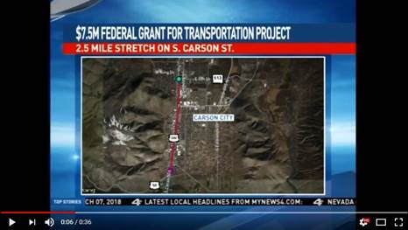](https://youtu.be/10TockjnRWY)

Click [HERE](https://youtu.be/10TockjnRWY) or the above image to play the video.

**Background:**

Senator Heller supported funding for the TIGER grant program with passage of Public Law 114-113, which allocated $500 million to the TIGER program to remain available through fiscal year 2019.

The 2.5-mile South Carson Street Complete Streets Corridor Project begins in the north at 5th Street near the government complex and ends in the south at Roland Street near the I-580 bypass. The project will improve pedestrian safety in the area, including accessible sidewalks and crosswalks; new bike facilities; and enhanced commercial and business access.

The Department of Transportation awarded the project a grant of $7,570,202.00 to Carson City Public Works Department.

 ###

[cid:image003.png@01D3B633.30F75820](http://www.facebook.com/pages/US-Senator-Dean-Heller/325751330177)[cid:image004.png@01D3B633.30F75820](http://twitter.com/SenDeanHeller)[cid:image005.png@01D3B633.30F75820](http://www.youtube.com/user/SenDeanHeller)