

|  |  |
| --- | --- |
| **For Immediate Release:** | **Contact:** [Megan Taylor](mailto:Megan_Taylor@heller.senate.gov) |
| May 29, 2018 | 202-224-6244 |

**In Case You Missed It: Heller Honors Memorial Day, Heroes, in Southern Nevada**

**LAS VEGAS –** U.S. Senator Dean Heller (R-NV) yesterday honored Nevada’s fallen heroes at Memorial Day events in Las Vegas, Henderson, Boulder City and Pahrump.

“*Whether it is service members who are standing guard and patrolling rough terrain in Afghanistan today, or the young U.S. Marines who gallantly fought in the high mountains and freezing temperatures at the Battle of Chosin, these heroes’ sacrifices demonstrate an undisputed fact: Freedom is not free*,” **Heller said** **at the Memorial Day service at Bunkers Memory Gardens Cemetery.** “*We all have an obligation to remember them, and the loved ones they have left behind. We have an obligation to honor their service, their patriotism, and their fights – away from their homes and families – all calendar year*.”

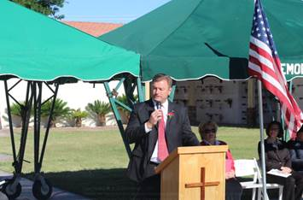

*Heller speaks at the Bunkers Memory Memorial Gardens Cemetery in Las Vegas.*

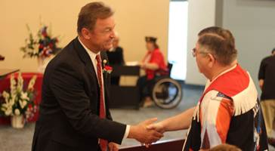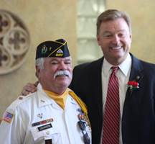 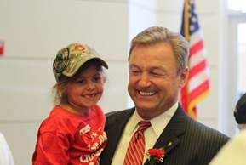  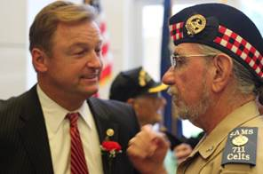

*Heller speaks with Nevada veterans and their families at Memorial Day Ceremonies in Las Vegas and Boulder City.*

*\*Media has the permission to use the photographs above.*

Below are excerpts from the media’s coverage of the Memorial Day ceremonies, as well as photographs that the media has permission to use.

cid:image007.jpg@01D3F767.A5F55FD0

[**Memorial Day: A special tribute unveiled**](http://www.lasvegasnow.com/news/memorial-day-a-special-tribute-unveiled/1205128339)

By Orko Manna

*Memorial Day is a day to remember those who've paid the ultimate price for defending our freedom. A day to remember the hundreds of thousands who died bravely serving our country.*

*Men and women who made the ultimate sacrifice.*

*"I understand that here in America, that we live in an extraordinary country because of your extraordinary sacrifices," said Senator Dean Heller.*

[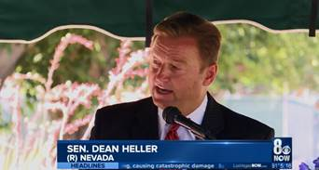](http://www.lasvegasnow.com/news/memorial-day-a-special-tribute-unveiled/1205128339)

*[Click* [*HERE*](http://www.lasvegasnow.com/news/memorial-day-a-special-tribute-unveiled/1205128339) *or on the above image to view the video]*



[**Fox 5: Heller Attends Palm Mortuary Memorial Day Service**](https://www.youtube.com/watch?v=L1QjABaVpuQ&feature=youtu.behttps://www.youtube.com/edit?o=U&video_id=L1QjABaVpuQ)

KVVU Fox 5

[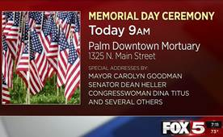](https://youtu.be/L1QjABaVpuQ)

*[Click* [*HERE*](https://youtu.be/L1QjABaVpuQ) *or on the above image to view the video]*



[**Memorial Day: Before Knights, take time to honor those who gave their lives for us**](http://news3lv.com/news/local/memorial-day-before-knights-take-time-to-honor-those-who-gave-their-lives-for-us)

By Marvin Clemons

*Palm Downtown Mortuary and Cemetery in conjunction with American Legion Post No. 8: 9 a.m. Monday at 1325 N. Main St. Special addresses by Las Vegas Mayor Carolyn Goodman, Sen. Dean Heller, Congresswoman Dina Titus, former Sen. Richard Bryan and a representative from Sen. Catherine Cortez Masto.*

Full story is available [here](http://news3lv.com/news/local/memorial-day-before-knights-take-time-to-honor-those-who-gave-their-lives-for-us).

cid:image012.jpg@01D3F767.A5F55FD0

[**Palm Mortuary Memorial Day Service**](https://www.youtube.com/watch?v=rZb442nK19U&feature=youtu.be)

KLAS Channel 8 Las Vegas

*This Memorial Day Senator Dean Heller took a moment to honor Nevada’s Fallen Heroes. Many community members and veterans joined him for a day of remembrance at Palm Boulder Highway Mortuary and Cemetery. As a senior member of the U.S. Senate Veteran’s Affairs Committee, Heller says it’s important to him to fight for Nevada’s 300,000 veterans.*

[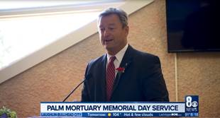](https://youtu.be/rZb442nK19U)

*[Click* [*HERE*](https://youtu.be/rZb442nK19U) *or on the above image to view the video]*

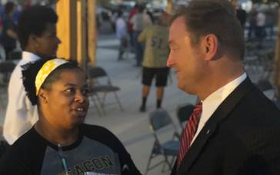   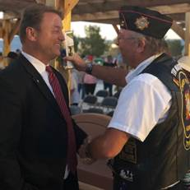

*Heller greets veterans in Pahrump at the Candlelight Salute, hosted by Pahrump’s Disabled Veterans Chapter 15.*

*\*Media has permission to use the above photographs.*

*###*