

|  |  |
| --- | --- |
| For Immediate Release: | **Contact:** [Megan Taylor](mailto:Megan_Taylor@heller.senate.gov) |
| October 27, 2017 | 202-224-6244 |

**IN CASE YOU MISSED IT: Heller Honors WWII Filipino Veterans at Congressional Gold Medal Ceremony**

**Washington, D.C.** –  During a [Congressional Gold Medal Ceremony honoring World War II Filipino and Filipino-American veterans](https://www.heller.senate.gov/public/index.cfm/pressreleases?ID=3C00AB54-83C0-4602-9837-14C0E4FE3AFB), U.S. Senator Dean Heller (R-NV) [recognized Sergeant Regalado Baldonado of Las Vegas](https://www.youtube.com/watch?v=2EejN9PjE_g&feature=youtu.be), who is just one of four recognized Filipino-American veterans who reside in Nevada.   
  
As a senior member of the U.S. Senate Veterans’ Affairs Committee, Heller has fought to ensure that World War II Filipino and Filipino-American veterans receive the recognition they have earned and deserve for their instrumental wartime service to the United States and strategic role in the Allied victory over the Empire of Japan. Heller worked with U.S. Sen. Mazie Hirono (D-HI) to pass into law the [Filipino Veterans of World War II Congressional Gold Medal Act](https://www.heller.senate.gov/public/index.cfm/2016/7/senate-passes-heller-hirono-legislation-awarding-congressional-gold-medal-to-wwii-filipino-veterans), which recognizes the dedication and heroism of these individuals.

cid:image002.png@01D34F18.76036620

**Las Vegas resident, other Filipino-Americans honored for WWII service**

By Gary Martin

October 26, 2017

<http://bit.ly/2xuEyc5>  
  
Las Vegas resident Regalado Baldonado was honored at a congressional ceremony this week along with other Filipino and Filipino-Americans for their service in World War II.  
  
Baldonado, 90, is one of four recognized Filipino-American World War II veterans who reside in Nevada. Only Baldonado was able to attend the Washington event.  
  
But all Filipino and Filipino-American WWII veterans were honored at the Congressional Gold Medal Ceremony at the U.S. Capitol on Wednesday.  
  
Sen. Dean Heller, R-Nev., who with Sen. Mazie Hirono, D-Hawaii, co-sponsored the Filipino Veterans of World War II Gold Medal Act, singled out Baldonado, who joined the Fil-American Army in 1942 at age 15.  
  
“I’m incredibly humbled to be here as Nevada’s own Sergeant Regalado Baldonado and the entire Filipino veteran community receive the Congressional Gold Medal for answering America’s call to service,” said Heller, a member of the Senate Veterans’ Affairs Committee.

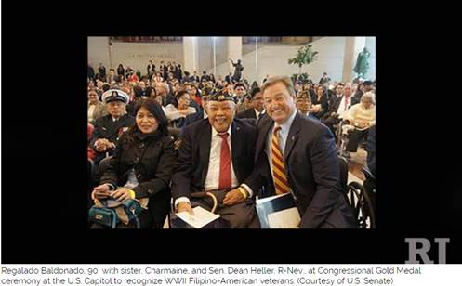

Baldonado traveled with his sister, Charmaine, to Washington to take part in the Gold Medal Ceremony.  
  
Heller said the bill he co-sponsored recognizes the strategic role of Filipinos in the U.S. and Allied victory over Japan in World War II.  
  
There are 138,000 Filipino-Americans living in Las Vegas.



Channel 8

October 25, 2017

<http://bit.ly/2hexQ3T>

*“Sergeant Baldonado - thank you for fighting, thank you for your bravery, and thank you for being faithful to America. This day is for you and for every other World War II Filipino veteran- even those who have yet to be recognized for their service. This medal ensures your place in history is not forgotten.”*

[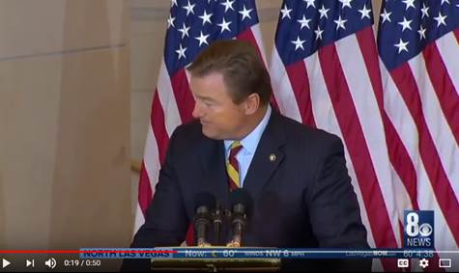](http://bit.ly/2hexQ3T)  
[Click [HERE](http://bit.ly/2hexQ3T) or on the above image to view the story]

###

[cid:image006.png@01D34F18.76036620](http://www.facebook.com/pages/US-Senator-Dean-Heller/325751330177)[cid:image007.png@01D34F18.76036620](http://twitter.com/SenDeanHeller)[cid:image008.png@01D34F18.76036620](http://www.youtube.com/user/SenDeanHeller)