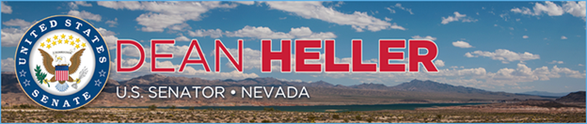

|  |  |
| --- | --- |
| **For Immediate Release:** | **Contact:** [Megan Taylor](mailto:Megan_Taylor@heller.senate.gov) |
| March 14, 2018 | 202-224-6244 |

**In Case You Missed It: Heller Introduces Bill to Reauthorize Colorado River System Conservation Program**



[**Heller introduces bill to reauthorize Colorado River program**](https://www.reviewjournal.com/news/politics-and-government/nevada/heller-introduces-bill-to-reauthorize-colorado-river-program/)

Gary Martin

WASHINGTON — Legislation has been introduced in the Senate to reauthorize the Colorado River System Conservation Program critical to water supplies for Southern Nevada.

Sen. Dean Heller, R-Nev., filed the bill to reauthorize for four years the conservation program, first passed by Congress in 2015 to conserve water and mitigate impacts of drought in the Colorado River Basin.

The basin is comprised of two halves. Colorado, New Mexico, Utah and Wyoming comprise the upper half, while Nevada, Arizona and California make up the lower half.

Southern Nevada, which includes Clark County and Las Vegas, receives nearly 90 percent of its water supply from the Colorado River.

“Southern Nevada is no stranger to drought, and that’s why I continue to fight for policies that strengthen our state’s water supply and infrastructure,” Heller said in a statement.

Heller filed the bill on Tuesday.

A report by the U.S. Bureau of Reclamation in January projected that the level of Lake Mead, where Las Vegas draws its water, would be about 5 feet lower by the end of the year.

The surface of Lake Mead has fallen 131 feet since 2000.

###

[cid:image003.png@01D3BBB1.458CB090](http://www.facebook.com/pages/US-Senator-Dean-Heller/325751330177)[cid:image004.png@01D3BBB1.458CB090](http://twitter.com/SenDeanHeller)[cid:image005.png@01D3BBB1.458CB090](http://www.youtube.com/user/SenDeanHeller)