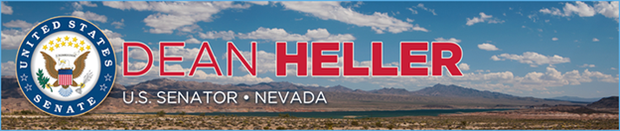

|  |  |
| --- | --- |
| **For Immediate Release:** | **Contact:** [Megan Taylor](mailto:Megan_Taylor@heller.senate.gov) |
| January 12, 2018 | 202-224-6244 |

**PHOTOS:**

**In Case You Missed It: Heller Joins Vice President Pence in Rallying Troops at Nellis Air Force Base**

**Las Vegas, NV** – In case you missed it, [U.S. Senator Dean Heller (R-NV) joined Vice President Mike Pence at Nellis Air Force Base](https://www.heller.senate.gov/public/index.cfm/pressreleases?ID=D6277CD7-F9C2-4CB6-8404-BCB907E1D681) in Las Vegas, NV yesterday at a rally for Airmen and their families. Earlier in the day, Heller welcomed Pence and U.S. Air Force Secretary Heather Wilson to the state where they also visited AFwerX Vegas, a new program that brings together the Air Force, entrepreneurs, and more to innovate and improve Air Force capabilities. Watch [Sen. Heller’s opening remarks here](https://youtu.be/TXk-aMXLtiQ).

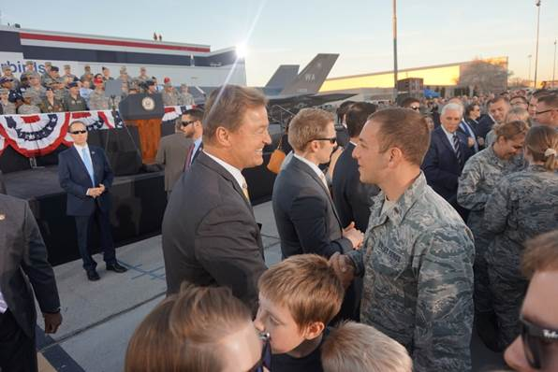

*Sen. Heller and Vice President Pence shake hands with Airmen at Nellis Air Force Base*

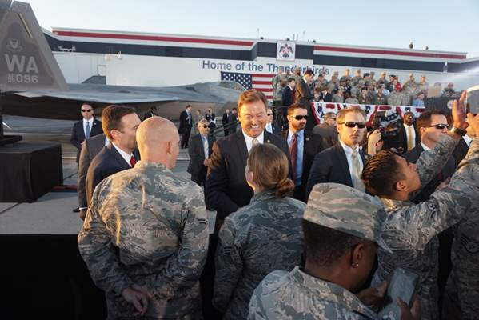

*Attorney General Adam Laxalt and Sen. Heller talk to Airmen at Nellis Air Force Base*

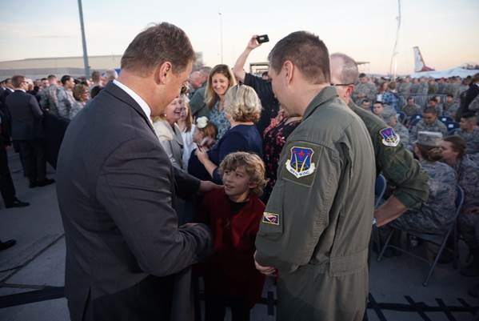

*Sen. Heller greets troops and their families following Pence’s speech at Nellis Air Force Base*

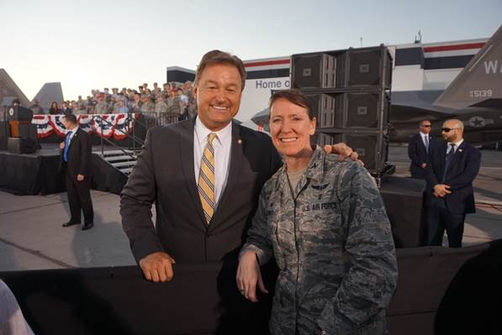

*Sen. Heller and an Airman following the rally at Nellis Air Force Base*

**###**

[cid:image006.png@01D38BB3.112412E0](http://www.facebook.com/pages/US-Senator-Dean-Heller/325751330177)[cid:image007.png@01D38BB3.112412E0](http://twitter.com/SenDeanHeller)[cid:image008.png@01D38BB3.112412E0](http://www.youtube.com/user/SenDeanHeller)