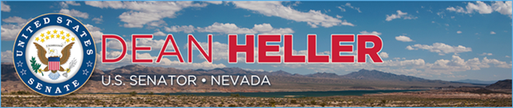

|  |  |
| --- | --- |
| **For Immediate Release:** | **Contact:** [Megan Taylor](mailto:Megan_Taylor@heller.senate.gov) |
| February 7, 2018 | 202-224-6244 |

**In Case You Missed It: Heller Pushes Congress to Approve His Public Lands Bills**

**WASHINGTON, D.C.** – During a U.S. Energy and Natural Resources Subcommittee on Public Lands, Forests, and Mining hearing this morning, U.S. Senator Dean Heller (R-NV) urged Congress to take swift action on two of his public lands bills: [the Pershing County Economic Development and Conservation Act](https://www.heller.senate.gov/public/index.cfm/pressreleases?ID=8FF99227-8014-4FFE-8D23-A7EF515D4C3C) and the [Eastern Nevada Economic Development and Land Management Improvement Act](https://www.heller.senate.gov/public/index.cfm/pressreleases?ID=CD83FA82-005C-4827-84CD-4E80AB88F936). Watch the clip [HERE](https://youtu.be/F-SFttBCxHc).

*“As most of you know, over 75 percent of the lands within this [Pershing] county are administered by the federal government – and much of that land is in a ‘checkerboard pattern.’ … It is confusing for sportsmen and other outdoor recreationalists, it limits economic development opportunities along the I-80 corridor, and it is a bureaucratic headache for BLM and private land owners. Resolving this mess in a common-sense manner will benefit all Nevadans,”* ***said Heller.***

[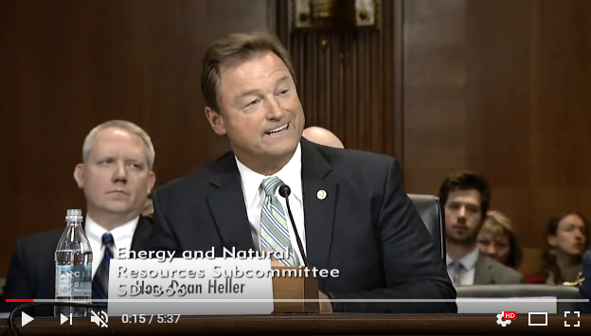](https://youtu.be/F-SFttBCxHc)

Click [HERE](https://youtu.be/F-SFttBCxHc) to watch the video.

The Pershing County Economic Development and Conservation Act, S. 414, will provide new opportunities for economic development throughout the county while promoting conservation. Rep. Mark Amodei (R-NV-02) introduced the bill in the U.S. House of Representatives, and it recently [passed the chamber in a unanimous vote](https://www.heller.senate.gov/public/index.cfm/pressreleases?ID=B897F922-DBB1-4F8D-9625-6C9773302EA0).

The Eastern Nevada Economic Development and Land Management Improvement Act, S. 1046, is a bicameral, bipartisan bill designed in collaboration with local officials to jumpstart economic development and enhance conservation efforts in Eastern Nevada. Heller introduced the bill with Sen. Catherine Cortez Masto (D-NV) in May 2017.

**Heller’s testimony reads in full:**

Chairman Lee thank you, and to the Ranking Member, for holding this hearing today. I want to thank the Committee, most of you are very familiar with some of these land issues, and I’m appreciative of that knowledge. I also want to thank my colleague, also from Nevada, for her help and support in making this bipartisan legislation.   
  
I’m here to talk on the issues she may have mentioned to you, and that is the Pershing County Economic Development and Conservation Act (S.414), and the Eastern Nevada Economic Development and Land Management Improvement Act (S.1046).

Both of these bills are a product of grassroots efforts to solve the public lands issues in my state, and both represent years of hard work by the affected communities.

For years, residents of Pershing County have worked to produce and develop this proposal to provide their community with new opportunities for economic development and increase outdoor recreational activities and opportunities. It builds on the efforts of the Pershing County Checkerboard Lands Committee, yes there is a Checkerboard Lands Committee in this particular county. It was initiated about a decade ago and it was a community-driven process to solve these land management issues, and they were hashed out by grassroots-driven public process, including the county officials, local residents, and stakeholders.

As most of you know, over 75 percent of the lands within this county are administered by the federal government – and much of that land is in a “checkerboard pattern.” A remnant of railroad construction in the 1800s, these checkerboard lands now present a major land management problem. It is confusing for sportsmen and other outdoor recreationalists, it limits economic development opportunities along the I-80 corridor, and it is a bureaucratic headache for BLM and private land owners. Resolving this mess in a common-sense manner will benefit all Nevadans.

First, it advances a sale and exchange plan for BLM lands in Pershing County already identified for disposal by the BLM’s resource management plans. This process is modeled off the highly successful Southern Nevada Public Land Management Act (SNPLMA) that has facilitated sustainable development in the Las Vegas Valley since its enactment. Together with Pershing County, the Department of the Interior will jointly select lands and the parcels to be sold through a competitive bidding process for no less than fair market value – ensuring a fair return for the American taxpayer.  Responsibly facilitating these targeted land sales and exchanges along the Interstate 80 corridor will increase the county’s tax base, increase outdoor recreation opportunities, spur economic development, and improve land stewardship.

Second, it will facilitate the expansion and development of existing mining projects within Pershing County. The county has a wide variety of mineral resources, but silver, gold, and tungsten have been the mainstays for more than a century and a half. This initiative will be a boon for economic growth, yielding millions of dollars of investments in the county and greatly improving the county’s tax base.

Third, it will also allow Pershing County to acquire land in the Unionville Cemetery, which was established in the 1870s. This cemetery is part of the historic, unincorporated mining town of Unionville, Nevada, where Mark Twain lived for a period of time. The land that comprises the cemetery was thought to be on private grounds; but at some point, it was discovered that the cemetery lies on BLM land, and the BLM is now prohibiting new burials there. By transferring this land to the county, the cemetery will be able to go back into use.

Finally, the bill resolves some long-standing land designations within the county. Five wilderness study areas within the county have been in limbo for nearly 30 years, all being managed as wilderness by the BLM. These areas were looked at by the residents on the ground, and the boundaries were carefully designed. The resulting maps conserve important wildlife habitat, ensure existing road access into wilderness, and resolve local ranchers’ issues with the current “wilderness study area” boundaries that will provide their operations more flexibility and stability moving forward.

So you can see, this proposal in its entirety will yield major benefits not only for Pershing County, but also for the American people. It is important to note that this non-controversial legislation has the unanimous support of the Nevada Congressional Delegation, and companion legislation, H.R.1107, introduced by my good friend Congressman Mark Amodei passed the House of Representatives by voice vote on January 16th.

It has garnered the support of a diverse group of stakeholders throughout Nevada for this legislation, including business groups like the Nevada Mining Association and the Nevada Farm Bureau Federation; the Coalition for Nevada’s Wildlife, and even environmental groups like the Friends of Nevada Wilderness. That support is indicative of the residents’ hard work to develop a lands package that balances the opinions of diverse stakeholders.

I do also want to testify in support of my legislation, the Eastern Nevada Economic Development and Land Management Improvement Act, which I introduced alongside my colleague, Senator Cortez Masto. I can see Mr. Chairman that my time has run out, and without giving you the details of this, I do want to share with you the importance of both of these pieces of legislation. And I’m more than willing to work with this Subcommittee to make sure that we move both of these pieces of legislation forward.   
  
Thank you.

**###**

[cid:image003.png@01D3A01C.543C4200](http://www.facebook.com/pages/US-Senator-Dean-Heller/325751330177)[cid:image004.png@01D3A01C.543C4200](http://twitter.com/SenDeanHeller)[cid:image005.png@01D3A01C.543C4200](http://www.youtube.com/user/SenDeanHeller)