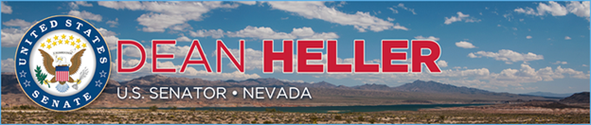

|  |  |
| --- | --- |
| **For Immediate Release:** | **Contact:** [Megan Taylor](mailto:Megan_Taylor@heller.senate.gov) |
| January 23, 2018 | 202-224-6244 |

**In Case You Missed It: Heller Questions FDIC Nominee Jelena McWilliams**

**WASHINGTON, D.C.** – During a U.S. Senate Banking, Housing, and Urban Affairs Committee hearing this morning, U.S. Senator Dean Heller (R-NV) questioned Jelena McWilliams, President Trump’s nominee to lead the Federal Deposit Insurance Corporation (FDIC), about ways to help community banks in Nevada and across the United States as well as chartering new industrial loan companies (ILCs). Watch the clip [HERE](https://youtu.be/TE4GugNO8eI).

Specifically, Heller asked McWilliams about her views on ILCs, which play an important role in Nevada’s economy, as well how she would stop the consolidation of community banks across the country. In her response to Heller, McWilliams said she is “concerned” about the mass consolation of community banks, especially in rural counties, where consumers may have to drive 30 to 40 miles for banking services.

[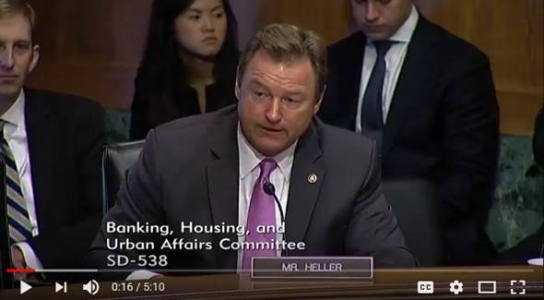](https://youtu.be/TE4GugNO8eI)

Click [HERE](https://youtu.be/TE4GugNO8eI) to watch the video.

**###**

[cid:image003.png@01D39452.B0DC67E0](http://www.facebook.com/pages/US-Senator-Dean-Heller/325751330177)[cid:image004.png@01D39452.B0DC67E0](http://twitter.com/SenDeanHeller)[cid:image005.png@01D39452.B0DC67E0](http://www.youtube.com/user/SenDeanHeller)