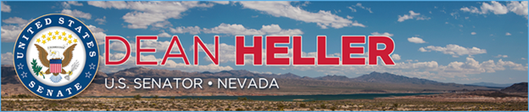

|  |  |
| --- | --- |
| **For Immediate Release:** | **Contact:** [Megan Taylor](mailto:Megan_Taylor@heller.senate.gov) |
| January 30, 2018 | 202-224-6244 |

**In Case You Missed It: Heller Shares Tax Reform’s Positive Impact in Nevada with Treasury Secretary Mnuchin**

**WASHINGTON, D.C.** – During a U.S. Senate Banking, Housing, and Urban Affairs Committee hearing this morning, U.S. Senator Dean Heller (R-NV) shared with U.S. Department of the Treasury Secretary Steven Mnuchin how Nevadans are already benefiting from the recently-signed [Tax Cuts and Jobs Act](https://www.heller.senate.gov/public/index.cfm/pressreleases?ID=BA866358-7F63-4C5E-B72E-57616EBBBA0C), historic tax relief legislation championed by Heller. Watch the clip [HERE](https://youtu.be/KifbuEDgoTc).

Specifically, Heller noted that because of tax reform, companies that employ Nevadans are now giving back to their workers, such as [South Point Hotel, Casino & Spa](https://www.heller.senate.gov/public/index.cfm/pressreleases?ID=406B6212-5D07-4677-89AC-4726F308187D) in Las Vegas, NV which recently pledged to double its 2,300 full-time workers’ bonuses and [Wal-Mart, which announced it will be increasing wages, handing out bonuses, and expanding maternity and parental leave benefits for roughly 8,700 Nevadans](https://www.heller.senate.gov/public/index.cfm/pressreleases?ID=8AD09848-1691-47C6-93F0-5202A10DB08A). Heller also shared that tax reform is proving to help spur job creation as Fontainebleau’s developers said they will resume a stalled project, which is expected to create approximately 10,000 jobs.

In response to one of Heller’s questions, Mnuchin said that the average Nevada worker will see wage growth as a result of tax reform and pro-economic growth policies.

[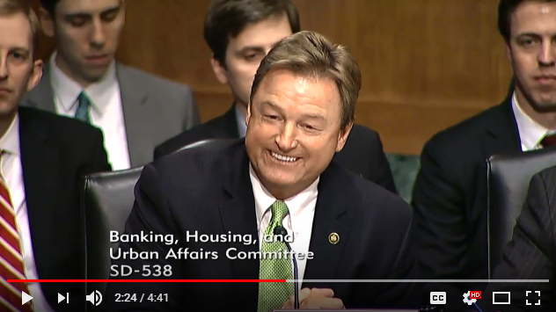](https://youtu.be/KifbuEDgoTc)

Click [HERE](https://youtu.be/KifbuEDgoTc) to or the above image to watch the video.

Heller, [who hosted Mnuchin in Las Vegas, NV in August for a roundtable discussion with some of Nevada’s job creators](https://www.heller.senate.gov/public/index.cfm/pressreleases?ID=D3C0DCA1-F0FC-4984-B631-C559E928F306), also thanked the Secretary for his work in helping Congress deliver tax relief to hardworking families and small business owners in Nevada and across the country.

[cid:image003.png@01D399C8.E733B1B0](http://www.facebook.com/pages/US-Senator-Dean-Heller/325751330177)[cid:image004.png@01D399C8.E733B1B0](http://twitter.com/SenDeanHeller)[cid:image005.png@01D399C8.E733B1B0](http://www.youtube.com/user/SenDeanHeller)