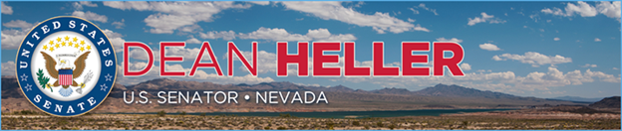

|  |  |
| --- | --- |
| **For Immediate Release:** | **Contact:**[Megan Taylor](mailto:Megan_Taylor@heller.senate.gov) |
| June 15, 2018 | 202-224-6244 |

**In Case You Missed It: Nevada Media Highlight $12 Million Heller Secured to Preserve Lake Tahoe, Fight Wildfires**

**WASHINGTON –**In case you missed it, Nevada media highlighted U.S. Senator Dean Heller’s [announcement](https://www.heller.senate.gov/public/index.cfm/pressreleases?ID=322AEF3B-1632-4966-A6A8-1103563F34D0) that he secured $12 million in federal funding for his [Lake Tahoe Restoration Act](https://www.heller.senate.gov/public/index.cfm/2016/9/heller-carries-lake-tahoe-restoration-act-across-senate-finish-line), as well as funding to help detect wildfires in a spending measure approved by the U.S. Senate Appropriations Subcommittee on the Interior, Environment, and Related Agencies.  
  
Specifically, the appropriations bill includes $6 million that will go toward wildfire management in Lake Tahoe, and $6 million to combat invasive species at the Lake. Additionally, the bill includes $2 million that will go toward organizations that integrate technological advances to fight wildfire, such as AlertTahoe, a camera system that helps firefighters around the Lake Tahoe area.

/var/folders/py/y368pz856vq9t8rzxjdkm4ch0000gp/T/com.microsoft.Outlook/WebArchiveCopyPasteTempFiles/cidimage002.jpg@01D4049B.71756CF0

[**Fox 5 – KVVU TV**](https://www.youtube.com/watch?v=PNcDe0-Z86g)

[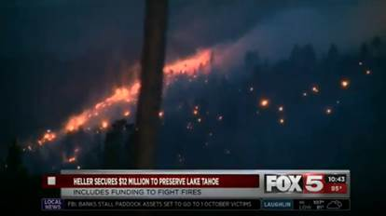](https://youtu.be/PNcDe0-Z86g)

[The video is available above and [HERE](https://youtu.be/PNcDe0-Z86g). ]

/var/folders/py/y368pz856vq9t8rzxjdkm4ch0000gp/T/com.microsoft.Outlook/WebArchiveCopyPasteTempFiles/cidimage004.jpg@01D4049B.71756CF0

[**Heller Secures Tahoe Funds**](http://www.kkoh.com/2018/06/14/heller-secures-tahoe-funds/)

KOH News Talk

*Senator Dean Heller says he’s secured $12 million in federal funding for his Lake Tahoe Restoration Act, as well as funding to help detect wildfires in a spending measure approved by the U.S. Senate Appropriations Subcommittee on the Interior, Environment, and Related Agencies today. Specifically, the appropriations bill includes $6 million that will go toward wildfire management in Lake Tahoe, and $6 million to combat invasive species at the Lake.*

The full story is available [HERE](http://www.kkoh.com/2018/06/14/heller-secures-tahoe-funds/).

*###*