

|  |  |
| --- | --- |
| **For Immediate Release:** | **Contact:** [Megan Taylor](mailto:Megan_Taylor@heller.senate.gov) |
| March 7, 2017 | 202-224-6244 |

**In Case You Missed It: Nevada Media Highlights Heller Bill to Boost School Security, Prevent Violence**

**WASHINGTON, D.C. –** Nevada media continues to highlight bipartisan legislation introduced by Senator Dean Heller (R-NV) and a group of 21 other Senators aimed at preventing school violence. [The STOP School Violence Act of 2018](https://www.heller.senate.gov/public/index.cfm/pressreleases?ID=E26AD292-AB4D-48DC-A005-8D93043C2963) funds school security improvements and invests in early intervention and prevention programs to stop school violence before it happens.

[](https://youtu.be/uVSz_Czhc2A)

Click [HERE](https://youtu.be/uVSz_Czhc2A) or the above image to play the video.



[**Heller Proposes New Bill to Improve School Security**](https://youtu.be/uVSz_Czhc2A)

Fox 5 Las Vegas

Nevada Senator Dean Heller is one of 20 lawmakers in a bipartisan group proposing a new bill that would improve school security and focus on preventing violence. It’s called the “Students, Teachers and Officers Preventing School Violence Act of 2018.” The bill would allow the Department of Justice to fund several programs, including training students, school staff and local law enforcement to identify warning signs and intervene to stop violence before it happens,  school security improvements, threat assessment and crisis intervention teams, and provide coordination between schools and law enforcement.

[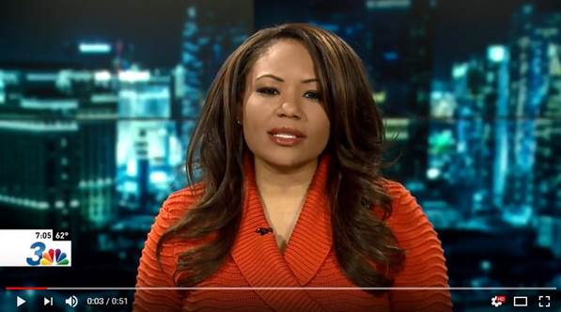](https://youtu.be/utWjPtA-PNY)

Click [HERE](https://youtu.be/utWjPtA-PNY) or the above image to play the video.

cid:image005.jpg@01D3B61B.7E36F720

[**Senator Heller, Bipartisan senators back bill aimed at stopping violence in U.S. schools**](http://news3lv.com/news/local/senator-heller-bipartisan-senators-back-bill-aimed-at-stopping-violence-in-us-schools)

Channel 3 Las Vegas

LAS VEGAS — On Tuesday, Senator Dean Heller introduced new school safety legislation, and one of the key parts of the legislation focuses on the training of students and teachers to look for warning signs of violence before it happens.

  
[**Senator Dean Heller Supporting School Violence Legislation**](http://www.kkoh.com/2018/03/07/senator-dean-heller-supporting-school-violence-legislation/)

KKOH AM 780

Senator Dean Heller joined Senator Orrin Hatch of Utah and a bipartisan group of 20 other senators to introduce the Students, Teachers, and Officers Preventing (STOP) School Violence Act of 2018, legislation that funds school security improvements and invests in early intervention and prevention programs to stop school violence before it happens.

 ###

[cid:image007.png@01D3B61B.7E36F720](http://www.facebook.com/pages/US-Senator-Dean-Heller/325751330177)[cid:image008.png@01D3B61B.7E36F720](http://twitter.com/SenDeanHeller)[cid:image009.png@01D3B61B.7E36F720](http://www.youtube.com/user/SenDeanHeller)