

|  |  |
| --- | --- |
| **For Immediate Release:** | **Contact:**[Megan Taylor](mailto:Megan_Taylor@heller.senate.gov) |
| August 10th, 2018 | 202-224-6244 |

**In Reno, Heller Visits Noah’s Animal House, Affirms His Support for Policies to Help Stop Domestic Abuse**

**RENO** – U.S. Senator Dean Heller (R-NV), a strong supporter and author of legislation to help fight domestic abuse, today visited Noah’s Animal House (NAH) in Reno, a full-service pet shelter to assist animals from homes experiencing domestic violence.   
  
Specifically, Noah’s Animal House is a facility that shelters animals and provides veterinary services and kennels. The shelter, which opened in February, can accommodate up to 36 pets at a time, including cats and dogs. Staci Alonso, founder of NAH, joined Heller on the tour. Alonso opened the first NAH shelter in Las Vegas more than a decade ago.

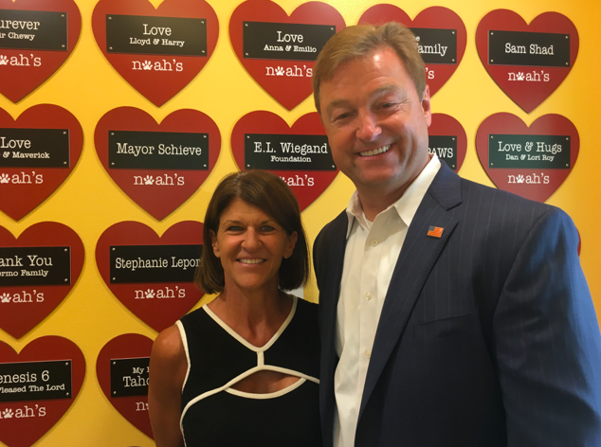

*Sen. Heller pictured with Staci Alonso, founder of NAH*

Heller has a long history of introducing – and passing – legislation to aid victims of domestic violence. Along with U.S. Senator Gary Peters (D-MI), Heller introduced the [Pet and Women Safety Act (PAWS) Act](applewebdata://19916AE3-4F4A-4554-B85E-4407AE33BDD9/a%20bill%20he%20introduced%20with%20Senator%20Gary%20Peters%20(D-MI),%20that%20protects%20victims%20of%20domestic%20violence,%20sexual%20assault,%20stalking%20and%20dating%20violence%20from%20emotional%20and%20psychological%20trauma%20caused%20by%20violence%20against%20their%20pets.%20The%20legislation%20today%20passed%20the%20U.S.%20Senate%20Committee%20on%20Agriculture,%20Nutrition%20&%20Forestry%20as%20part%20of%20broader%20agriculture%20legislation.), bipartisan legislation that protects victims of domestic violence, sexual assault, stalking and dating violence from emotional and psychological trauma caused by violence against their pets. Earlier this summer, the legislation passed the U.S. Senate as part of the Senate’s Farm Bill.  
  
“I will always stand up for survivors of domestic violence, and find ways to help prevent future victims,” **said Heller.** “In both Reno and Las Vegas, Noah’s Animal House is doing incredible work by allowing victims to bring their pets with them to a shelter. This facility empowers survivors and it’s why I’m going to continue to work with my colleagues to pass my PAWS Act into law so domestic abuse victims in Nevada do not have to choose between their pets and their own safety.”   
  
“Noah’s Animal House is fortunate to have Senator Dean Heller in our corner, fighting not only for our shelter, but also to help us carry out our mission of supporting domestic violence survivors,” **said Alonso.** “We are hopeful that Congress will take action and pass Senator Heller’s PAWS Act so that more shelters can offer pet services.”

Earlier this year, [Heller introduced legislation to reauthorize the Family Violence Prevention and Services Act (FVPSA](https://www.heller.senate.gov/public/index.cfm/pressreleases?ID=10B46EC8-A85C-4DD3-BBE7-8FA9DD011EC9)). The legislation reauthorizes a historic law enacted in 1984 that directs funding to states and tribes to help provide supportive services such as shelter, counseling, legal assistance and more to victims of domestic abuse and their dependents. Additionally the bill funds prevention programs and 24-hour victim assistance through the National Domestic Violence Hotline, a toll-free helpline in which highly-trained advocates offer victims of relationship abuse assistance over the phone and through their website at <http://www.thehotline.org/>.

###