

|  |  |
| --- | --- |
| **For Immediate Release:** | **Contact:**[Megan Taylor](mailto:Megan_Taylor@heller.senate.gov) |
| April 10, 2018 | 202-224-6244 |

**In Response to Heller, Zuckerberg Says Facebook’s 87 Million Users Are Victims**

*Zuckerberg: “They Did Not Want Their Information to Be Sold to Cambridge Analytica by a Developer”*

**WASHINGTON** – In response to a question asked by U.S. Senator Dean Heller (R-NV) during a joint U.S. Senate Commerce Committee and Judiciary Committee hearing, Mark Zuckerberg, chief executive officer and founder of Facebook, acknowledged that Facebook’s 87 million users are victims of having their information given away without their consent. Watch the clip [HERE](https://youtu.be/UH52iyBAcQk).

[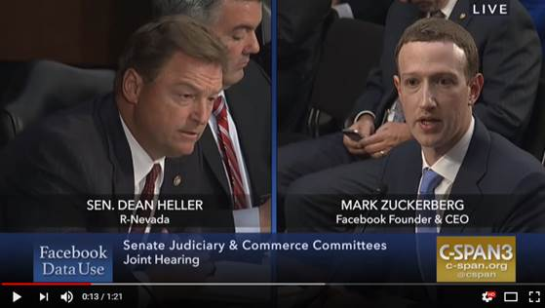](https://youtu.be/UH52iyBAcQk)

Click [HERE](https://youtu.be/UH52iyBAcQk) to or the above image to watch the video.

“Senator, I think…yes. They did not want their information to be sold to Cambridge Analytica by a developer. And that happened, and that happened on our watch,” **said Zuckerberg.** “So even though we didn’t do it, we have a responsibility to be able to prevent that, and be able to take action sooner, and we are committing to make sure that we do that going forward, which is why the steps that I announced before are the two most important things that we are doing. We are looking down the platform to make sure that developers cannot get access to that much data so this can’t happen again going forward, which I think is largely the case since 2014. And, going backwards, we need to investigate every single app that might have had access to a large amount of people’s data to make sure that no one else was misusing it. And if we find out that they are, we going to get into their system and do a full audit and make sure they delete it. And we are going to tell everyone that is affected.”

Heller also asked Zuckerberg how many Nevadans were impacted by the collection, in which Zuckerberg said he did not have that information broken down by state. Heller intends to follow up with Facebook to request that information.

[cid:image003.png@01D3D105.E3DC65B0](http://www.facebook.com/pages/US-Senator-Dean-Heller/325751330177)[cid:image004.png@01D3D105.E3DC65B0](http://twitter.com/SenDeanHeller)[cid:image005.png@01D3D105.E3DC65B0](http://www.youtube.com/user/SenDeanHeller)