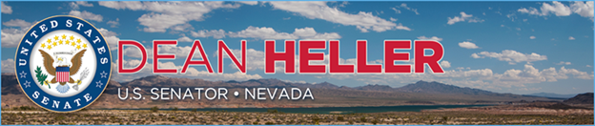

|  |  |
| --- | --- |
| **For Immediate Release:** | **Contact:**[Megan Taylor](mailto:Megan_Taylor@heller.senate.gov) |
| May 23, 2018 | 202-224-6244 |

**In Testimony Ahead of U.S. Senate Panel, Heller Makes the Case for Action on His Bill to Stop Brutal Gang Violence**

**WASHINGTON**– As President Trump and members of the Administration discussed gang violence at a roundtable in New York today, U.S. Senator Dean Heller (R-NV) urged a key Senate panel to take action on his [Criminal Alien Gang Member Removal Act](https://www.heller.senate.gov/public/index.cfm/2018/2/heller-introduces-bill-to-crackdown-on-criminal-gangs-protect-nevada-communities), legislation that gives law enforcement the tools they need to protect Americans from dangerous criminal gangs such as MS-13. [According to the Review-Journal](https://www.reviewjournal.com/crime/courts/4-reputed-ms-13-members-charged-in-las-vegas-murder/), in March the Las Vegas Metropolitan Police Department announced that MS-13 has been connected to 10 brutal killings that occurred in Clark County, Nevada within the last year.  
  
*“In February 2017, after evaluating the rise in crime in Las Vegas, the Las Vegas Metro Police Department announced a new Gang and Vice Unit, given the nature of the increasing crime. This is one of the many factors that drove me to introduce this bill that empowers law enforcement and gives them the tools they need to help protect our country and boost public safety,”***Heller said.**Earlier this year, Heller introduced the Criminal Alien Gang Member Removal Act to help protect Nevada’s communities from criminal gangs, including MS-13, a brutal gang [operates in Nevada and nearly every other state](https://www.justice.gov/opa/speech/file/958481/download). U.S. Reps. Barbara Comstock (R-VA-10), Peter King (R-NY-02), Raúl Labrador (R-Idaho), and House Judiciary Committee Chairman Bob Goodlatte introduced the bill in the U.S. House of Representatives and it passed with a bipartisan vote of 233-175. Senator Heller also [filed the bill as an amendment to immigration legislation](https://www.heller.senate.gov/public/index.cfm/2018/2/heller-files-amendments-to-crackdown-on-criminal-gangs-help-veterans-get-jobs) the Senate considered in February.

*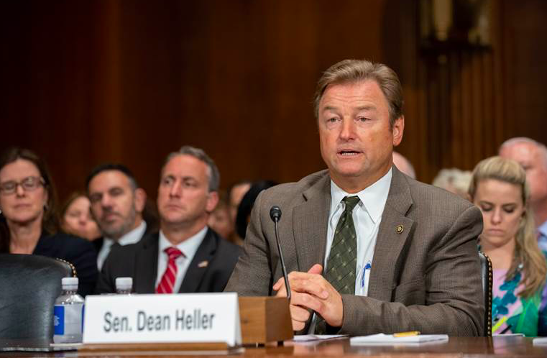  
Heller testifies before the Judiciary Subcommittee on Border Security and Immigration.  
**Media has permission to use this photo.\*\**

Heller testified during a U.S. Senate Committee on the Judiciary Subcommittee on Border Security and Immigration hearing. During his testimony, Heller stressed that protecting our country from violent gangs is not a partisan issue. “*I want to make clear that this is a safety issue. I strongly believe that we need to act to make our communities safer for everyone. Our immigration system is broken and in need of significant reform, and today’s hearing will reflect that*,” **he said.***“I think we can all agree that brutal gang members should not step foot in our country, and those in our country found to be involved in these organizations must be expeditiously deported and immigration authorities should be given the tools they need to remove them,”***said Heller.**

**Background**:

The Criminal Alien Gang Member Removal Act would prohibit gang members from entering the country, and permit the immediate removal of criminal gang members who already are in the United States. Additionally, the proposal ensures that criminal alien gang members are ineligible for immigration benefits, such as asylum, special immigrant juvenile status, and temporary protected status.

###

[cid:image002.png@01D454FA.27751A10](http://www.facebook.com/pages/US-Senator-Dean-Heller/325751330177)[cid:image003.png@01D454FA.27751A10](http://twitter.com/SenDeanHeller)[cid:image004.png@01D454FA.27751A10](http://www.youtube.com/user/SenDeanHeller)