

|  |  |
| --- | --- |
| **For Immediate Release:** | **Contact:**[Megan Taylor](mailto:Megan_Taylor@heller.senate.gov) |
| April 17, 2018 | 202-224-6244 |

**KRNV Reno Reports on Heller’s Efforts to Send $33.5 Million to the Northern Nevada Veterans Home**

**WASHINGTON –**Yesterday evening KRNV Reno reported on U.S. Senator Dean Heller’s (R-NV) efforts to deliver $33.5 million in federal funding to the Northern Nevada Veterans Home. Heller, a senior member of the U.S. Senate Veterans’ Affairs Committee, [recently announced that the U.S. Department of Veterans Affairs (VA) is directing $33.5 million for construction of the Sparks facility](https://www.heller.senate.gov/public/index.cfm/pressreleases?ID=10A6770F-6B7B-4E5C-AE8C-537A9D7C8EC5). **Watch the clip**[**here**](https://youtu.be/qfupvgvprDA)**.**Heller helped secure this funding for the construction of the 96-bed facility into the [recently-signed fiscal year 2018 omnibus measure](https://www.heller.senate.gov/public/index.cfm/2018/3/heller-s-bill-to-expand-veterans-mental-health-services-in-government-funding-measure). Last year he [urged the Appropriations Committee to continue federal support for the state facilities](https://www.heller.senate.gov/public/_cache/files/7f9f37b7-d38f-4e47-a963-a06b9e7a3ee0/05032017%20Cosign%20Letter%20to%20Appropriations%20re%20State%20Veterans%20Home%20Grant%20Program.pdf), arguing that they “serve the long-term needs of our country’s veterans.”  
  
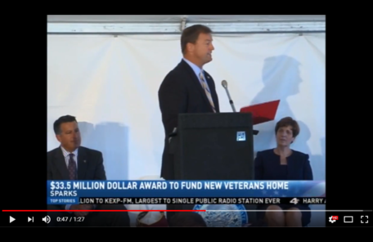

Click [HERE](https://youtu.be/qfupvgvprDA) or the above image to play the video.

###

[cid:image002.png@01D46D6A.F79CB3F0](http://www.facebook.com/pages/US-Senator-Dean-Heller/325751330177)[cid:image003.png@01D46D6A.F79CB3F0](http://twitter.com/SenDeanHeller)[cid:image004.png@01D46D6A.F79CB3F0](http://www.youtube.com/user/SenDeanHeller)