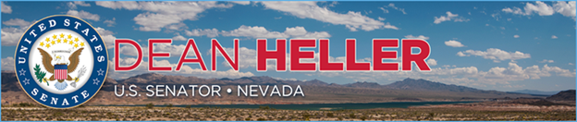

|  |  |
| --- | --- |
| **For Immediate Release:** | **Contact:**[Megan Taylor](mailto:Megan_Taylor@heller.senate.gov) |
| May 30, 2018 | 202-224-6244 |

**KSNV-TV News 3: Heller Speaks to Business Owners, Las Vegas Metro Chamber of Commerce**

**LAS VEGAS –**Yesterday, KSNV-TVNews 3 Las Vegas covered [U.S. Senator Dean Heller’s (R-NV) speech before the Las Vegas Metro Chamber of Commerce](https://www.heller.senate.gov/public/index.cfm/pressreleases?ID=90193A64-6221-4C9D-BC20-65286CD32E5D) where he discussed his fight to stop Yucca Mountain, as well as his work to grow Nevada’s economy and ensure that America’s military veterans receive the benefits, support, and care that they’ve earned. [**Watch the clip here**](https://youtu.be/u5SOnzyLHh8).  
  
At the event, which is part of the Chamber’s Business Power Lunch series, Heller was also presented with the Spirit of Enterprise Award for his commitment to pro-growth policies.

[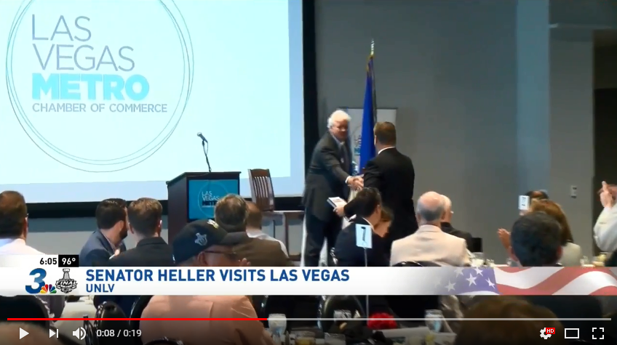](https://youtu.be/u5SOnzyLHh8)  
Click [HERE](https://youtu.be/u5SOnzyLHh8) or the image above to play the clip.

###

[cid:image002.png@01D454FA.27751A10](http://www.facebook.com/pages/US-Senator-Dean-Heller/325751330177)[cid:image003.png@01D454FA.27751A10](http://twitter.com/SenDeanHeller)[cid:image004.png@01D454FA.27751A10](http://www.youtube.com/user/SenDeanHeller)