

|  |  |
| --- | --- |
| **For Immediate Release:** | **Contact:** [Megan Taylor](mailto:Megan_Taylor@heller.senate.gov) |
| September 14, 2017 | 202-224-6244 |

**At First Hearing on Tax Relief, Heller Questions Witnesses on Savings for Nevada Families**

**Washington, D.C.** – During the tax-writing Senate Finance Committee’s first hearing on tax reform, U.S. Senator Dean Heller (R-NV) discussed how bringing tax relief to Nevada’s hardworking families and small businesses will help spur job growth and increase wages.

Heller asked the committee’s witnesses what they anticipate middle-class families will see under a tax relief proposal. Click [here](https://youtu.be/WH3lgJdOvVo) or the image below to watch the exchange.

[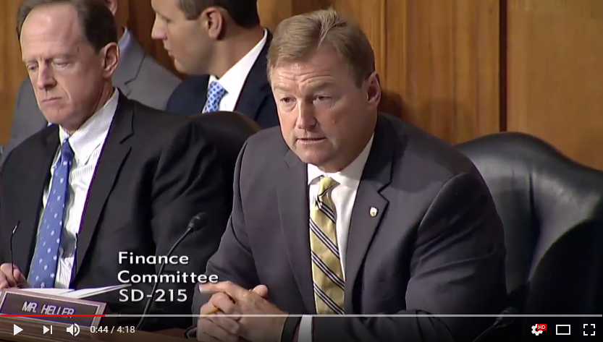](https://youtu.be/WH3lgJdOvVo)

[Click [HERE](https://youtu.be/WH3lgJdOvVo) or above image to play].

Heller recently outlined his priorities for tax relief in an [opinion piece](https://www.heller.senate.gov/public/index.cfm/pressreleases?ID=A55478F6-72E1-4A11-9EB9-DC701FF4BBC6) published Sunday in the Las Vegas Review-Journal, and released a [video](https://www.heller.senate.gov/public/index.cfm/pressreleases?ID=8FEB5FC4-55A9-4764-AC35-F8C864DFD83B) yesterday ahead of the hearing.

**Below is his opening statement as prepared for delivery:**

*Chairman Hatch and Ranking Member Wyden, thank you for holding this hearing. Also, thank you and welcome to our witnesses.*

*Today, we are focused on a topic of immediate importance to America’s middle class – individual tax relief.*

*Our middle class has suffered under an outdated and unfair tax code that discourages job creation and makes it harder for Nevadans, and people all across America, to get ahead.*

*Just the other night during my telephone town hall, I heard from a teacher in Las Vegas who spoke about stagnant wages.*

*I also recently spoke with a young Nevadan who started his own business while going to school full time. The 21-year-old brought up the enormous amount of money he is paying in taxes as well as how complicated it is to navigate our system.*

*Nevadans have been waiting for a fairer, simpler tax code for too long. According to a recent poll conducted by my office, more than half of Nevadans said it is important that Congress pass tax reform legislation by the end of this year.*

*And now, we have a prime opportunity to do that and provide relief to the Americans who have been waiting for a fairer, simpler tax code.*

*To me, relief means letting the middle class keep more of their hard-earned paycheck and making our tax code easy to understand.*

*Less paperwork and more money in their back pockets.*

*It also means more quality jobs, higher wages, and growth in our communities.*

*The current economic situation is not acceptable, and I look forward to working with my colleagues to address it.*

*With that, I have a few questions for our witnesses.*

###  
  
[cid:image003.png@01D32D7B.A02430B0](http://www.facebook.com/pages/US-Senator-Dean-Heller/325751330177)[cid:image004.png@01D32D7B.A02430B0](http://twitter.com/SenDeanHeller)[cid:image005.png@01D32D7B.A02430B0](http://www.youtube.com/user/SenDeanHeller)